DEVELOPING A GRADUATE STUDENT LIFECYCLE MONITORING AND ANALYTICS PLATFORM FOR THE UNIVERSITY OF ST. LA SALLE GRADUATE SCHOOL

A Capstone Project Proposal Presented to the
Department of Information Technology
College of Computer Studies
De La Salle University

In Partial Fulfillment of the Requirements for the Degree of
Bachelor of Science in Information Technology

Prepared and Submitted By:

Mendoza, Natalie U.
Oseña, Khloe Cassandra M.
Sanson, Miguel Joaquin A.
Tumbaga, Myrine Rena Princess B.

Submitted to:

_________________________
Mr. Malabanan, Oliver A.

March 7, 2026

ABSTRACT

Graduate schools manage complex academic and research activities that require continuous coordination among students, advisers, academic coordinators, and Graduate School personnel across multiple lifecycle stages. However, in many institutions, including the University of St. La Salle – Bacolod Graduate School, monitoring graduate student progress relies on spreadsheets, email communication, and distributed document files, making it difficult to verify student status, identify pending requirements, and determine responsibility for the next action. This study proposes the development of a Graduate Student Lifecycle Monitoring and Analytics Platform that consolidates lifecycle records, milestone events, scheduling activities, and document submissions into a centralized monitoring environment to improve visibility of graduate student progression from admission to graduation. The platform organizes lifecycle events into structured workflow states and timestamps that support role-based monitoring, task ownership tracking, and analytics-ready reporting for Graduate School stakeholders. The system is designed using workflow modeling and root-cause analysis to examine existing operational practices and identify coordination gaps. The development approach integrates stakeholder validation, process modeling using BPMN, Ishikawa root-cause analysis, and iterative system prototyping guided by an Agile development methodology. The expected outcome is a web-based monitoring platform that provides dashboards, lifecycle status views, milestone tracking, and operational analytics to support timely follow-ups, reduce coordination delays, and improve decision-making in Graduate School operations.

Keywords: Graduate student lifecycle, milestone tracking, academic monitoring, Agile development, workflow modeling, Graduate School operations, lifecycle analytics, task ownership tracking, monitoring platform.

TABLE OF CONTENTS
ABSTRACT 1
TABLE OF CONTENTS 2
LIST OF FIGURES 8
LIST OF TABLES 10
Chapter 1 – Project Background 11
1.1 Introduction 11
1.2 Organizational Profile 12
1.2.1 Key Stakeholders 13
1.2.2 Ownership Mapping 16
Table 1. Ownership Mapping 18
1.2.3 Graduate School Research Protocol Forms 19
Table 2. Graduate School Research Protocol Forms and Their Purpose 20
1.2.4 Important Stakeholder Documents 21
Table 3. Source-to-mapping 21
1.3 Description of Existing Systems 22
1.3.1 Admission 23
Figure 1. BPMN Diagram – Admission 24
1.3.2 Enrollment 25
Figure 1.1 BPMN Diagram – Enrollment 25
Figure 1.2 BPMN Diagram – Course Adjustments 27
Figure 1.3 BPMN Diagram – Coursework 28
1.3.5 Leave of Absence and Readmission 29
Figure 1.4 BPMN Diagram – Leave of Absence and Readmission 29
1.3.6 Title Defense 31
Figure 1.5 BPMN Diagram – Title Defense 31
1.3.7 Advisor Designation 33
Figure 1.6 BPMN Diagram – Advisor Designation 35
1.3.7 Defense Scheduling and Rescheduling 36
Figure 1.7 BPMN Diagram – Defense Scheduling and Rescheduling 36
1.3.9 Defense and Revisions 38
Figure 1.8 BPMN Diagram – Defense and Revisions 38
1.3.10 Practicum 39
Figure 1.9 BPMN Diagram – Practicum 40
1.3.11 Withdrawal 41
Figure 1.10 BPMN Diagram – Withdrawal 42
1.3.12 Graduation 42
Figure 1.11 BPMN Diagram – Graduation 43
1.4 Statement of the Problem 44
Figure 2. Ishikawa Diagram – Root Causes of Difficulty in Monitoring and Processing Graduate Student Progress 47
1.5 Objectives of the Study 49
1.5.1 SDG Alignment (Sustainable Development Goals): 49
1.6 Conceptual Framework/Design Architecture 51
1.6.1 Conceptual Framework 51
Figure 3. Conceptual Framework Diagram 51
Figure 3.1 Module 1: Student Progress Management 53
Figure 3.2 Module 2: Case Status and Action Tracking 54
Figure 3.3 Module 3:Defense Scheduling Management 55
Figure 3.4 Module 4: Case Monitoring and Follow Up 57
Figure 3.5 Module 5: Analytics and Decision Support 58
Figure 3.6 Module 6:Policy and Case Guidance 60
Figure 3.7 Module 7: Reporting and Dashboards 62
1.6.2 Design Architecture 63
Figure 4. High-Level System Architecture Diagram 63
1.7 Scope and Limitations 66
1.7.1 Scope 66
1.7.1.1 User Scope 66
1.7.1.2 Process Scope 67
1.7.1.3 Data Scope 68
1.7.1.4 Key Performance Indicators (KPIs) of the Conceptual Framework 69
Table 3.1 User and Access Management KPI 70
Table 3.2 Audit Trail and Accountability KPI 71
Table 3.3 Module 1: Student Progress Management KPI 71
Table 3.4 Module 2: Case Status and Action Tracking KPI 72
Table 3.5 Module 3: Defense Scheduling Management KPI 72
Table 3.6 Module 4: Case Monitoring and Follow-Up KPI 73
Table 3.7 Module 5: Monitoring and Follow-ups KPI 74
Table 3.8 Module 6: Policy and Case Guidancet KPI 74
Table 3.9 Module 6: Reporting and Dashboards KPI 75
Table 4. Reference labels used in the KPI table 76
1.7.1.2 Existing (AS-IS) vs Proposed (TO-BE) System 77
Table 5. Existing system (as-is) vs proposed system (to-be) 78
1.7.2 Limitations 79
1.8 Significance of the Study 81
Chapter 2 – Review of Related Literature 83
2.1 Review of Related Concepts 83
2.1.1 Key Terms/Scope Labels 83
2.1.2 Graduate Student Lifecycle Tracking and Milestone-Centric Progress 84
2.1.3 Thesis/Dissertation Pipeline as an Operational Workflow 85
2.1.4 Time-to-Degree, Residency, Delay, and Attrition as Monitoring Measures 85
2.1.5 Academic Operations Analytics and Decision Support 86
2.1.6 Data Privacy, and Role-Based Access in Higher Education Systems 87
2.1.7 Retrieval-Augmented Generation for Policy-Grounded AI Systems 87
2.1.8 API-Based System Integration in Academic Information Systems 88
2.2 Review of Related Systems/Infrastructure 89
2.2.1 Thesis/Dissertation Management Portals and Scheduling Systems 90
2.2.2 Workflow-Based Approval Systems for Graduate Submissions 90
2.2.3 Institutional Policies and Handbooks as Operational Infrastructure 90
2.2.4 Sector Digital Transformation and Data Platform Context 91
2.3 Review of Related Methodologies 91
2.3.1 BPMN for Workflow Modeling and Analysis 91
2.3.2 Ishikawa (Fishbone) Analysis for Root Cause Identification 91
2.3.3 Decision Support, Dashboards, and Process/Operations Analytics 92
2.4 Conflicting Arguments, Context Differences, and Monitoring Implications 93
2.4.1 Normative Timelines vs. Policy Ceilings 93
2.4.2 Milestone-Centric Progress vs. Enrollment-Centric Status 93
2.4.3 Manual Operational Reality vs. Analytics Expectations 94
Chapter 3 – Methodology 95
Figure 5.1 Methodology Flow of the Study with Scrum-Based Prototype Development 96
3.1 Proposed System Development 98
Figure 5.2 Proposed System Development Approach 98
Figure 5.3. Proposed System Development Overview Using Agile Scrum 101
3.2 Phases 103
Figure 5.4. Specification Phases for the Proposed Graduate School Monitoring and Decision Support Platform 104
3.2.1 Data Requirements 105
Table 5. Data to be collected and sources 110
3.2.2 Milestone Gate Criteria 110
Table 6. Milestone Gate Criteria explaining definition of completion 115
3.2.3 Functional Requirements 116
Table 7. Functional Requirements of the modules 117
3.2.4 Non-Functional Requirements 118
Table 8. Non-Functional Requirements of the modules 118
3.2.5 Technology Stack and Tools 119
3.2.5.1 Summary of IT Tools 120
Table 9. IT tools to be used 123
3.2.5.2 Platform Approach 123
3.2.5.3 Database and Reporting 123
3.2.5.4 Prescriptive Analysis for Decision Support 124
3.2.5.5 RAG-Based Decision Support Assistant 126
Figure 6. RAG-Based Decision Support Assistant Architecture 127
3.2.5.6 Authentication, RBAC, and Audit Logging Tools 129
3.2.5.7 Reporting, Dashboards, and Analytics Tools 129
3.2.5.8 Notifications and Alerts Tools 130
3.2.5.9 Development, Collaboration, and Documentation Tools 131
3.2.6 Database Design 131
3.2.6.1 Core Entities/Tables 132
Table 10. Core tables and their purpose 135
3.2.6.2 Key Relationships and Integrity Rules 135
Table 11. Key relationships (high-level PK/FK design) 137
3.2.6.3 Entity-Relationship Diagram (ERD) and Table Group Overview 139
Figure 7. Full ERD of the proposed platform database (grouped) 139
Figure 7.1 Group A. Student and Program Context 140
Figure 7.2 Group B. Identity, Roles, and Assignments 141
Figure 7.3 Group C. Lifecycle & Milestones 142
Figure 7.4 Group D. Workflow Tasks & Decisions 144
Figure 7.5 Group E. Documents & Revisions 146
Figure 7.6 Group F. Scheduling & Coordination 147
Figure 7.7 Group G. Monitoring, Alerts, and Interventions 148
Figure 7.8 Group H. Auditability 149
3.2.6.4 Computed Indicators for Prescriptive Analytics and Decision Support 150
Table 13. Computed indicators from event history used for prescriptive analytics and decision support 151
3.2.6.5 Resource Planning 152
Table 14. Cost table for on-site premises 154
3.3 Workplan 155
3.3.1 Target Accomplishment for CAP-IT1 (80% of IT development) 155
3.3.2 Target Accomplishment for CAP-IT2 (20% of IT development) 155
3.3.3 CAP-IT1 Work Timeline 156
Table 15.1. CAP-IT1 Work Timeline (80% target) 161
3.3.4 CAP-IT2 Work Timeline 161
Table 15.2. CAP-IT2 Work Timeline (20% target) 163
REFERENCES 165
GLOSSARY OF TERMS 174
LIST OF ACRONYMS 184
APPENDICES 186
Appendix A. BPMN Workflows 186
Appendix A.1. Admission 186
Appendix A.2. : Enrollment 187
Appendix A.3. Course Adjustments 188
Appendix A.4. Coursework 189
Appendix A.5. Leave of Absence and Readmission 190
Appendix A.6. Title Defense 191
Appendix A.7. Advisor Designation 192
Appendix A.8. Thesis/Dissertation Pipeline (Milestone Workflow) 194
Appendix B. Ishikawa Diagram – Root Causes of Difficulty in Monitoring and Processing Graduate Student Progress 198
Appendix C. Conceptual Framework Diagram 198
Appendix D. High-Level System Architecture Diagram 200
Appendix E. Key Performance Indicators (KPIs) of the Conceptual Framework 201
Appendix E.1. User and Access Management KPI 201
Appendix E.2. Audit Trail and Accountability KPI 201
Appendix E.3. Student Progress Management KPI 201
Appendix E.4. Case Status and Action Tracking KPI 202
Appendix E.5. Defense Scheduling Management KPI 202
Appendix E.6. Case Monitoring and Follow-Up KPI 202
Appendix E.7.Analytics and Decision Support KPI 203
Appendix E.8. RAG-Based Decision Support Assistant KPI 203
Appendix E.9. Reporting and Dashboards KPI 203
Appendix F. Reference labels used in the KPI table 203
Appendix G. Existing (AS-IS) vs Proposed (TO-BE) System 204
Appendix H. Methodology 206
Appendix H.1. Methodology Flow of the Study with Scrum-Based Prototype Development 206
Appendix H.2. Proposed System Development Approach 207
Appendix H.3. Proposed System Development Overview Using Agile Scrum 207
Appendix H.4. Specification Phases for the Proposed Graduate School Monitoring and Decision Support Platform 208
Appendix I. Data Requirements 208
Appendix I.1. Data to be collected and sources 208
Appendix J. Milestone Gate Criteria 213
Appendix J.1 Milestone Gate Criteria explaining definition of completion 213
Appendix K. Functional Requirements 218
Appendix L. Non-Functional Requirements 220
Appendix M. IT tools to be used 221
Appendix N. Core tables and their purpose 223
Appendix O. Key relationships (high-level PK/FK design) 227
Appendix P. RAG-Based Decision Support Assistant Architecture 229
Appendix Q. Entity-Relationship Diagram (ERD) and Table Group Overview 230
Appendix Q.1. Group A. Student and Program Context 231
Appendix Q.2. Group B. Identity, Roles, and Assignments 231
Appendix Q.3. Group C. Lifecycle & Milestones 232
Appendix Q.4. D. Workflow Tasks & Decisions 234
Appendix Q.5. Group E. Documents & Revisions 235
Appendix Q.6. Group F. Scheduling & Coordination 235
Appendix Q.7. Group G .Monitoring, Alerts, and Interventions 237
Appendix Q.8. Group H. Auditability 238
Appendix R. Computed indicators from event history used for prescriptive analytics and decision support 238
Appendix S. Cost table for on-site premises 240
Appendix T. Workplan 241
Appendix T.1. CAP-IT1 Work Timeline (80% target) 241
Appendix T.2. CAP-IT2 Work Timeline (20% target) 247

LIST OF FIGURES

Figure 1. BPMN Diagram – Admission
Figure 1.1 BPMN Diagram – Enrollment
Figure 1.2 BPMN Diagram – Course Adjustments
Figure 1.3 BPMN Diagram – Coursework
Figure 1.4 BPMN Diagram – Leave of Absence and Readmission
Figure 1.5 BPMN Diagram – Title Defense
Figure 1.6 BPMN Diagram – Advisor Designation
Figure 1.7 BPMN Diagram – Thesis/Dissertation Pipeline (Milestone Workflow)
Figure 1.8 BPMN Diagram – Defense and Revisions
Figure 1.9 BPMN Diagram – Practicum
Figure 1.10 BPMN Diagram – Withdrawal
Figure 1.11 BPMN Diagram – Graduation
Figure 2. Ishikawa Diagram – Root Causes of Difficulty in Monitoring and Processing Graduate Student Progress
Figure 3. Conceptual Framework Diagram
Figure 3.1 Module 1: Student Progress Management
Figure 3.2 Module 2: Case Status and Action Tracking
Figure 3.3 Module 3: Defense Scheduling Management
Figure 3.4 Module 4: Case Monitoring and Follow-Up
Figure 3.5 Module 5: Analytics and Decision Support
Figure 3.6 Module 6: Policy and Case Guidance
Figure 3.7 Module 7: Reporting and Dashboards
Figure 4. High-Level System Architecture Diagram (Appendix D)
Figure 5.1 Methodology Flow of the Study with Scrum-Based Prototype Development
Figure 5.2 Proposed System Development Approach
Figure 5.3. Proposed System Development Overview Using Agile Scrum
Figure 5.4. Specification Phases for the Proposed Graduate School Monitoring and Decision Support Platform
Figure 6. RAG Architecture
Figure 7. Full ERD of the proposed platform database (grouped)
Figure 7.1 Group A. Student and Program Context
Figure 7.2 Group B. Identity, Roles, and Assignments
Figure 7.3 Group C. Lifecycle & Milestones
Figure 7.4 Group D. Workflow Tasks & Decisions
Figure 7.5 Group E. Documents & Revisions
Figure 7.6 Group F. Scheduling & Coordination
Figure 7.7 Group G. Monitoring, Alerts, and Interventions
Figure 7.8 Group H. Auditability

LIST OF TABLES

Table 1. Ownership Mapping
Table 2. Modules, in-scope features, and measurable KPIs (Prototype)
Table 3.1 User and Access Management KPI
Table 3.2 Audit Trail and Accountability KPI
Table 3.3 Module 1: Student Progress Management KPI
Table 3.4 Module 2: Case Status and Action Tracking KPI
Table 3.5 Module 3: Defense Scheduling Management KPI
Table 3.6 Module 4: Case Monitoring and Follow-Up KPI
Table 3.7 Module 5: Analytics and Decision Support KPI
Table 3.8 Module 6: Policy and Case Guidance
Table 3.9 Module 7: Reporting and Dashboards KPI
Table 4. Reference labels used in the KPI table
Table 5. Existing system (as-is) vs proposed system (to-be)
Table 6. Data to be collected and sources
Table 7. Milestone Gate Criteria explaining definition of completion
Table 8. Functional Requirements of the modules
Table 9. Non-Functional Requirements of the modules
Table 10. IT tools to be used
Table 11. Core tables and their purpose
Table 12. Key relationships (high-level PK/FK design)
Table 13. Computed indicators from event history used for prescriptive analytics and decision support
Table 14. Cost table for on-site premises
Table 15.1. CAP-IT1 Work Timeline (80% target)
Table 15.2. CAP-IT2 Work Timeline (20% target)

Chapter 1 – Project Background

1.1 Introduction
Graduate education involves long-term academic and research work that requires continued coordination among graduate students, advisers, panel members, coordinators, and Graduate School offices. Unlike many undergraduate processes that often move in more synchronized batches, graduate students may progress at different speeds across admission, enrollment, coursework, leave of absence and readmission, practicum where applicable, research milestones, withdrawal, and graduation endorsement. Students may move forward at different times depending on reviews, approvals, revisions, and scheduling. Because of this, student progress is not only about completing requirements. It also depends on passing milestone stages, getting approvals, and coordinating with different roles. In this kind of setting, the practical question, “Where is the student right now?” becomes difficult to answer when records and updates are scattered across different tools, offices, and communication channels.
In graduate school operations, milestone-based tracking is important for maintaining visibility and consistency across programs. Young et al. (2024) explain that graduate progress is often centered on milestones and may not fit the same kind of dashboards used for undergraduate monitoring. This suggests that institutions need tracking approaches that reflect different program rules and non-linear progress patterns. In the same way, doctoral monitoring literature shows that progress oversight depends on structured signals and not only on informal judgment (Brooks, 2023). When progress evidence is divided across admissions records, enrollment records, monitoring sheets, forms, decisions, and schedules spread across email threads, shared drives, and spreadsheets, status visibility often becomes a best-guess reconstruction instead of a clear and reliable record.
In response to this need, the proposed capstone is an AI-enhanced business system in the form of a web-based Graduate Student Lifecycle Monitoring and Analytics Platform. As an AI system, it is designed to support Graduate School work by bringing student monitoring, milestone tracking, document tracking, scheduling, follow-ups, and reporting into one platform. It also includes an AI-supported feature that uses Retrieval-Augmented Generation (RAG) through NotebookLM. This allows the system to provide answers and guidance based on Graduate School policies, guidelines, and related records, instead of relying only on general AI responses. The AI feature is meant to assist staff and administrators in reviewing cases and understanding the next steps, while final decisions remain with the proper offices and authorized personnel. In this way, the capstone combines the functions of a business system for daily Graduate School processes with AI support that improves monitoring and decision support.

1.2 Organizational Profile
This project is situated in the higher education sector, specifically in graduate school administration and student lifecycle operations in the Philippine context. Graduate schools need to coordinate many roles involved in academic decisions, such as curriculum alignment, subject planning, title approval, proposal acceptance, defense outcomes, and graduation endorsement, as well as operational tasks such as routing documents, scheduling panels, tracking compliance requirements, and monitoring student status across different stages of the lifecycle. These processes are shaped by institutional policies, program-level differences, and role restrictions related to privacy and academic records.
The main organizational setting of this project is the University of St. La Salle Graduate School in Bacolod City. The Graduate School offers programs in several academic areas, including Arts and Sciences, Business, Education, Engineering and Technology, and Nursing. Because of this, Graduate School processes must support multiple disciplines that may differ in curriculum structure, documentation requirements, practicum needs, research milestones, and review or scheduling practices.

In terms of admissions, the Graduate School follows a structured set of steps and requirements. Applicants are asked to submit requirements through the Graduate School admissions email, create an AIMS applicant account, pay the required processing and examination fees through the approved channels, and proceed through the examination and interview stages before acceptance is confirmed. These published steps show that Graduate School administration already relies on a mix of digital tools and coordination across multiple offices. This reflects the same kind of operational complexity that also appears later in enrollment monitoring, coursework tracking, leave of absence and readmission, research milestones, and graduation endorsement.
The Graduate School also operates within a defined administrative structure. The Graduate School overview identifies the academic officers of the unit, including the Dean, Academic Coordinators, Research Coordinators, and other related contact references. This is important because it helps clarify where decision-making authority and oversight may be located across Graduate School processes, policy interpretation, and escalation.

1.2.1 Key Stakeholders
Graduate School operations involve several stakeholders with different responsibilities and information needs across the full graduate student lifecycle. The process is not limited to thesis or dissertation stages alone. It also includes admission handoff, enrollment monitoring, curriculum alignment, coursework tracking, leave of absence and readmission, practicum for applicable programs, research milestones, withdrawal, and graduation endorsement. These activities are carried out through a series of handoffs among students, faculty, coordinators, administrative staff, and decision-making offices. Because of this, monitoring and process support must reflect both the academic side of decisions, such as subject completion, defense outcomes, and graduation readiness, and the operational side of coordination, such as routing, scheduling, document completeness, status updates, and approvals. The following stakeholders represent the main roles involved in the graduate student lifecycle and its related monitoring processes.
- Graduate Students. Graduate students move through both academic and research-related stages of the graduate lifecycle. These may include admission onboarding, enrollment, coursework completion, leave of absence or readmission when applicable, practicum for certain programs, title defense, proposal and final defense, revisions, and graduation endorsement. Their main need is clear visibility of their current stage, required documents, next steps, deadlines, and realistic time expectations. Students also need to know what is still pending and who is responsible for the next action to reduce repeated follow-ups and uncertainty.
- Research Adviser(s). Advisers guide manuscript development, provide technical and academic supervision, endorse readiness for proposal and final defense stages, and confirm revision completion when needed. Their monitoring needs include visibility of assigned students, pending review tasks, correct document versions, revision status, and upcoming or requested schedule windows.
- Academic Coordinator. The Academic Coordinator supports program compliance and day-to-day process flow by reviewing study plans, confirming curriculum alignment, identifying subject needs, endorsing required forms, and providing inputs related to panel nomination or research-stage requirements depending on institutional practice. Their monitoring needs include visibility of student status across the program, exception handling, and queues of pending endorsements, validation checks, or subject-related concerns
- Research Coordinator. The Research Coordinator supports research-stage coordination, such as panel nomination, defense scheduling, and routing of research-related decisions and requirements. Their monitoring needs include visibility of milestone status, compliance checks, adviser and panel assignments, and indicators that help identify cases needing follow-up or escalation.
- Graduate School Office Staff. Administrative staff coordinate schedules, track documents, route submissions, and maintain day-to-day visibility of student progress across different stages of the lifecycle. This may include onboarding support, enrollment-related monitoring, leave of absence and readmission records, defense-related coordination, and graduation endorsement preparation. In many cases, this role also maintains monitoring artifacts such as spreadsheets or email-based tracking. For example, the interview discussion referenced Ms. Lyra as an administrative support role for monitoring, which shows how visibility can become person-dependent when tracking relies on manual practices. Their monitoring needs include counts per stage, pending items, overdue cases, scheduling status, and turnaround-time signals that help identify bottlenecks.
- Dean. The Dean serves as a decision-making and approval authority in key parts of the graduate lifecycle. This may include leave of absence decisions, withdrawal requests, onboarding review, adviser designation, and graduation endorsement review. The Dean’s monitoring needs include visibility of cases awaiting approval, supporting documents, exception cases, and summary views that help support timely decisions.
- Faculty. Faculty members support the academic side of the graduate student lifecycle, particularly in coursework delivery, grade submission, and subject-related academic requirements. In the current process, faculty encode grades that students later view through the existing system, while the Graduate School uses the resulting signals mainly for completion and monitoring rather than detailed grade management. Their monitoring needs include visibility of class lists, assigned teaching loads, submitted grade status, and any subject-related information that affects Student Progress Management.

1.2.2 Ownership Mapping
Process Area | Sub-area | Accountable Office/Role (AS-IS) | Student View (AS-IS) | Current System (AS-IS) | In System Scope? (Yes/No)
Admission | Requirements submission | Admission Office | AIMS / admissions email | AIMS and email | No
 | Admission status confirmation | Graduate School Staff / Academic Coordinator | Graduate School | AIMS status and email | No
 | Program onboarding | Graduate School Staff / Academic Coordinator | Graduate School | Manual onboarding steps, email, and forms | Yes
Enrollment | Enrollment status confirmation | Graduate School Staff / Academic Coordinator | AIMS / Graduate School | Existing enrollment system and spreadsheets | Yes
 | Monitoring of enrolled classes | Academic Coordinator / Graduate School Staff | Graduate School |  | Yes
 | Monitoring of class changes | Academic Coordinator / Graduate School Staff | Graduate School | Enrollment platform + spreadsheets | Yes
 | Subject needs and class offering planning | Academic Coordinator | Graduate School | Manual planning, spreadsheets, and monitoring sheets | Yes
 | Academic progress tracking (course audit) | Academic Coordinator | Graduate School | AC-Student-Monitoring template / Excel | Yes
Coursework | Planned class schedule visibility | Academic Coordinator / Graduate School Staff | CANVAS / Graduate School | Existing student portal / CANVAS | Yes
 | Grade and standing summary signals | Faculty / Academic Coordinator | Graduate School | Registrar-side grade system | No
LOA & Readmission | LOA application tracking | Dean / Graduate School Staff | Graduate School | Email-based routing | Yes
 | Residency pause tracking | Graduate School Staff | Graduate School | Manual tracking and AIMS reports | Yes
 | Readmission application tracking | Graduate School Staff / Dean | Graduate School | Email and manual tracking | Yes
Thesis/Dissertations | Research milestone tracking | Research Coordinator / Graduate School Staff / Adviser | Graduate School | Research monitoring sheets and protocol forms | Yes
Practicum | Practicum hours and document tracking | Academic Coordinator / Program Coordinator | Graduate School | Manual logs, certificates, and paper submissions | Yes
Withdrawal | Withdrawal request tracking | Dean / Academic Coordinator | Graduate School | Email and manual tracking | Yes
 | Withdrawal status confirmation | Academic Coordinator / Graduate School Staff | Graduate School |  | Yes
Graduation | Graduation candidate review | Graduate School Staff / Academic Coordinator / Research Coordinator | Graduate School | Manual checklist and endorsement preparation | Yes
 | Graduation endorsement list review | Dean | Graduate School | Manual endorsement list | Yes
 | Graduation status output | Registrar |  | Registrar process and output | No

Table 1. Ownership Mapping
Table 1 shows the ownership mapping of each graduate student lifecycle process area and sub-area by identifying the accountable office or role in the current process, where the student usually refers for the transaction, the current system or document used, and whether the item is within the scope of the proposed system. This mapping helps define scope boundaries and supports the role lanes used in the AS-IS process diagrams and access control design. The mapping also reflects the confirmed setup that the proposed system is for monitoring and support, and does not replace official admissions, Registrar, or Accounting processes.

1.2.3 Graduate School Research Protocol Forms
Form ID | Form Name | Purpose | Key Monitoring Signal
Form 1 | Application for Title Defense | Title Defense Application | “Title defense application submitted” (date/time)
Form 2 | Report of Title Defense | Title Defense Outcome | “Approved title selected / disapproved” (outcome + date)
Form 3 | Application for Designation of Research Adviser | Adviser Designation Request | “Adviser designation requested”
Form 3.1 | Appointment for Research Adviser | Adviser Confirmed | “Adviser appointed” (date)
Form 3.2 | Research Timetable | Advising Setup | “Timetable submitted/approved”
Form 3.3 | Thesis/Dissertation Advising Contract | Advising Setup | “Advising contract completed”
Form 3.4 | Request for Change of Title of the Study | Exception / Change Control | “Title change requested/approved”
Form 3.1.1 | Request for Change of Research Adviser | Exception / Change Control | “Adviser change requested/approved”
Form 4 | Endorsement for Proposal/Final Defense | Defense Readiness Endorsement | “Endorsed for defense” (date)
Form 4.1 | Statistical Consultation Form | Conditional (Quantitative) | “Stat consultation completed”
Form 4.2 | Co-authorship Information for Publication | Conditional (Publication-related) | “Co-authorship declared”
Form 4.3 | Endorsement for Public Defense | Public Defense Readiness | “Endorsed for public defense”
Form 5 | Comments Sheet for Proposal Defense | Proposal Defense Outcome | “Proposal comments consolidated” (date)
Form 5.1 | Technical Review Certificate | Proposal Post-Revision Gate | “Technical review cleared”
Form 5.2 | Application for Ethics Review | Ethics Review | “Ethics submitted / cleared” (status + date)
Form 6 | Comments Sheet for Final Defense | Final Defense Outcome | “Final defense comments issued”
Form 7 | Evaluation Sheet for Final Defense | Final Defense Evaluation | “Final rating recorded” (pass/minor/major)
Form 8 | Settlement of Provisional Thesis/Dissertation Approval | Provisional Pass Handling | “Provisional settlement recorded”
Form 9 | Editor Certification | Manuscript Finalization | “Editor certified”
Form 10 | Approval Sheet | Completion Evidence | “Approval sheet complete” / readiness for endorsement

Table 2. Graduate School Research Protocol Forms and Their Purpose
Table 2 shows the Graduate School Research Protocol forms used in thesis and dissertation monitoring. These forms mark key process events such as applications, endorsements, comments, clearances, evaluations, and completion evidence. For monitoring purposes, each form can be linked to a milestone, owner, status, and timestamp.

1.2.4 Important Stakeholder Documents
Output | Relevance
AC-STUDENT-MONITORING-Template.xlsx | Academic year entry, student identifiers, program or track, course list, unit totals, completion markers, and AY/Sem taken fields
Student-Research-Monitoring.xlsx | Adviser assignment, milestone dates, defense outcomes, required certifications such as Turnitin, editor certification, and approval sheet, and exception notes
Graduate School Research Protocol (AY 2024–2025) | Title, proposal, and final defense stages, form flow, required documents, and conditional requirements
2nd Meeting Transcript Confirmation w/ Sir Eddie De Paula | Confirmed AS-IS process details, role ownership, scope boundaries, current monitoring practices, and key lifecycle requirements discussed with and signed by Sir Eddie De Paula.

Table 3. Source-to-mapping
Table 3 shows how key stakeholder documents support monitoring across the graduate student lifecycle. The AC-STUDENT-MONITORING template supports coursework and study plan tracking, while the student research monitoring sheet supports milestone tracking, defense outcomes, and completion evidence. The Graduate School Research Protocol provides the required forms, stages, and document requirements used in research-related processes. Together, these documents serve as practical sources for status tracking, milestone recording, and completion checking.

1.3 Description of Existing Systems
Graduate student lifecycle tracking is currently handled through a mix of existing institutional systems and manual coordination. Official records such as enrollment status and grades are kept in institutional systems, primarily AIMS, while Graduate School processes such as checking requirements, scheduling, and endorsements are often handled through email, spreadsheets, person-to-person follow-ups, the AC-Student-Monitoring template, the STUDENT-MONITORING spreadsheet, and Graduate School research protocol forms.

1.3.1 Admission
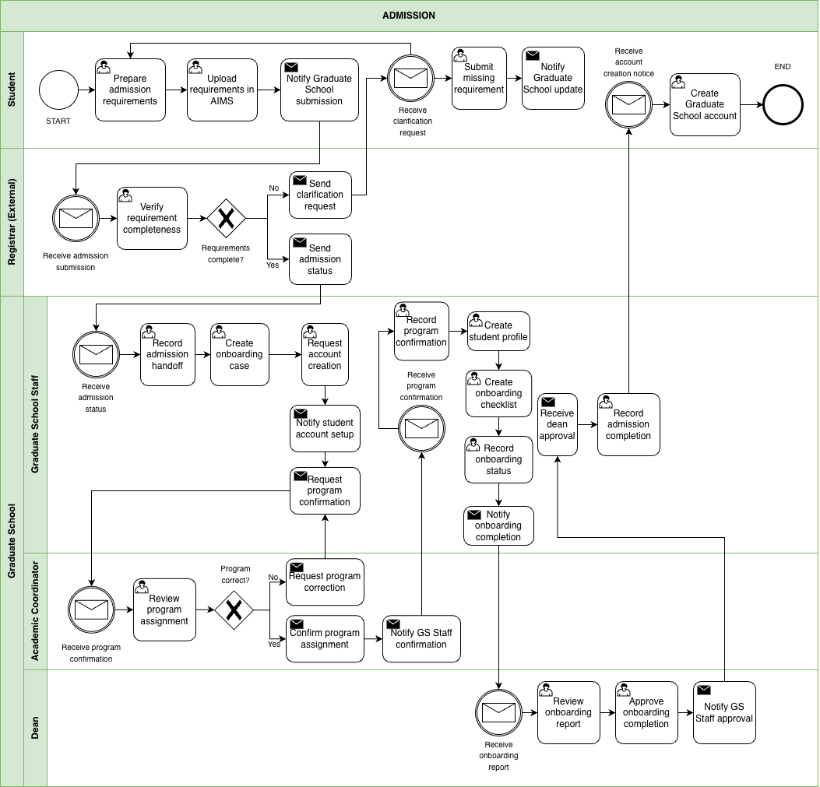

Figure 1. BPMN Diagram – Admission
This figure shows the admission monitoring handoff from AIMS to the Graduate School. The student uploads requirements in AIMS, and the Registrar checks completeness. If something is missing, a clarification request is sent and the student submits the missing items. Once admission status is confirmed, Graduate School Staff begin onboarding activities such as creating an onboarding case, requesting account creation, confirming the program assignment, and preparing an onboarding checklist. The Dean reviews onboarding completion before the Graduate School records admission completion.

1.3.2 Enrollment
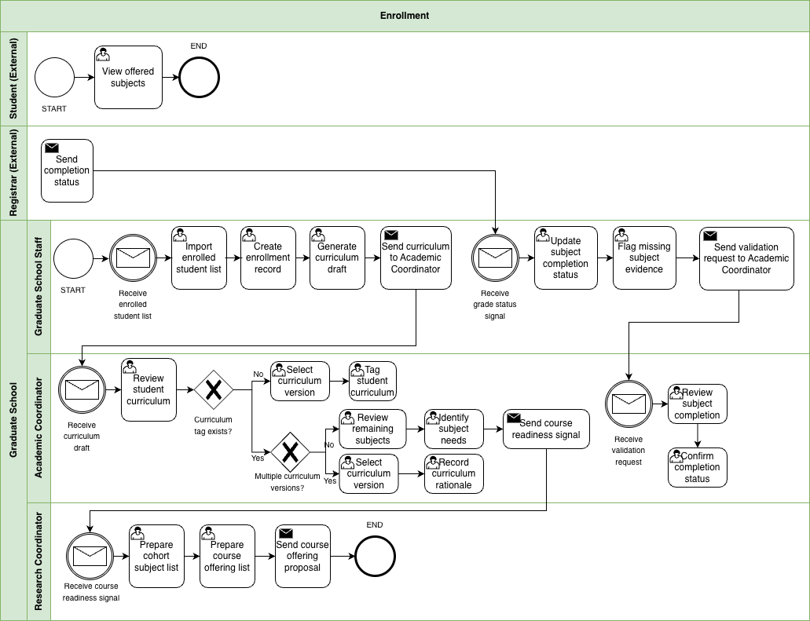

Figure 1.1 BPMN Diagram – Enrollment
This figure shows how the Graduate School takes enrollment signals and turns them into monitoring actions. Graduate School Staff receive the enrolled student list and create basic enrollment records and a curriculum draft. The Academic Coordinator reviews the curriculum, confirms or assigns the correct curriculum version, and tags the student to that curriculum. This monitoring view is based on records such as the AC-Student-Monitoring template and the STUDENT-MONITORING spreadsheet. When there are multiple curriculum versions, extra checking is needed to make sure the student is aligned correctly. After tagging, the Academic Coordinator identifies the remaining subjects and subject needs. When grade or completion signals arrive, Graduate School Staff update subject completion status, flag missing evidence, and send validation requests when needed.

1.3.3 Course Adjustments
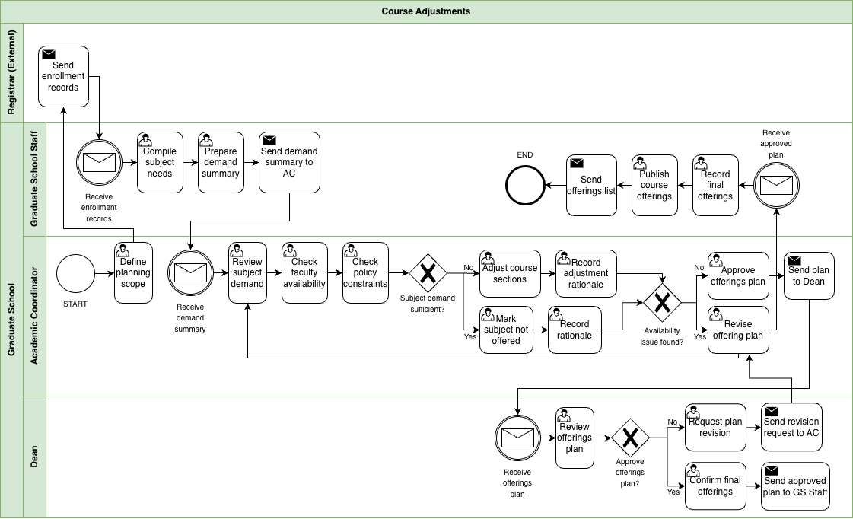

Figure 1.2 BPMN Diagram – Course Adjustments
This figure shows how the Graduate School reviews subject demand and adjusts planned course offerings before publication. Graduate School Staff compile subject needs from enrollment records and prepare a demand summary for the Academic Coordinator. The Academic Coordinator reviews subject demand, checks faculty availability and policy constraints, and decides whether to adjust course sections or mark a subject as not offered. If availability issues occur, the offering plan is revised before being sent to the Dean for approval. Once approved, Graduate School Staff record the final offerings and publish the course list. This reflects the current practice where the Academic Coordinator prepares course offerings based on student subject needs and curriculum requirements near the end of each term.

1.3.4 Coursework
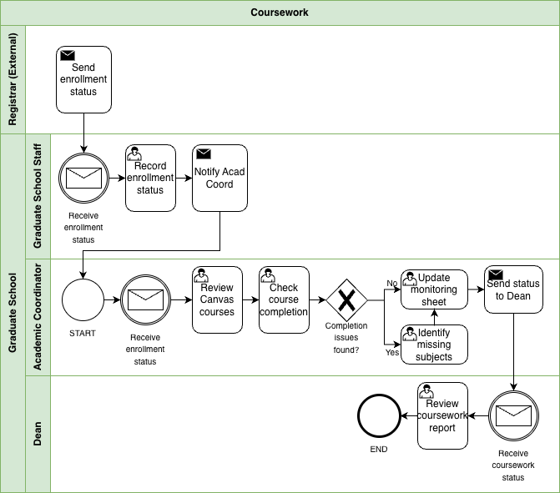

Figure 1.3 BPMN Diagram – Coursework
This figure shows how the Graduate School monitors coursework completion after enrollment. Enrollment status is received from existing institutional records, and Graduate School Staff record the status and notify the Academic Coordinator. The Academic Coordinator reviews coursework and checks subject completion to identify missing subjects or remaining requirements. Monitoring records are updated and the coursework status is sent to the Dean for review. This process reflects how Graduate School monitoring focuses on completion status and remaining subjects rather than exact grade values while official academic records remain within the Registrar’s system.

1.3.5 Leave of Absence and Readmission
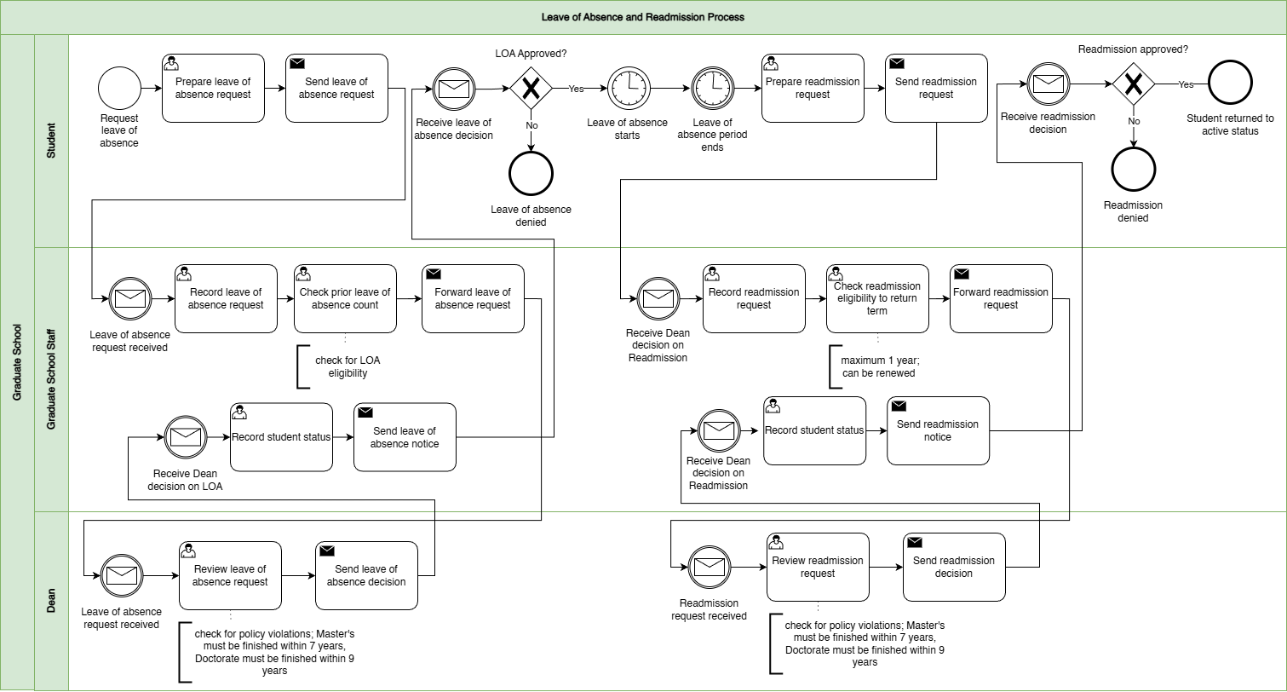

Figure 1.4 BPMN Diagram – Leave of Absence and Readmission
This figure shows leave of absence and readmission as a stop and start process. The student submits a leave of absence request, usually through email, and Graduate School Staff record it, check eligibility including prior leave of absence count, and forward it to the Dean for approval. Once the Dean decides, Graduate School Staff record the student’s status and send the decision notice. The stop and start part is important because leave of absence has an approved period, and readmission happens later when the student is ready to return. When the student requests readmission, staff record the request, check eligibility to return for the target term, and forward it again to the Dean. After the Dean’s decision, staff update the status and notify the student.

1.3.6 Title Defense
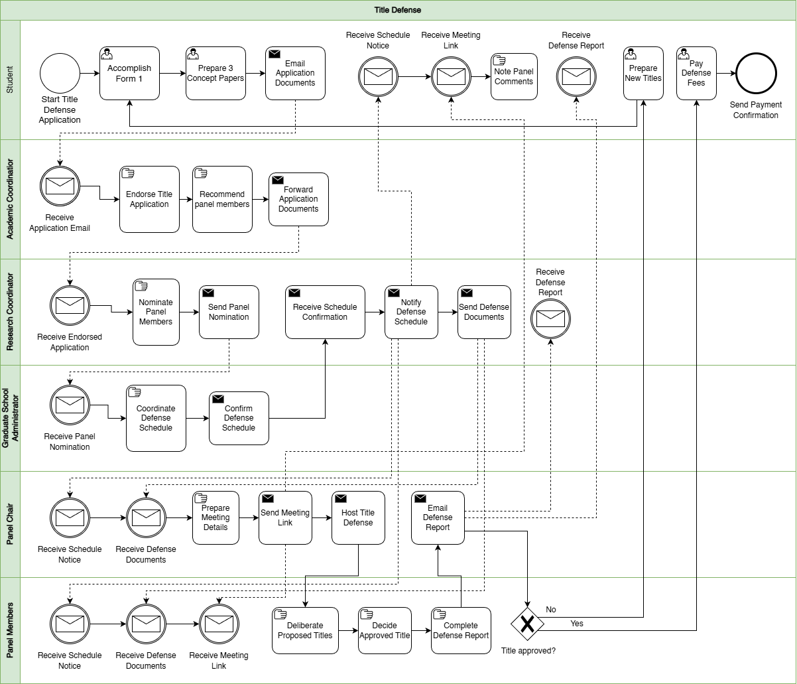

Figure 1.5 BPMN Diagram – Title Defense
This figure shows how the title defense application and decisions are coordinated. The student prepares and submits the required documents, including the concept papers, Form 1 Application for Title Defense, and the related application materials. The Academic Coordinator receives the submission, endorses it, and helps recommend panel members. The Research Coordinator handles panel nomination. Graduate School administration coordinates the schedule and sends notices. The Panel Chair prepares the meeting details, sends the meeting link, hosts the title defense, and sends the defense report through Form 2 Report of Title Defense. The Panel Members deliberate and decide whether the proposed title is approved. If the title is not approved, the student revises and prepares new titles for re-evaluation. If approved, the student proceeds with the next required actions, including payment, which is usually given in cash to the panel on the day of the defense.

1.3.7 Advisor Designation
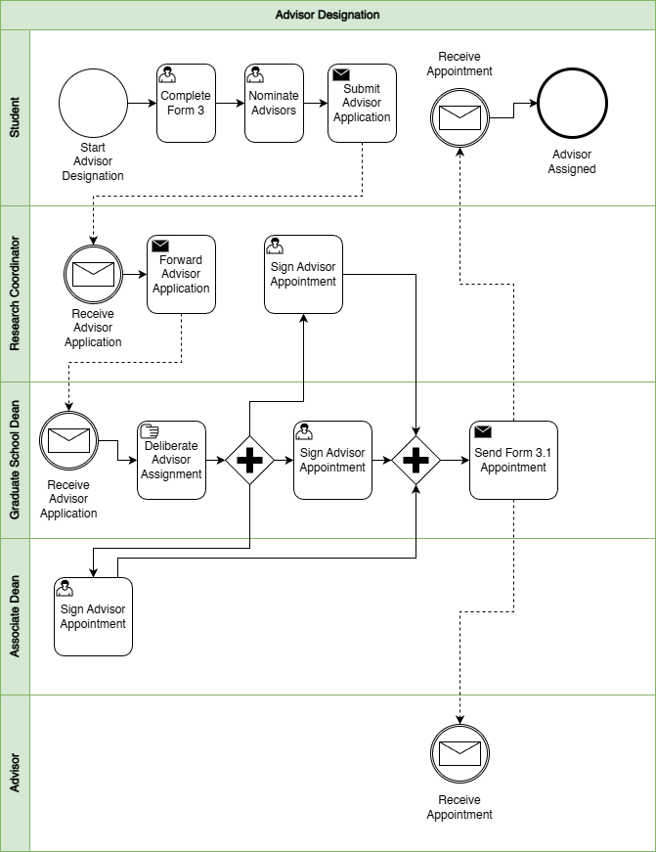

Figure 1.6 BPMN Diagram – Advisor Designation
This figure shows the adviser assignment process from student nomination to official appointment. The student completes Form 3 Application for Designation of Research Adviser and nominates advisers, then submits the adviser application. The Research Coordinator receives and forwards the application. The Graduate School Dean reviews and deliberates adviser assignment, and the appointment is signed and confirmed. After signing, Form 3.1 Appointment for Research Adviser is sent out, and both the student and adviser receive the appointment. After the adviser is confirmed, related advising setup documents such as Form 3.2 Research Timetable and Form 3.3 Thesis/Dissertation Advising Contract may also be completed as part of the advising setup.

1.3.7 Defense Scheduling and Rescheduling
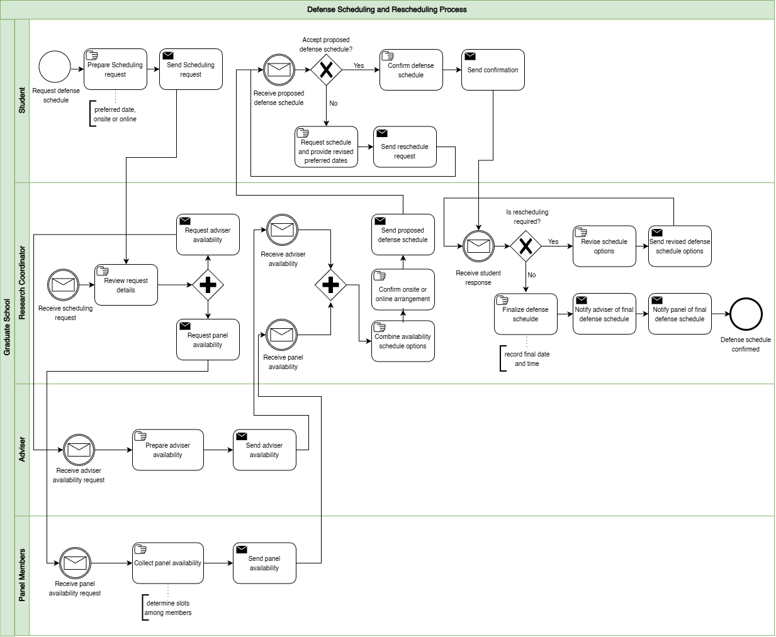

Figure 1.7 BPMN Diagram – Defense Scheduling and Rescheduling
This figure isolates defense scheduling as a coordination loop. The student submits a schedule request with a preferred date window and mode, either onsite or online. The Research Coordinator reviews the request and collects availability from the adviser and panel members. Once availability is received, the Research Coordinator combines it into schedule options, confirms the venue or online arrangement, and sends a proposed schedule to the student. The student either confirms or requests a reschedule with revised preferred dates. If rescheduling is required, the Research Coordinator revises options and the loop repeats. If confirmed, the schedule is finalized and notifications are sent to the adviser and panel. In the wider research process, this scheduling stage usually happens alongside defense readiness documents such as Form 4 Endorsement for Proposal/Final Defense and, when applicable, Form 4.3 Endorsement for Public Defense.

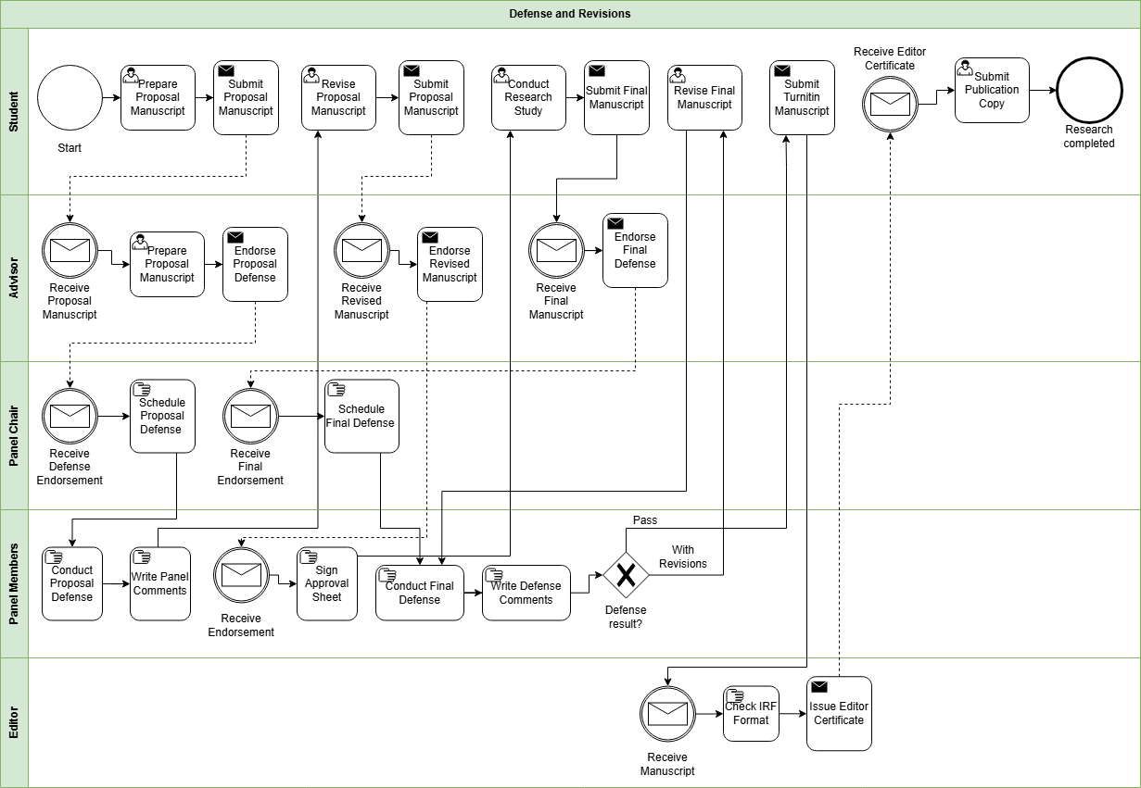
1.3.9 Defense and Revisions

Figure 1.8 BPMN Diagram – Defense and Revisions
This figure focuses on what happens after a defense decision and how revisions are handled. After the defense, panel comments and required revisions are captured and routed back to the student. Depending on the stage, this may involve documents such as Form 5 Comments Sheet for Proposal Defense, Form 6 Comments Sheet for Final Defense, and Form 7 Evaluation Sheet for Final Defense. If there is a provisional pass or conditional approval, Form 8 Settlement of Provisional Thesis/Dissertation Approval may also be used. The student revises and resubmits until the required changes are confirmed as complete. If revisions are incomplete or unclear, the process loops back for further updates. Related completion and clearance documents may also appear in this stage, including Form 5.1 Technical Review Certificate, Form 5.2 Application for Ethics Review, Form 9 Editor Certification, and Form 10 Approval Sheet.

1.3.10 Practicum
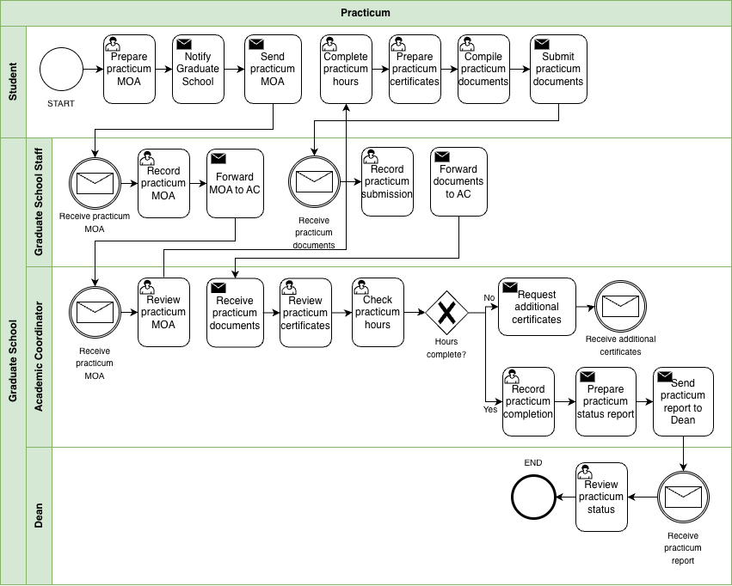

Figure 1.9 BPMN Diagram – Practicum
This figure shows how the Graduate School monitors practicum requirements for programs that require field hours. Practicum currently applies only to the Psychology and Master of Science in Guidance and Counseling (MSGC) programs, so this workflow functions as a conditional process that activates only when practicum is required. The student first notifies the Graduate School and submits the practicum MOA before completing the required practicum hours. After completing the hours, the student submits practicum certificates and supporting documents. Graduate School Staff record the submission and forward the documents to the Academic Coordinator. The Academic Coordinator reviews the certificates and checks whether the required practicum hours are completed. Because hours may be completed across multiple companies, several certificates may need to be reviewed. Once the requirement is satisfied, the Academic Coordinator records completion and sends a practicum status report to the Dean for review.

1.3.11 Withdrawal
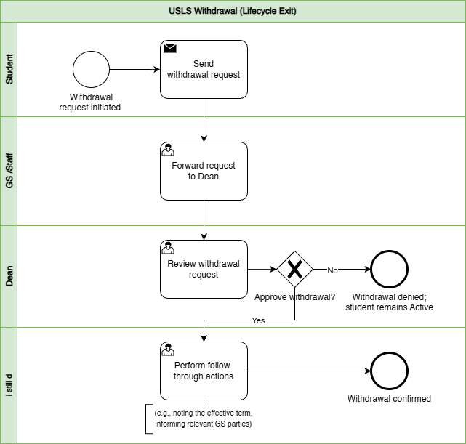

Figure 1.10 BPMN Diagram – Withdrawal
This figure shows withdrawal as a controlled exit process. The student submits a withdrawal request, Graduate School Staff forward it to the Dean, and the Dean approves or denies the request. If denied, the student remains active. If approved, follow-through actions are performed, such as noting the effective term and informing relevant Graduate School parties, and the withdrawal is confirmed.

1.3.12 Graduation
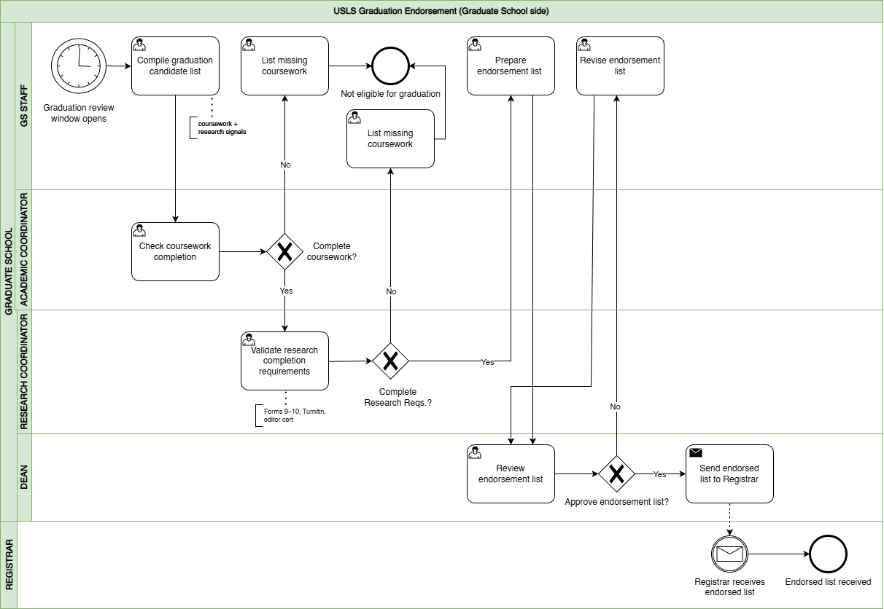

Figure 1.11 BPMN Diagram – Graduation
This figure shows graduation as an endorsement process on the Graduate School side, separate from Registrar graduation processing. Graduate School Staff compile a candidate list during the graduation review window. The Academic Coordinator checks coursework completion, and the Research Coordinator validates research completion requirements. This validation may include completion evidence drawn from the research protocol documents, especially Form 9 Editor Certification and Form 10 Approval Sheet, together with other credited subject and requirement checks. If requirements are missing, the student is marked not eligible and is placed under missing requirements tracking so the issue is visible instead of being lost in follow-ups. If complete, an endorsement list is prepared and sent to the Dean for review. If approved, the endorsed list is sent to the Registrar and the receipt is acknowledged.

1.4 Statement of the Problem
Graduate schools must maintain oversight of graduate student progression across the full graduate student lifecycle to support academic decisions, compliance monitoring, and timely intervention for delayed cases. This includes admission handoff, enrollment monitoring, coursework tracking, leave of absence and readmission, practicum for applicable programs, research milestones, withdrawal, and graduation endorsement. In current practice, however, graduate student lifecycle monitoring and processes are performed through manual coordination using multiple records and documents.
Information needed to verify a student’s standing is distributed across different files and tools maintained by various Graduate School stakeholders. For example, admissions results are recorded in spreadsheets, enrollment and coursework progress are tracked in monitoring sheets, and research-related requirements such as Form 4 (Research Protocol Submission Form) are reviewed by the academic coordinator and faculty advisers. Other supporting records, such as practicum documents and email coordination, are also used in monitoring. Because each stage of the process is recorded separately, confirming a student’s progress requires checking several files and communicating with multiple stakeholders.
As a result, stakeholders cannot easily determine key monitoring information such as the current lifecycle stage of a student, pending requirements, the responsible person for the next action, or which cases may already be delayed. Confirming this information often requires manual checking of records, reviewing forms, and coordinating through email or follow-ups.
This concern was also raised during the second confirmed meeting with Sir Eddie De Paula, documented in the review and sign-off file titled 2nd Meeting Transcript Confirmation w/ Sir Eddie De Paula. In that meeting, the Graduate School identified the need for reports such as subject needs for class planning, lists of graduating students, LOA monitoring, and residency tracking. The notes also confirm that staff sometimes generate reports from AIMS and still manually compute residency by counting the student’s start and end years, which takes more time and effort. In addition, the current monitoring view is often kept per student in spreadsheets rather than in one consolidated group view, so reporting still requires manual consolidation before it can support decisions. This shows that the issue is not simply solved by adding more manpower. Even if more people are assigned to do the work, the process remains manual, slower, more costly, and still prone to encoding errors, missed updates, and inconsistent results.
Main Problem Statement: “Graduate student status is recorded across multiple sources, and the Graduate School does not have one consolidated view. Because monitoring and processing rely on manual checking and encoding, status confirmation is slow and prone to human error.”
This means:
- Difficulty in maintaining a clear view of student progress. Graduate School tracking covers many stages of the student lifecycle and research milestones. Stakeholders need a clear view of where a student stands to support term decisions, compliance checks, and early intervention for delayed cases.
- Difficulty in receiving updates and supporting evidence on time. Status details come from different sources such as admissions signals, monitoring sheets, protocol forms, and email coordination. Because updates rely on manual checking and encoding, some updates may be delayed, missed, or recorded incorrectly.
- Difficulty in combining records into one status view. Even when the needed information exists, it is stored in separate tools and records. Staff often need to piece these together to confirm student standing and readiness, which takes time and effort.
- Difficulty in answering basic monitoring questions quickly. Without one shared view, stakeholders cannot quickly determine where the student is now, what is pending or overdue, who owns the next action, and which cases may be delayed without manual checking and reconciliation.
- Difficulty in acting early when confirmation is slow. When status confirmation takes too long, follow-ups and decisions are also delayed. This can lead to repeated follow-ups and slower response to stalled cases.
- Difficulty in generating timely and reliable reports. The Graduate School needs reports such as subject needs for class planning, lists of graduating students, LOA monitoring, and residency tracking. However, these are still pulled from separate records and manually combined. In some cases, staff still have to compute residency manually from AIMS reports, which takes time and increases the risk of delay and human error.

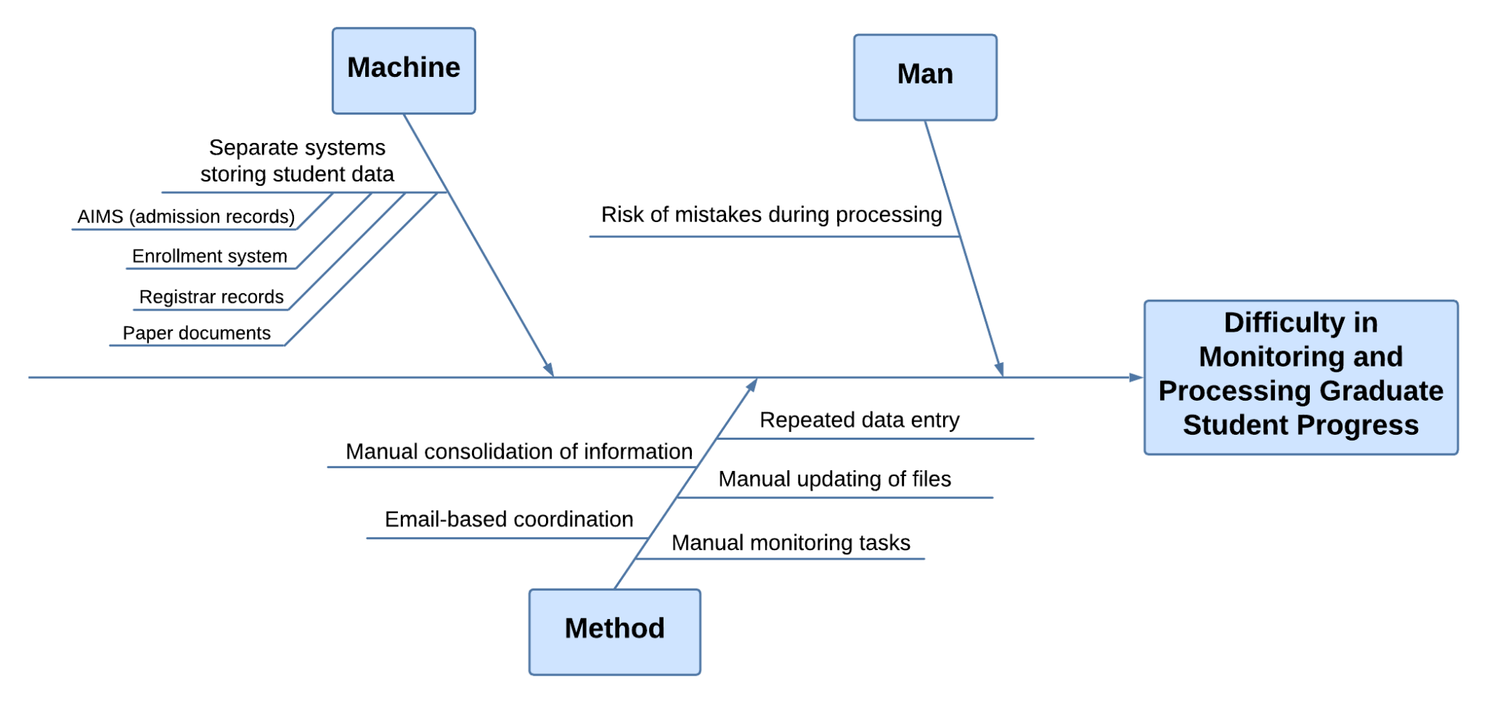

Figure 2. Ishikawa Diagram – Root Causes of Difficulty in Monitoring and Processing Graduate Student Progress
The difficulty in monitoring and processing graduate student progress is primarily caused by issues related to the systems used, the monitoring process, and the risk of errors during handling. Under the Machine category, student information is stored in separate systems such as AIMS for admission records, the enrollment system, registrar records, and paper documents. Because each system contains only a portion of the student lifecycle, staff are unable to view a complete and consolidated status in one place. This fragmentation requires them to access multiple sources when verifying student progress, which slows down monitoring and contributes to inefficiency.
Under the Method category, the monitoring process relies heavily on manual handling of information. Staff must manually consolidate information by gathering data from different records and combining them to confirm student status. Updates are also handled through manual file updates and repeated data entry, as the same information needs to be encoded across multiple records. In addition, coordination is done through email, which further delays communication and follow-ups. These practices make the monitoring process time-consuming and dependent on manual effort.
Under the Man category, the reliance on manual processes increases the risk of mistakes during processing. Because staff repeatedly encode and update information across multiple files, there is a higher chance of errors such as incorrect entries or missed updates. These errors can lead to inconsistencies in student records and affect the accuracy of monitoring. Altogether, the separation of systems, manual processes, and risk of human error contribute to inefficiencies and inconsistencies, which makes it difficult for the Graduate School to effectively monitor and process graduate student progress.
These root causes show why graduate student progress is difficult to monitor and process consistently, and why status confirmation and report generation often depend on delayed and manually combined information (Sorour & Atkins, 2024; CHED Region IV-B MIMAROPA, 2018).
These conditions make it difficult to maintain a consistent view of students standing across lifecycle stages and research milestones. Because process events, evidence requirements, ownership of next actions, and timestamps are kept across separate records and handled through manual coordination, Graduate School staff often need repeated checking, follow-up, and reconciliation just to confirm the current status of a case. This also makes pending items, delays, time in stage, scheduling status, and workload visibility harder to monitor reliably (Grooms et al., 2016; Sorour & Atkins, 2024; Datu, 2022; Tanate-Lazo, 2021).

1.5 Objectives of the Study
This study aims to analyze graduate school operations in order to identify operational inefficiencies that affect lifecycle monitoring and decision support. Specifically, it intends to:
- Understand and analyze graduate school operations to identify inefficiencies affecting lifecycle monitoring, follow-ups, and coordination of graduate student progress. (Grooms et al., 2016; CHED Region IV-B MIMAROPA, 2018)
- Identify the most appropriate solution to address the problem of divided monitoring signals and delayed status confirmation for Graduate School stakeholders. (Sorour & Atkins, 2024; Sancon, 2023)
- Design and implement modules that address the identified problems and sub-processes by enabling consistent capture of process events, evidence, next-action ownership, and timestamps. (Datu, 2022; Doce & Ching, 2018; Purcia & Velarde, 2022)
- Develop analytics outputs that match Graduate School monitoring needs such as dashboards, reports, queue aging, bottleneck indicators, process indicators, and rule-based next-action prompts. (Sorour & Atkins, 2024; Sancon, 2023)
- Conduct appropriate testing to verify the requirements of the Graduate School and confirm the platform supports its intended users. (Brooks, 2023; van Lill, 2024)

1.5.1 SDG Alignment (Sustainable Development Goals):
- SDG 4 – Quality Education: The study supports quality graduate education by making student progress easier to monitor, helping offices identify delayed cases earlier, and guiding timely follow-up so students can move through requirements and milestones more consistently.
- SDG 9 – Industry, Innovation and Infrastructure: The study supports digital improvement in graduate school operations by developing a centralized platform that brings together scattered records into a consistent monitoring and analytics system.
- SDG 16 – Peace, Justice and Strong Institutions: The study supports stronger institutional processes by clarifying responsibility for the next step, keeping key timestamps and status evidence consistent, and producing reports that are more traceable and less dependent on manual reconciliation.

1.6 Conceptual Framework/Design Architecture

1.6.1 Conceptual Framework

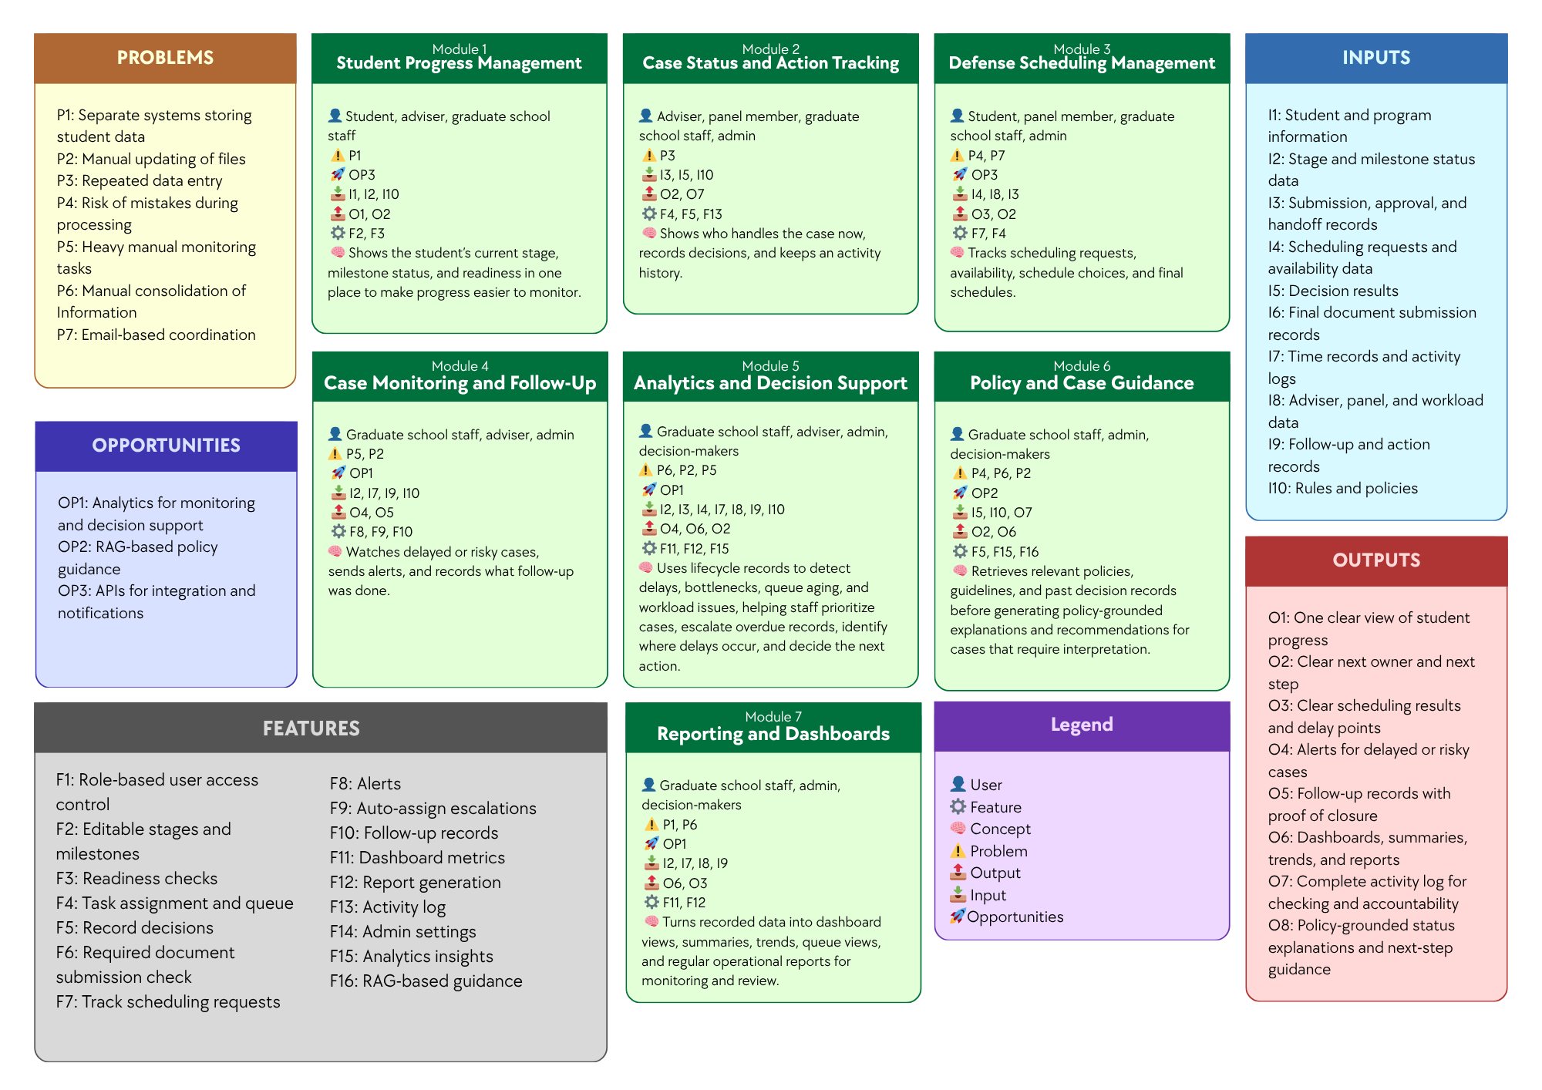

Figure 3. Conceptual Framework Diagram
The conceptual framework of the study presents the overall structure of the proposed Graduate Student Lifecycle Monitoring and Analytics Platform by linking the identified problems, opportunities, inputs, features, modules, and expected outputs. It serves as a high-level guide for understanding how the proposed system is intended to address the operational issues experienced by the Graduate School, such as Separate systems storing student data, Lack of integrated monitoring platform, Repeated data entry, Risk of mistakes during processing, Heavy manual monitoring tasks, Manual consolidation of Information, Email-based coordination, and Manual updating of files. At this stage, the framework is presented as an organizing model rather than a detailed technical design, showing the major parts of the proposed platform, how they are connected, and how they support graduate student lifecycle management. It also shows that the proposed modules and features are designed to respond directly to the identified problems while making use of the opportunities, namely Analytics for monitoring and decision support, RAG-based policy guidance, and APIs for integration and notifications. The discussion that follows explains how each module addresses specific problems, what technology can be used, and how such technology can help solve the problems and contribute to the expected outputs of the system.

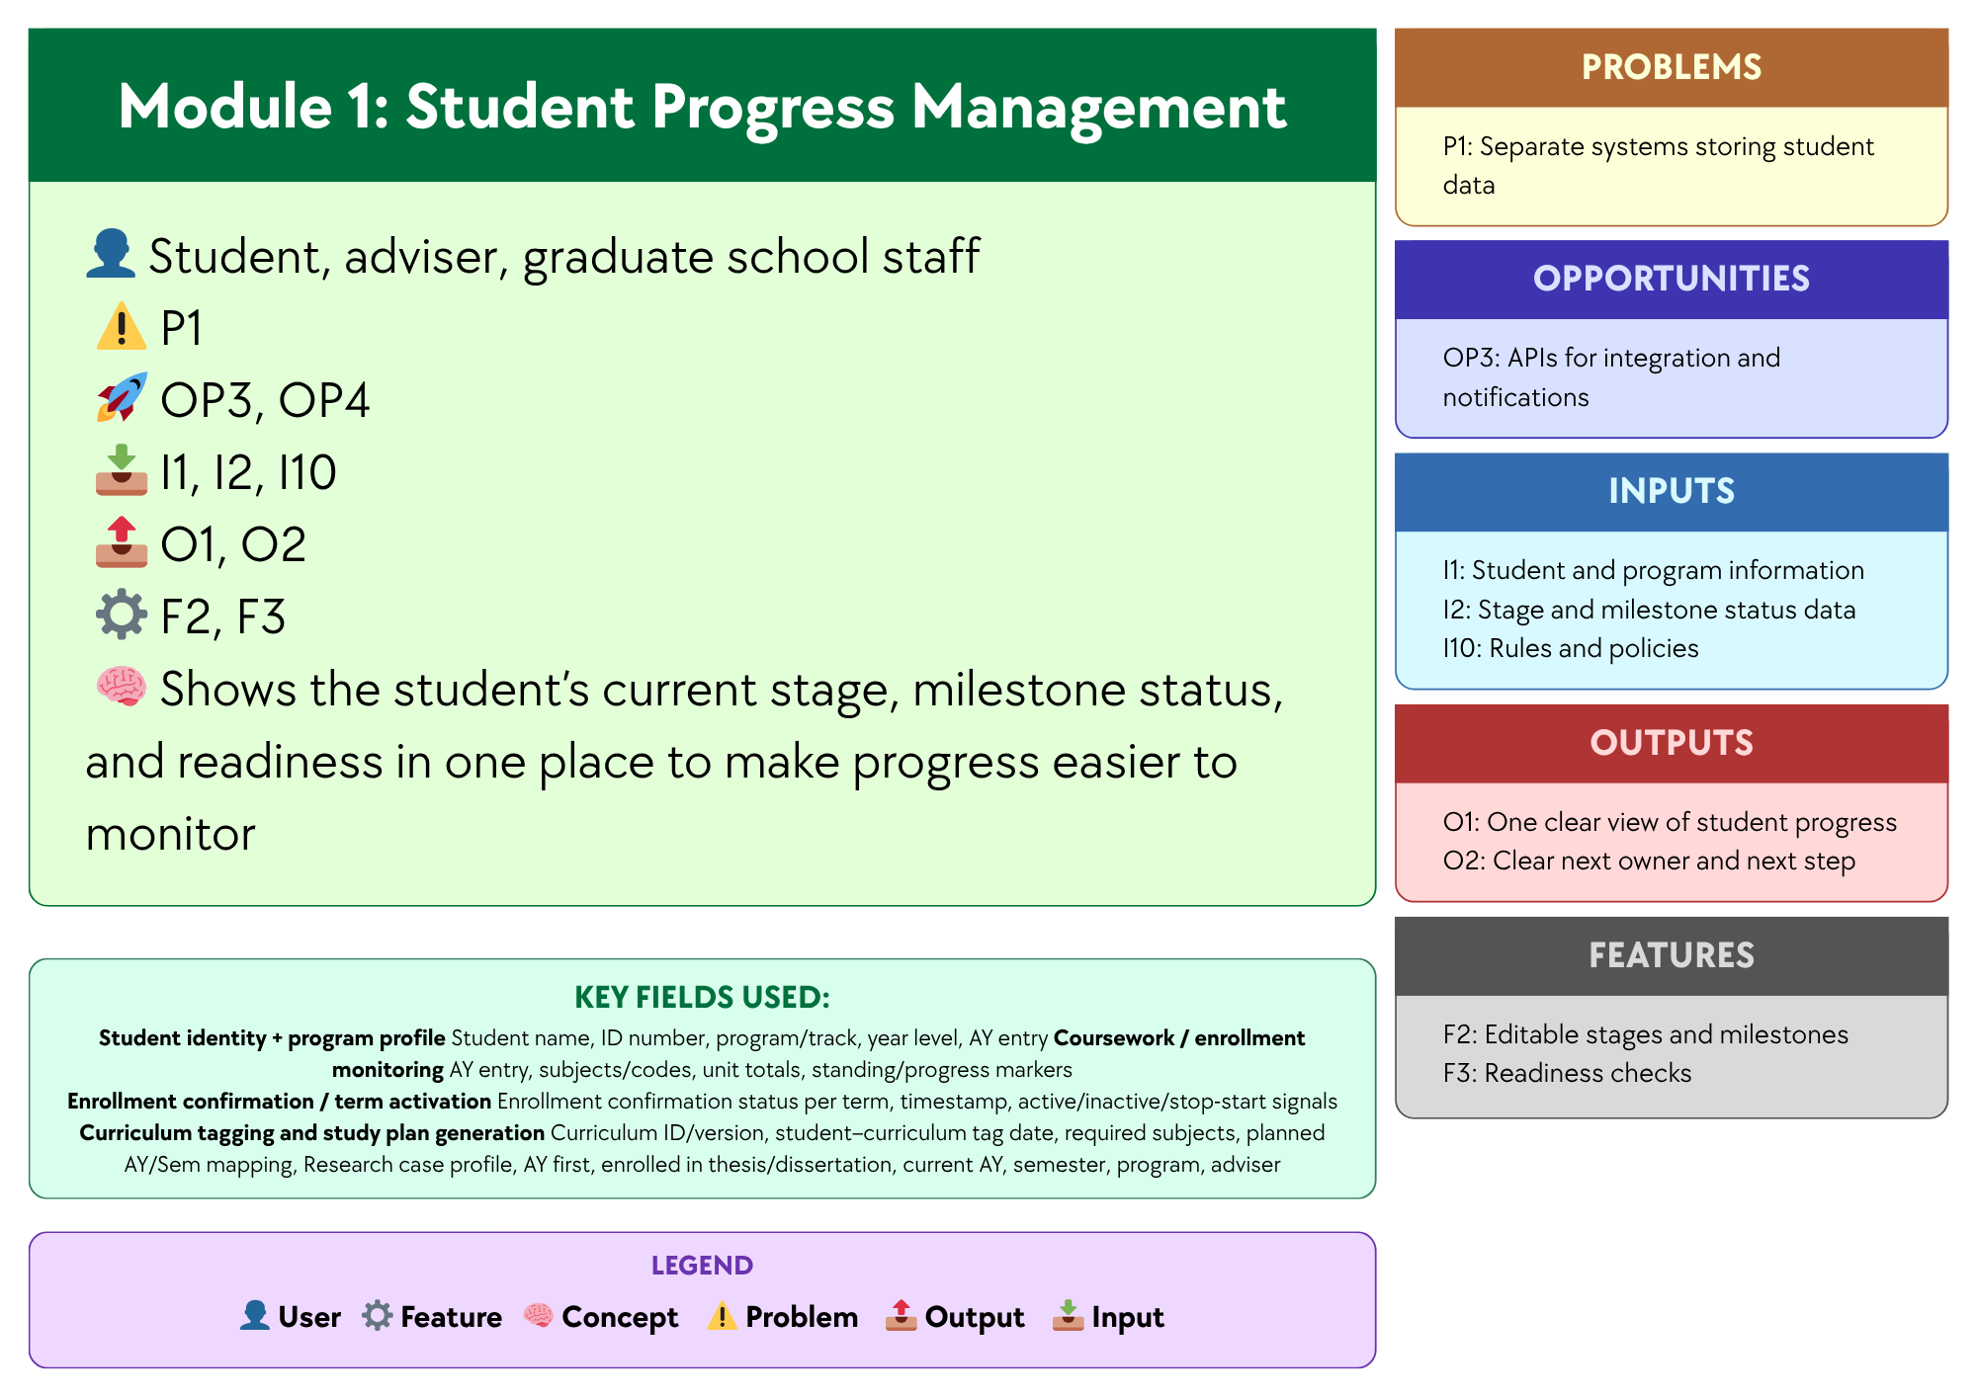

Figure 3.1 Module 1: Student Progress Management
This module focuses on providing a unified view of each student’s progress in the graduate student lifecycle by consolidating Student and program information, Stage and milestone status data, and Rules and policies. Through Editable stages and milestones and Readiness checks, the module helps address Separate systems storing student data and Lack of integrated monitoring platform by organizing progress-related records in one platform and showing the student’s current stage, milestone status, and readiness in a single view. A centralized database and a web-based monitoring interface may be used to support this module, since these technologies allow records to be stored, updated, and accessed in one place instead of across separate files or systems. In this way, the module produces One clear view of student progress and Clear next owner and next step, making progress monitoring more organized, consistent, and accessible for students, advisers, and Graduate School staff.

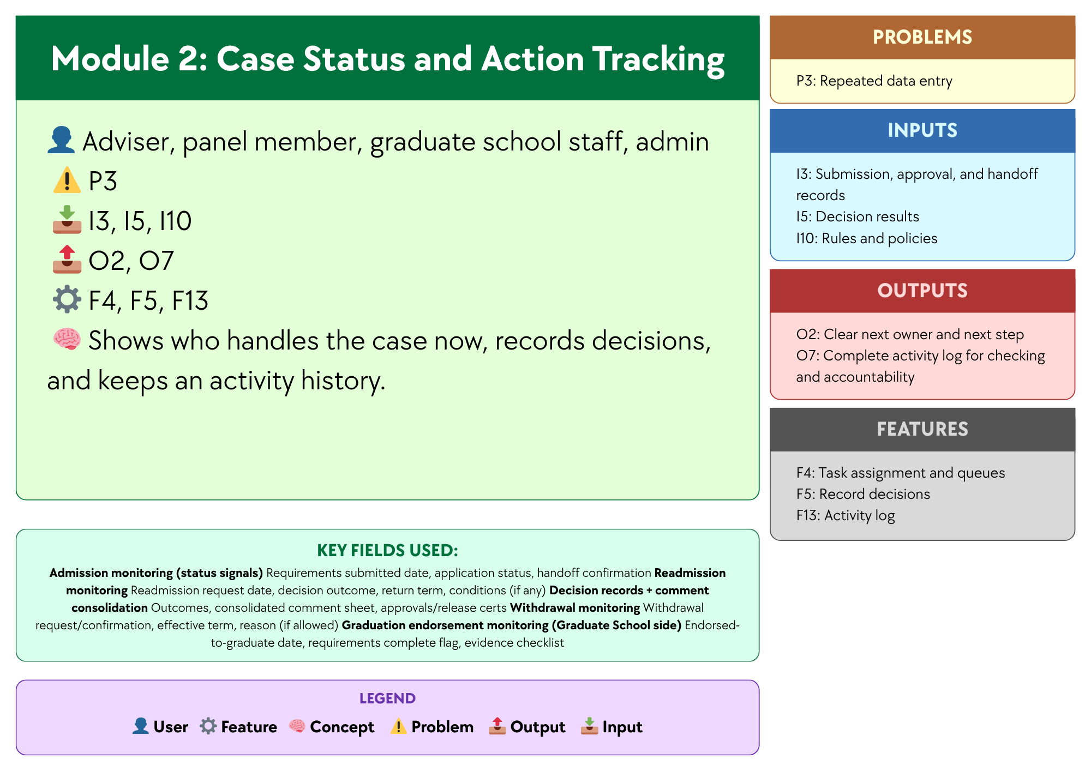

Figure 3.2 Module 2: Case Status and Action Tracking
This module focuses on recording case-related actions and status changes so users can see who currently handles the case, what action has been taken, and what should happen next. Using Submission, approval, and handoff records, Decision results, and Rules and policies, and supported by Task assignment and queue, Record decisions, and Activity log, the module helps address Lack of integrated monitoring platform and Repeated data entry by keeping case actions and records in one place instead of across separate files, emails, or manual logs. A centralized case record database and a status tracking interface may be used to support this module, since these technologies allow case updates, handoffs, and decision records to be stored and viewed in a structured and traceable way. In this way, the module produces Clear next owner and next step and Complete activity log for checking and accountability, helping improve visibility, coordination, and record consistency across the handling of graduate school cases.

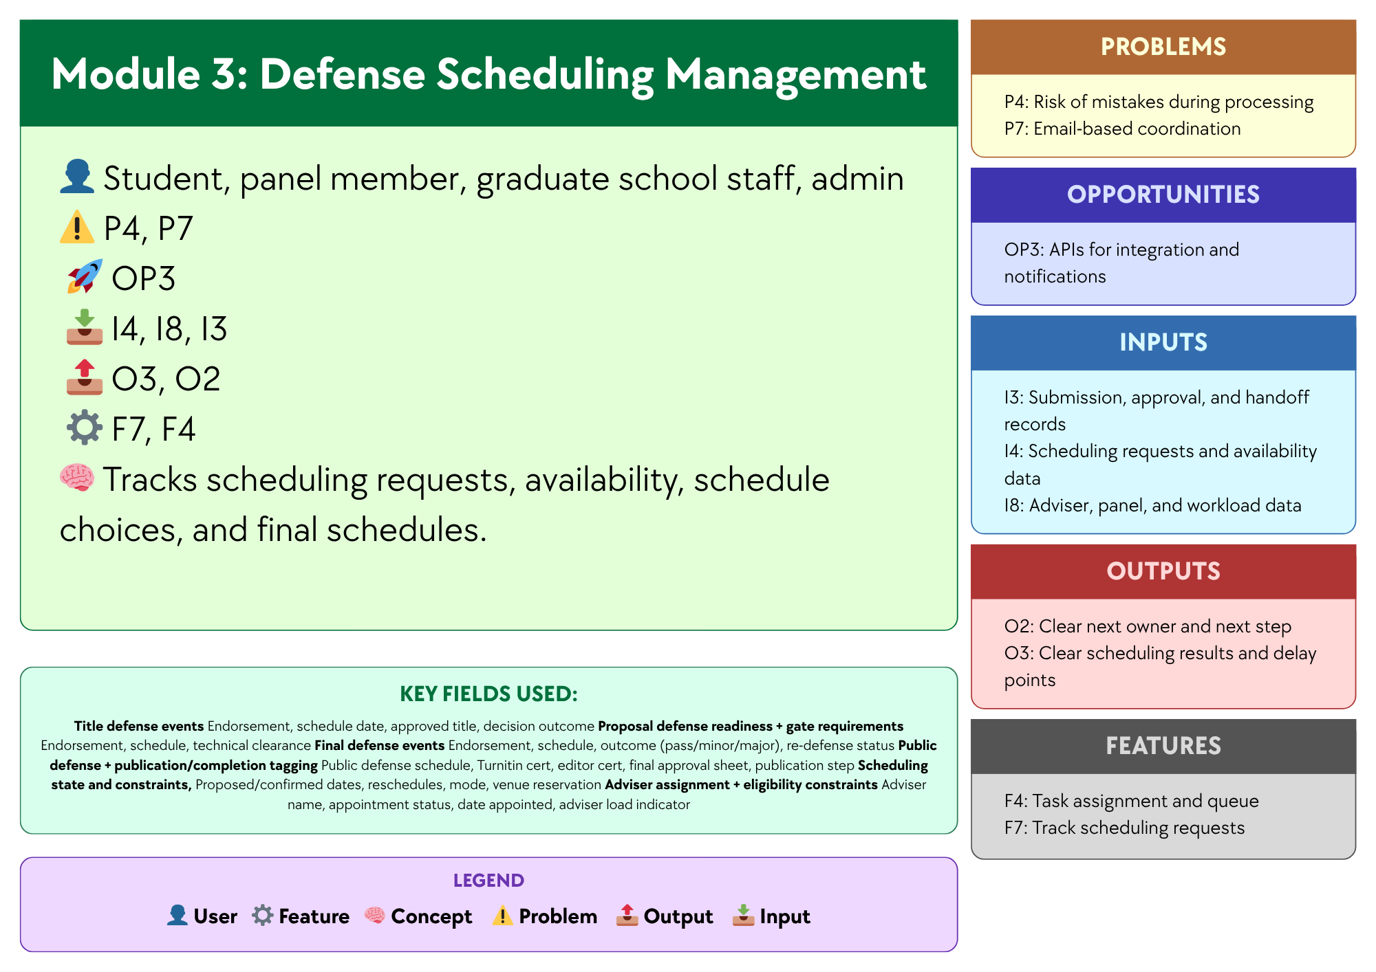

Figure 3.3 Module 3:Defense Scheduling Management
This module focuses on organizing and tracking the scheduling of defense-related activities by using Scheduling requests and availability data, Adviser, panel, and workload data, and Submission, approval, and handoff records. Supported by Track scheduling requests and Task assignment and queue, the module helps address Risk of mistakes during processing and Email-based coordination by recording schedule requests, availability, schedule choices, and final schedules in one place. A centralized scheduling database, a scheduling management interface, and APIs for integration and notifications may be used to support this module, since these technologies can help store scheduling records, match availability, and send updates or reminders to involved users. In this way, the module produces Clear scheduling results and delay points and Clear next owner and next step, making defense scheduling more organized, visible, and easier to coordinate among students, panel members, and Graduate School staff.

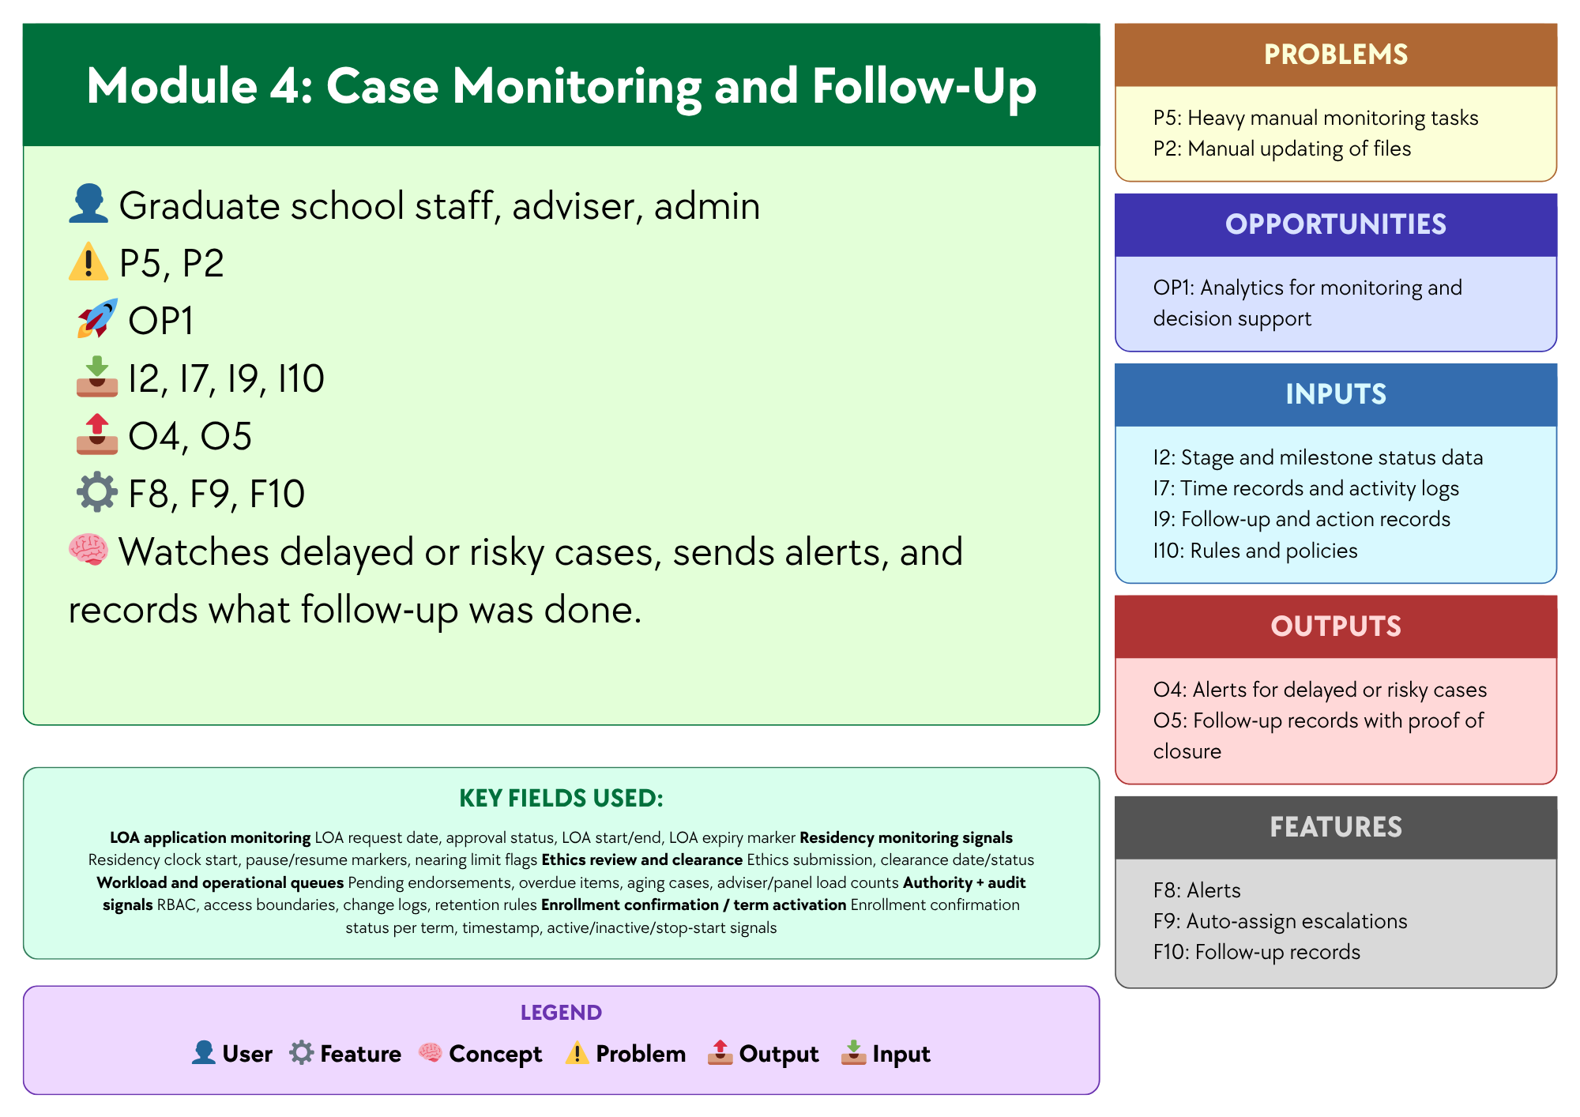

Figure 3.4 Module 4: Case Monitoring and Follow Up
This module focuses on monitoring ongoing cases and identifying those that need attention based on Stage and milestone status data, Time records and activity logs, Follow-up and action records, and Rules and policies. Supported by Alerts, Auto-assign escalations, and Follow-up records, the module helps address Heavy manual monitoring tasks and Manual updating of files by making delayed or risky cases easier to detect and by recording the follow-up actions taken. A monitoring dashboard, automated alert logic, and case tracking database may be used to support this module, since these technologies can help identify cases with delays or inactivity and keep follow-up records updated in a more consistent way. In this way, the module produces Alerts for delayed or risky cases and Follow-up records with proof of closure, helping Graduate School staff and advisers monitor cases more efficiently and respond to issues in a more timely manner.

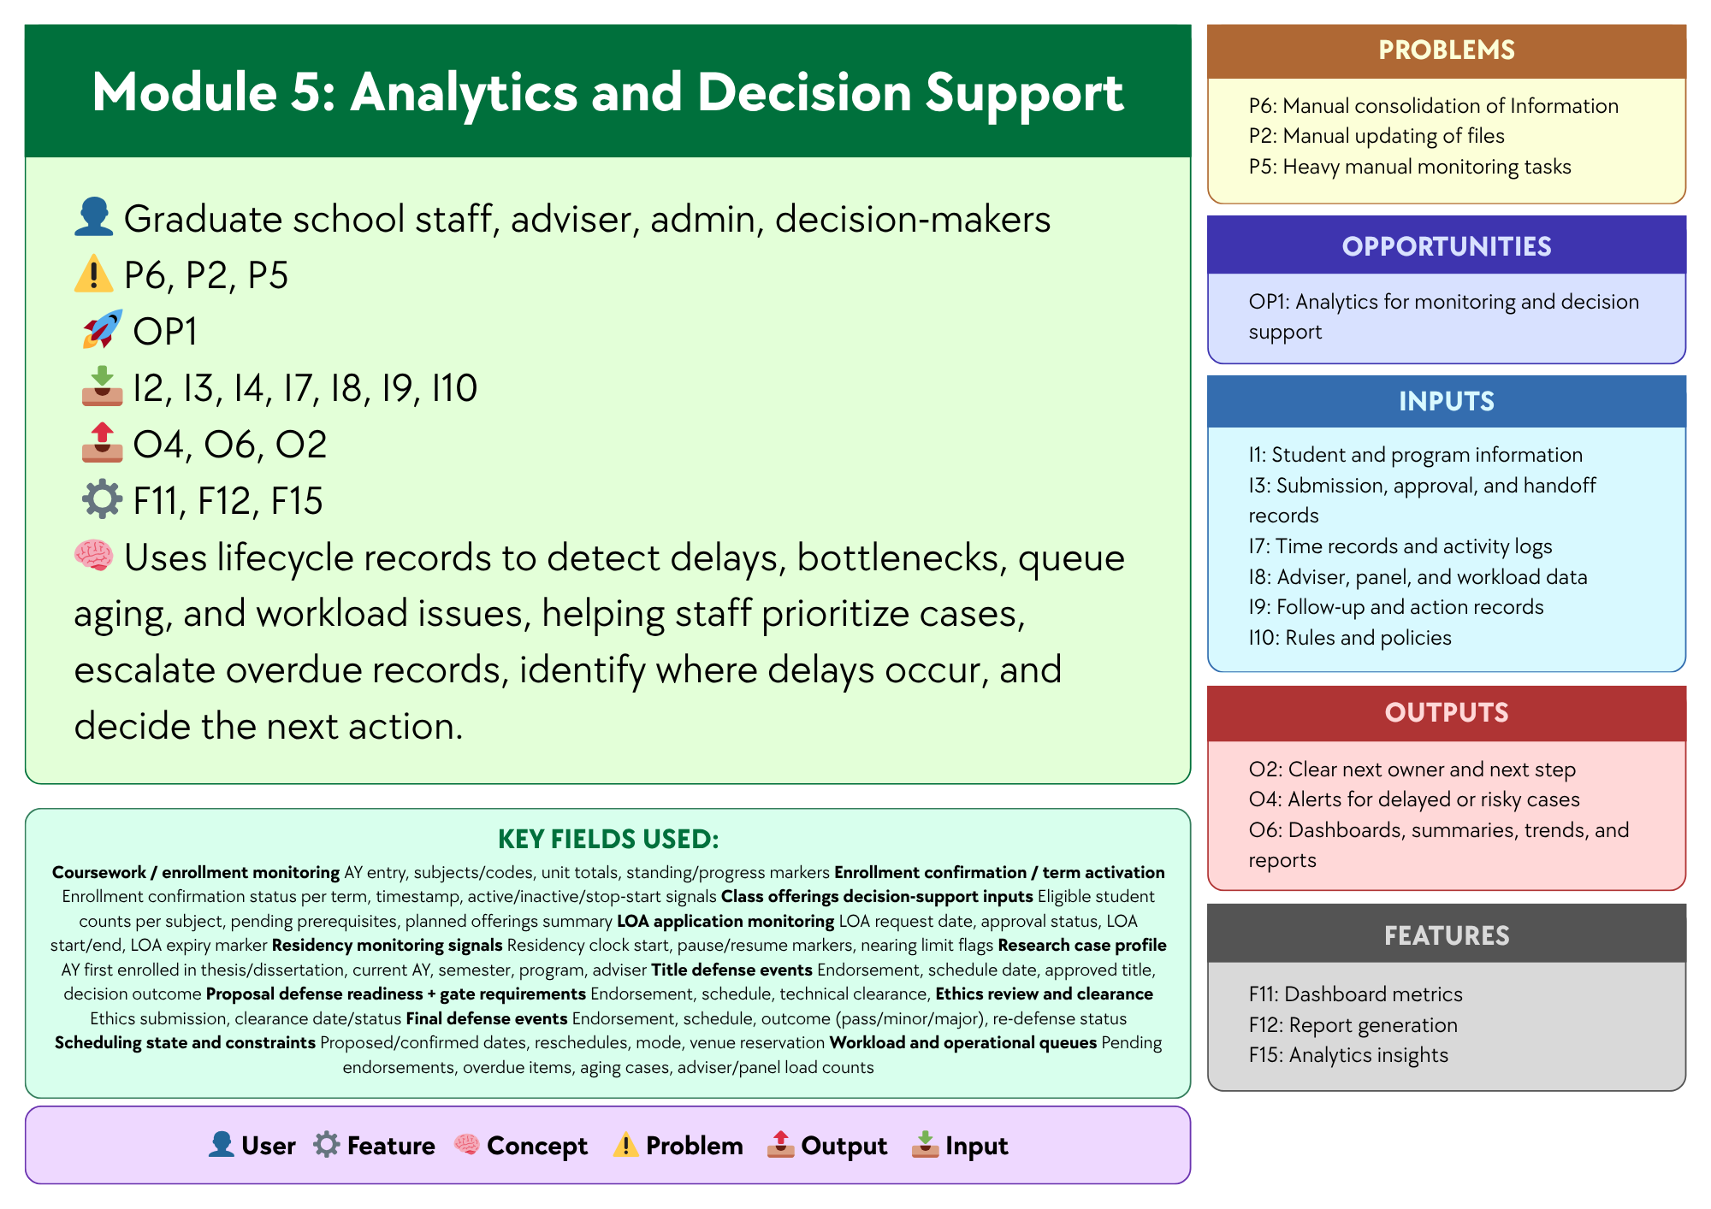

Figure 3.5 Module 5: Analytics and Decision Support
This module analyzes recorded lifecycle data to help the Graduate School better understand student progress and case movement. It uses data such as milestone status, approvals, scheduling records, activity logs, workload data, follow-up actions, and institutional rules and policies. By analyzing these data, the module helps identify patterns like delays, bottlenecks, queue aging, workload issues, and student risk trends. It also supports decisions such as identifying at-risk students, urgent cases, delayed stages, and groups with slower progress or higher attrition. These insights can help staff and decision-makers respond more quickly and appropriately.
The module is also designed to support key decision questions, including:
- Which students are at highest risk of delay, non-completion, or attrition?
- Which students require immediate intervention or priority follow-up?
- Which students are likely to exceed maximum residency based on current progress patterns?
- Which programs, cohorts, or student groups exhibit the slowest completion and highest attrition rates?
- Which lifecycle stages experience the longest delays and most significant bottlenecks?
- Which process areas show the greatest queue aging or case backlog?
- Which students are eligible or nearly ready for the next milestone, defense, or graduation endorsement?
- Which advisers, panels, or coordinators carry the heaviest workload or experience the slowest turnaround times?
- Which students show early signs of academic risk before entering the research stages?
- What completion, delay, and attrition trends should inform policy, resource allocation, and process improvement decisions?
Analytics is needed for these decision questions because reports only present raw or summarized information, while the answers to questions such as who is at risk, which cases need urgent action, where delays are happening, and which programs have slower completion require the system to combine and interpret multiple data points. The Associate Dean also emphasized the need for completion rates, attrition rates, average years to finish, residency tracking, and visibility into the student’s whole lifecycle, which may be presented in reports but require analytical interpretation to reveal patterns, identify risks, and support more informed decision-making.
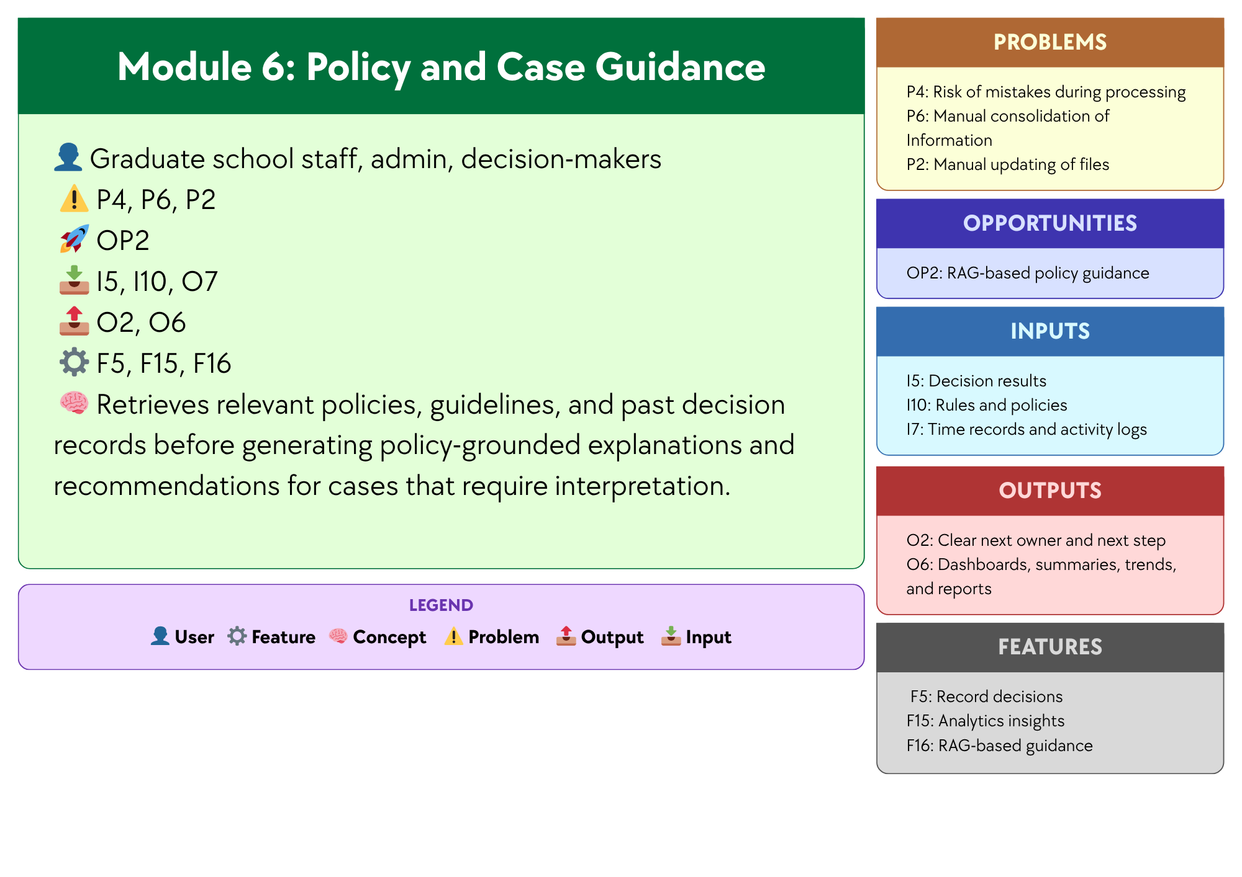

Figure 3.6 Module 6:Policy and Case Guidance
This module focuses on supporting policy and case review for situations that require interpretation in Graduate School operations. Using Graduate School policies, guidelines, forms, and past decision records, and supported by the opportunity to use AI through NotebookLM, the module helps address the time and effort needed to manually search for rules, check related documents, and review similar cases across different files and records. NotebookLM may be used to support this module, since it can work with uploaded reference materials and help users retrieve relevant information before giving explanations and recommendations. In this way, the module produces policy-grounded explanations and recommendations for cases that require interpretation, helping Graduate School staff, administrators, and decision-makers review cases more quickly and more consistently, while final decisions remain with the proper offices and authorized personnel.

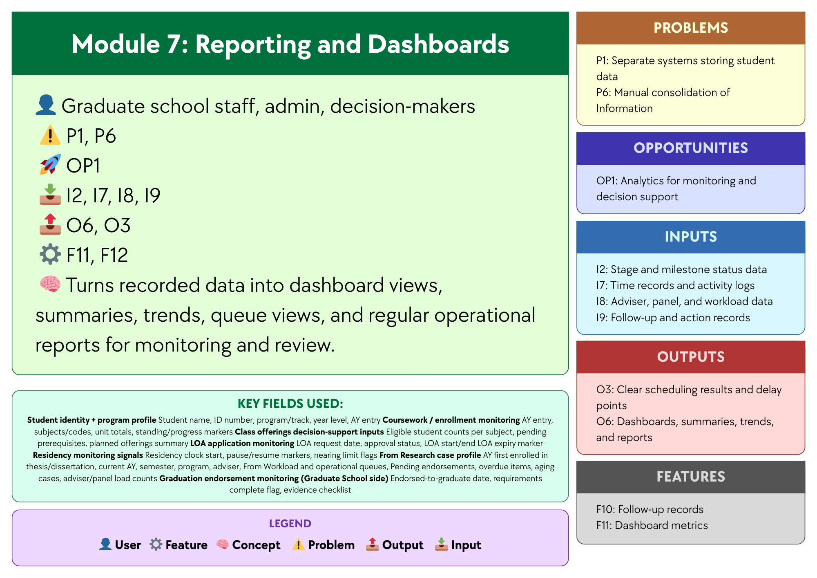

Figure 3.7 Module 7: Reporting and Dashboards
Module 7, Reporting and Dashboards, focuses on presenting recorded case and lifecycle data in a clear and organized form for monitoring, review, and communication. Using Stage and milestone status data, Time records and activity logs, Adviser, panel, and workload data, and Follow-up and action records, and supported by Dashboard metrics and Report generation, the module helps address Separate systems storing student data and Manual consolidation of Information by turning scattered records into summarized views that are easier to access and understand. Dashboard tools, reporting tools, and a centralized database may be used to support this module, since these technologies can gather data from different records and present them through dashboard views, summaries, trends, queue views, and regular operational reports. In this way, the module produces Dashboards, summaries, trends, and reports and Clear scheduling results and delay points, helping Graduate School staff, administrators, and decision-makers review operational conditions more efficiently.

1.6.2 Design Architecture

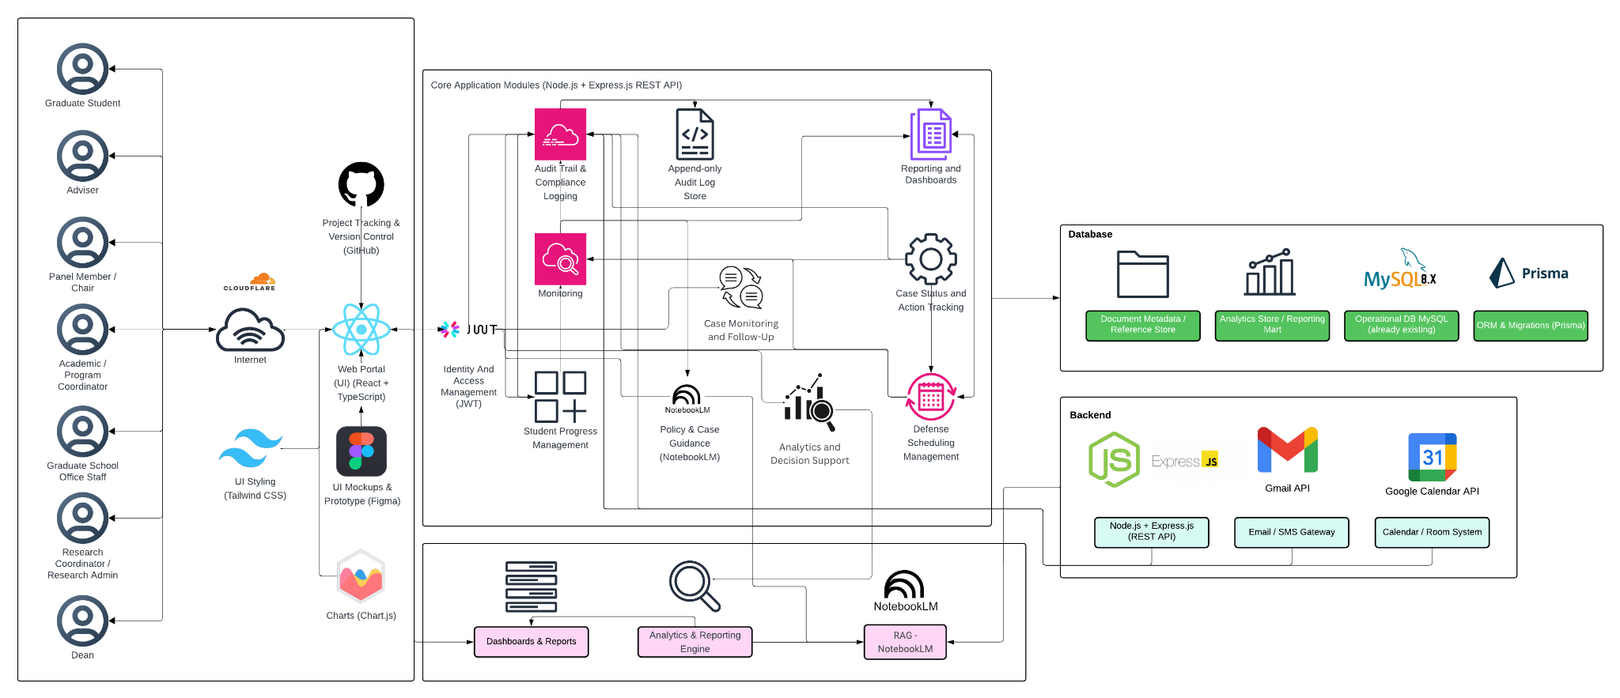

Figure 4. High-Level System Architecture Diagram
Figure 4 shows the high-level architecture of the proposed platform for graduate student lifecycle monitoring and decision support. The architecture begins with the main user groups, namely the graduate student, adviser, panel member or chair, Academic or Program Coordinator, Graduate School Office Staff, Research Coordinator or Research Admin, and the Dean. These users access the system through a web portal built with React and TypeScript, with Tailwind CSS for styling and Chart.js for data visualization. Figma is used for interface design and prototyping, while GitHub is used for project tracking and version control. Access to the platform is controlled through identity and access management using JWT.
At the center of the architecture are the Core Application Modules, built on Node.js and Express.js through a REST API. These modules handle the main functions of the system. The Student Progress Management module shows the student’s current stage, milestone status, and readiness in one place to make progress easier to monitor. The Case Status and Action Tracking module shows who handles the case now, records decisions, and keeps an activity history. The Defense Scheduling Management module tracks scheduling requests, availability, schedule choices, and final schedules. The Case Monitoring and Follow-Up module watches delayed or risky cases, sends alerts, and records what follow-up was done. The Analytics and Decision Support module uses lifecycle records to detect delays, bottlenecks, queue aging, and workload issues, helping staff prioritize cases, escalate overdue records, identify where delays occur, and decide the next action. The Policy and Case Guidance module retrieves relevant policies, guidelines, and past decision records before generating policy-grounded explanations and recommendations for cases that require interpretation. The Reporting and Dashboards module turns recorded data into dashboard views, summaries, trends, queue views, and regular operational reports for monitoring and review. The architecture also includes Audit Trail and Compliance Logging, supported by an append-only Audit Log Store, to keep a traceable record of actions and changes in the system.
The architecture connects these modules to the database layer. This layer includes the Operational Database in MySQL, the Analytics Store or Reporting Mart, and the Document Metadata or Reference Store, with Prisma used for ORM and migrations. This setup keeps daily operational records, reporting data, and document references connected but still organized according to their purpose. The architecture also shows the backend and integration components. The backend is built on Node.js and Express.js.
The use of APIs is also an important part of the architecture. APIs allow the platform to connect with other systems and services so that data does not need to be transferred manually. In the proposed system, APIs may be used to retrieve operational data from existing institutional systems and to support communication and scheduling functions. This helps reduce repeated encoding, lowers the risk of inconsistent records, and supports a more connected monitoring process across Graduate School activities.

Two API-based integrations are especially relevant in the design. The Google Calendar API may be used to support defense scheduling, meeting coordination, and possible room or calendar checks. This can help the system record and manage schedule requests in a more organized way. The Gmail API may be used to support email notifications, follow-up messages, and communication related to tasks, reminders, or case updates. These integrations make it easier for the platform to support actual Graduate School workflows, especially in areas where scheduling and communication are part of day-to-day monitoring.
For the proposed design, the study uses a RAG-based decision support approach for policy and case guidance. In this setup, the assistant retrieves relevant Graduate School policies, guidelines, forms, past case references, and other approved documents before generating any response. This means the assistant does not rely on free-form answers alone, but instead uses retrieved sources and system-generated indicators as the basis for its guidance. NotebookLM may be used as a practical prototyping environment for organizing and querying approved reference materials, but it is not treated as the core backend service or the source of truth of the platform. Official status signals, computed indicators, and rule-based recommendations remain generated by the system backend and database from validated records. In this way, the RAG layer serves as a retrieval and explanation tool for authorized users, while final decisions remain with the proper offices and authorized personnel.
Overall, Figure 4 shows that the proposed platform is designed as a web-based monitoring and decision-support system built around core modules, structured records, reporting tools, and controlled integrations. It supports multiple Graduate School roles while keeping lifecycle data, milestone tracking, case records, scheduling, alerts, and reporting within one connected system view. By combining a centralized platform, API-supported integration, and policy-grounded AI guidance through NotebookLM, the design supports faster monitoring, better record visibility, and more consistent administrative review.

1.7 Scope and Limitations
To avoid scope creep, this study uses a focused and depth-oriented scope. The prototype centers on a Graduate School monitoring and process coordination layer that supports milestone definitions, role-based task queues, dashboards and reports, event logging for analytics, and prescriptive decision support outputs. Its goal is to provide clear visibility and traceability of graduate student progress across lifecycle stages and research milestones, while also supporting day-to-day Graduate School follow-up through validated process signals and recorded timestamps.
This scope reflects the current AS-IS setup, where lifecycle signals and process steps already exist but are spread across spreadsheets, email coordination, and separate tools. The system will represent allowed progress indicators, such as completion markers, incomplete status flags, readiness checks, and document or evidence checkpoints. It will also formalize key process handoffs, such as next-step ownership and task routing. However, it will not replace institutional systems used for admissions processing, enrollment transactions, grading, learning management, registrar processing, or accounting and billing. Prescriptive analytics for decision support will be limited to rule-based recommendations based on allowed process events, timestamps, and encoded Graduate School policies. Final decisions and approvals will remain with authorized Graduate School stakeholders.

1.7.1 Scope

1.7.1.1 User Scope
The platform is intended for authorized Graduate School stakeholders responsible for monitoring, follow-up, and coordination of graduate student progress. These users include Graduate School administrative staff, coordinators, program-level coordinators, research advisers, panel members, research coordinators, designated reviewers or approvers, and the Graduate School dean. Each user accesses the platform through role-based dashboards that display lifecycle status, pending actions, submitted requirements, and scheduling information relevant to their responsibilities.
The platform supports graduate programs offered by the University of St. La Salle – Bacolod Graduate School, including programs under the following academic clusters:
- Arts and Sciences
- Business
- Education
- Engineering and Technology
- Nursing
Student coverage includes enrolled graduate students undergoing coursework, research milestones, or completion requirements within the Graduate School. The platform monitors lifecycle progression from admission onboarding to graduation endorsement within Graduate School processes.

1.7.1.2 Process Scope
The platform supports monitoring and coordination of the following Graduate School process areas:
- Admission Monitoring and Process Coordination – tracking requirements submission status signals, intake verification, enrollment confirmation handoff, and Graduate School onboarding.
- Enrollment Monitoring and Process Coordination – monitoring enrollment status, adding and dropping tracking, enrollment confirmation, offerings planning support, and course audit signals for program requirements.
- Coursework Monitoring and Process Coordination – monitoring student progress during coursework stages, including schedule visibility, module tracking, allowed monitoring signals for grade or standing, and readiness checks for transition to thesis or dissertation milestones.
- Leave of Absence and Readmission Monitoring – recording LOA applications, tracking pause in residency as a monitoring signal, and monitoring readmission processing for returning students.
- Thesis and Dissertation Monitoring and Defense Coordination – tracking research milestones such as adviser designation, title defense, proposal defense, revision cycles, manuscript finalization, defense scheduling, final defense completion, and evidence tracking.
- Practicum Monitoring (Program-Dependent) – tracking practicum hours, schedule monitoring, and related documentation for programs that require practicum completion.
- Withdrawal Monitoring – recording withdrawal requests, confirming withdrawal actions, and monitoring handoff closure steps.
- Graduation Endorsement Monitoring – verifying completion requirements, preparing endorsement lists on the Graduate School side, and handing off endorsed cases to the Registrar for final graduation processing.

1.7.1.3 Data Scope
The platform captures and uses only the operational data needed to support lifecycle monitoring and process coordination. These data elements include:
- Student lifecycle status signals and stage markers.
- Milestones, requirements, and evidence checklists linked to each stage.
- Process events such as submitted, received, verified, returned, approved, scheduled, and rescheduled.
- Ownership records and task assignments identifying the stakeholder responsible for the next action.
- Event timestamps and key dates used to support monitoring indicators such as time-in-stage and cycle-time tracking.
- Prescriptive analytics and decision-support signals derived from encoded policies and allowed process logs, such as next-step prompts, overdue flags, and escalation prompts.

1.7.1.4 Key Performance Indicators (KPIs) of the Conceptual Framework
To align the KPI section with the current conceptual framework and the Existing (AS-IS) vs Proposed (TO-BE) System section, the KPIs are grouped into two categories. The first category covers inherent system modules, which support access control, accountability, and secure use of the platform across all functions. The second category covers the new system modules (TO-BE), which directly address the Graduate School’s monitoring and processing needs. This grouping keeps the seven operational TO-BE modules unchanged while still allowing User and Access Management and Audit Trail and Accountability to be included in the KPI section.

A. Inherent System Modules
User and Access Management KPI
KPI | Target | Measurement Method | Reporting Frequency
Access control enforcement rate | 100% pass for all defined role-permission test cases | (Passed role-permission test cases ÷ Total defined role-permission test cases) × 100 | Every test cycle

Table 3.1 User and Access Management KPI
The User and Access Management KPI measures whether access to the platform is limited to the correct roles and permissions. Since the proposed system uses role-based access control, access restrictions must work consistently across modules and user types. This KPI is supported by ISO/IEC 25010 for system quality requirements and OWASP ASVS for access control testing.
Audit Trail and Accountability KPI
KPI | Target | Measurement Method | Reporting Frequency
Audit event coverage | 100% of defined auditable actions create timestamped log entries | (Auditable actions with valid timestamped logs ÷ Total defined auditable actions tested) × 100 | Every test cycle

Table 3.2 Audit Trail and Accountability KPI
The Audit Trail and Accountability KPI measures whether important actions in the system create timestamped logs that support accountability and traceability. These logs are needed to confirm who updated what, when the update happened, and what action was taken. This KPI is supported by ISO/IEC 25012 for data quality and NIST SP 800-53 for audit logging and accountability controls.
A. New System Modules (TO-BE)
Module 1: Student Progress Management KPI
KPI | Target | Measurement Method | Reporting Frequency
Required monitoring field completion rate | 100% of active prototype records have all required monitoring fields | (Active prototype records with all required monitoring fields ÷ Total active prototype records) × 100 | Every academic term

Table 3.3 Module 1: Student Progress Management KPI
This KPI checks whether the system records the required monitoring information needed to maintain a clear view of student progress. These records include lifecycle stage, completion status, curriculum tag, and AY/Sem taken markers. This KPI is based on the confirmed monitoring needs discussed in the 2nd Meeting Transcript Confirmation w/ Sir Eddie De Paula and is supported by ISO/IEC 25012 for completeness of records.
Module 2:Case Status and Action Tracking KPI
KPI | Target | Measurement Method | Reporting Frequency
Next-action ownership coverage | 100% of active in-scope cases have an assigned next-action owner | (Active in-scope cases with assigned next-action owner ÷ Total active in-scope cases) × 100 | Weekly

Table 3.4 Module 2: Case Status and Action Tracking KPI
This KPI checks whether active cases have a clearly assigned next-action owner. This helps confirm that handoffs, follow-ups, and decisions are visible and not left unclear across roles. This KPI is based on the confirmed role ownership and process needs documented in the 2nd Meeting Transcript Confirmation w/ Sir Eddie De Paula.
Module 3: Defense Scheduling Management KPI
KPI | Target | Measurement Method | Reporting Frequency
Scheduling record completeness | ≥ 90% of scheduling cases have both request and outcome timestamps | (Scheduling cases with complete request and outcome timestamps ÷ Total scheduling cases) × 100 | Per defense cycle

Table 3.5 Module 3: Defense Scheduling Management KPI
This KPI checks whether the required checklist items for a student’s current stage are recorded in the system. It supports monitoring of submissions, revisions, missing evidence, and linked document records. This KPI is supported by the Graduate School Research Protocol for required forms and stage rules, the 2nd Meeting Transcript Confirmation w/ Sir Eddie De Paula for confirmed process needs, and ISO/IEC 25012 for completeness of records.
Module 4: Case Monitoring and Follow-Up KPI
KPI | Target | Measurement Method | Reporting Frequency
Follow-up closure logging rate | ≥ 90% of flagged cases have a recorded follow-up action and closure status | (Flagged cases with recorded follow-up and closure status ÷ Total flagged cases) × 100 | Monthly

Table 3.6 Module 4: Case Monitoring and Follow-Up KPI
This KPI checks whether scheduling cases contain the records needed to monitor requests, outcomes, and delays. These records must be complete enough to measure scheduling cycle time. This KPI is supported by the Graduate School Research Protocol for scheduling rules and ISO/IEC 25012 for completeness and timeliness of scheduling records.
Module 5: Analytics and Decision Support
KPI | Target | Measurement Method | Reporting Frequency
Analytics report generation rate | ≥ 90% of required analytics outputs are successfully generated from recorded lifecycle data | (Number of required analytics outputs successfully generated ÷ Total required analytics outputs) × 100 | Monthly

Table 3.7 Module 5: Monitoring and Follow-ups KPI
This KPI checks whether flagged or delayed cases have recorded follow-up actions and closure status. It supports LOA monitoring, residency watchlists, alerts, and intervention tracking. This KPI is based on the confirmed monitoring needs in the 2nd Meeting Transcript Confirmation w/ Sir Eddie De Paula and on Google SRE guidance for tracking follow-up timing and operational response measures.
Module 6: Policy and Case Guidance KPI
KPI | Target | Measurement Method | Reporting Frequency
Policy-grounded response match rate for decision-support outputs | 100% match on the defined prototype rule and reference test set | (Decision-support outputs that correctly match the approved rule and retrieved reference test set ÷ Total rule-based test cases) × 100 | Every test cycle

Table 3.8 Module 6: Policy and Case Guidancet KPI
This KPI checks whether the decision-support assistant produces outputs that are consistent with the defined prototype rules and grounded on the retrieved approved reference documents. Since the assistant only supports monitoring and processing, its outputs must remain aligned with authorized rules, policies, and reference materials and must not replace authorized decisions. This KPI is based on the confirmed scope in the 2nd Meeting Transcript Confirmation w/ Sir Eddie De Paula and is supported by ISO/IEC 25010 for consistency and functional suitability.
Module 7: Reporting and Dashboardss KPI
KPI | Target | Measurement Method | Reporting Frequency
Required report availability | 100% of the agreed report set is available in the prototype | (Available agreed reports ÷ Total agreed report set) × 100 | Every academic term

Table 3.9 Module 6: Reporting and Dashboards KPI
This KPI checks whether the agreed report set is available in the prototype. These reports include subject needs, graduation candidate lists, LOA monitoring, residency tracking, and completion summaries. This KPI is based on the confirmed reporting needs in the 2nd Meeting Transcript Confirmation w/ Sir Eddie De Paula and is supported by ISO/IEC 25010 for consistent system outputs.
Reference labels used in the KPI table
Reference | Source | Brief explanation
SDP | 2nd Meeting Transcript Confirmation w/ Sir Eddie De Paula | Used for the confirmed AS-IS process, role ownership, monitoring needs, reporting needs, and scope boundaries.
GSRP | Graduate School Research Protocol | Used for required forms, stage rules, document checkpoints, and scheduling rules.
ISO 25012 | ISO/IEC 25012 Data Quality Model | Used for data quality measures such as completeness, consistency, and timeliness of records.
ISO 25010 | ISO/IEC 25010 System and Software Quality Model | Used for measurable system and software quality requirements.
Google SRE | Google Site Reliability Engineering guidance | Used for alert timing, follow-up timing, and target-setting ideas such as service level indicators and objectives.
OWASP ASVS | OWASP Application Security Verification Standard | Used to guide access control testing.
NIST SP 800-53 | NIST Security and Privacy Controls | Used to guide audit logging and accountability checks.

Table 4. Reference labels used in the KPI table
Table 4 explains the short reference labels used in the KPI table. These labels point to the main documents and standards used to support the expected outputs, KPI choices, and initial targets of the conceptual framework modules.
Note: The KPI types used in this study are aligned with recognized references. ISO/IEC 25012, which is an international standard for data quality in structured computer systems, supports measures related to completeness, consistency, and timeliness. ISO/IEC 25010, which is an international quality model for software and systems, supports defining measurable quality requirements. ISO 9241-11, which is a usability standard, explains usability in terms of effectiveness, efficiency, and satisfaction. For operational targets, Google SRE guidance, which is Google’s approach to service reliability, uses SLIs or service level indicators as measures and SLOs or service level objectives as target values. For security controls, OWASP ASVS, which is an open standard for testing web application security controls, can guide access control testing. For audit-related controls, NIST SP 800-53 and NIST SP 800-53A, which are NIST guidelines for security controls and their assessment, can guide what should be logged and how those controls can be checked.

1.7.1.2 Existing (AS-IS) vs Proposed (TO-BE) System
Module | AS-IS (Existing System) | TO-BE (Prototype)
Module 1: Student Progress Management | Student progress is tracked across spreadsheets, monitoring sheets, email updates, and separate records. There is no single view of where a student is in the graduate lifecycle or whether the student is ready for the next stage. | One monitoring view shows the student’s current lifecycle stage, milestone status, readiness checks, key status markers, required next steps, and recorded timestamps.
Module 2: Case Status and Action Tracking | Case actions, handoffs, and decisions are often handled through manual follow-up, email coordination, and person-to-person checking. It is not always clear who currently owns the case, what action was taken, or what should happen next. | Role-based task queues and case records show the current owner, recorded actions, decision results, handoff history, and the next required step for each case.
Module 3: Defense Scheduling Management | Defense scheduling is mainly coordinated through email and manual follow-up. Availability, schedule requests, delays, reschedules, and final outcomes are not consistently recorded in one place. | Scheduling requests, availability, assigned schedules, confirmations, reschedules, and outcomes are recorded as structured scheduling records with dates and status updates.
Module 4: Case Monitoring and Follow Up | Monitoring depends on manual checking, reminders, and role-maintained records. Delayed or risky cases may only be noticed after repeated follow-up, and proof of closure is not always easy to confirm. | Alerts, flagged cases, follow-up actions, escalation records, and proof of closure are tracked in one place to support faster monitoring and more consistent follow-through.
Module 5: Analytics and Decision Support | Staff often need to manually consolidate information from separate files, records, and updates before they can identify delays, bottlenecks, workload issues, or cases needing attention. | Dashboard metrics, summaries, trends, and analytics insights are generated from structured lifecycle data to help identify delays, workload concerns, bottlenecks, and priority cases.
Module 6: Policy and Case Guidance | Status questions, policy checking, and next-step guidance depend on manual review of forms, policy documents, previous records, spreadsheets, and emails. This takes time and may vary depending on who is doing the review. | A RAG-based assistant retrieves relevant policy documents, guidelines, and past case references, then produces grounded summaries, case guidance, and suggested next steps to support monitoring and processing. Final decisions still remain with authorized personnel.
Module 7: Reporting and Dashboards | Reports are prepared manually from separate files and records. Definitions may vary, and staff often need to consolidate data before reports can be used for monitoring and review. | Dashboards and reports are generated from the same structured data source, making operational views, summaries, trends, and monitoring reports more consistent and easier to prepare.

Table 5. Existing system (as-is) vs proposed system (to-be)
Table 5 compares the current setup and the proposed prototype based on the updated modules in the conceptual framework. The AS-IS side shows that monitoring, case handling, scheduling, follow-up, policy checking, and reporting are still spread across spreadsheets, forms, email coordination, policy documents, and manual checking. The TO-BE side shows how each module is intended to organize these activities into a more consistent monitoring and processing platform. Through structured records, analytics, dashboards, and RAG-based policy and case guidance, the proposed prototype is designed to improve visibility, consistency, and support for graduate student lifecycle management.

1.7.2 Limitations
The project is limited to Graduate School monitoring and decision support. It will not replace institutional systems or offices that handle official records, transactions, or financial processes. Specifically:
- The system will not replace AIMS admissions processing. It will only monitor status signals and handoffs where allowed.
- The system will not handle official enrollment transactions, grade encoding, or learning management functions. It will only represent allowed monitoring signals, such as completion markers, incomplete status flags, and readiness checks.
- The system will not replace Registrar functions, official academic records, transcript processing, or official graduation processing. Graduation status remains under Registrar ownership.
- The system will not implement accounting, billing, or payment processing, and it will not manage financial approvals.
- The system will not track private adviser-student communication, such as personal message threads. Monitoring will focus only on submissions, decisions, schedules, required evidence, and validated status signals.
- Predictive analytics that depend on unavailable or restricted data will not be implemented. Reporting will be limited to data that can be captured within the platform’s privacy and access limits.
- Program-dependent components, such as practicum, will only be included where the practicum are confirmed as part of the graduate program. In the validated notes, practicum was confirmed for Psychology and MSGC, and the current process is still paper-based with multiple certificates and MOAs where needed.

1.8 Significance of the Study
This study is significant because it helps improve how Graduate School monitoring and processing can be handled across the student lifecycle. The proposed platform makes student progress easier to see, supports coordination across roles, and improves reporting by capturing clear status signals, next-action ownership, and timestamps. It also keeps access to sensitive records controlled through role-based access and audit-ready logging (Datu, 2022; Doce & Ching, 2018; Tanate-Lazo, 2021).
For the University of St. La Salle – Bacolod Graduate School. The platform supports monitoring of student standing across lifecycle stages and research milestones. This can reduce the need to reconstruct status manually from spreadsheets, forms, and email coordination. It also supports queue-based visibility by showing what is pending, overdue, or waiting for action. This is important because the confirmed notes show that the Graduate School still needs reports such as subject needs, graduating student lists, LOA monitoring, and residency tracking, and that some reports still require manual checking and year counting from AIMS exports. The same notes also show that the current view is often per student in spreadsheets rather than a consolidated group view, which makes it harder to support class planning and status checking at the program level. In this sense, the study is significant to the Graduate School because it directly addresses the current difficulty of monitoring student progress, preparing reports, and following up cases using scattered records and manual processing.
For other educational institutions. The study provides a reference for how graduate lifecycle monitoring can be organized into one operational model, from admission up to graduation endorsement. It shows how status signals, exceptions, and role-based coordination can be structured in a way that supports term-level decisions and reporting needs. This is especially useful for institutions where monitoring is still spread across spreadsheets, forms, and email coordination (CHED Region IV-B MIMAROPA, 2018; Grooms et al., 2016). It is also useful for schools that want to improve visibility without replacing official admissions, Registrar, or accounting systems, since the confirmed scope in the Graduate School notes clearly keeps the platform as a monitoring and support layer only.
For academic purposes and other researchers. This study contributes an applied systems development perspective by translating graduate lifecycle operations into structured monitoring elements such as states, events, queues, and time-based indicators. It also shows how practical Graduate School records, such as monitoring templates, research protocol forms, and signed process validations, can be used as the basis for a monitoring and decision-support platform. In addition, it highlights the importance of privacy-aware design in educational monitoring platforms by showing how privacy and accountability can be supported through role-based access control and auditability mechanisms (Datu, 2022; Doce & Ching, 2018; Tanate-Lazo, 2021). The study may also support future research on how visibility, traceability, and milestone-based monitoring relate to student progress, delays, and completion in graduate education (van Lill, 2024; Willess, 2023; Young et al., 2024).

Chapter 2 – Review of Related Literature

2.1 Review of Related Concepts

2.1.1 Key Terms/Scope Labels
To keep the manuscript readable, this proposal uses five simple scope labels to organize the review of literature and the stakeholder-validated workflow analysis. These labels are not included to sound technical; they are used to group related operational issues and to clarify what the system is (and is not) intended to cover. Any technical term introduced later will be defined the first time it is used.
- Graduate Student Lifecycle & Progression Tracking refers to monitoring the student’s overall journey from entry/admission, through coursework progression, into research milestones, up to completion, so the institution can see where a student is “right now” without manual reconstruction across multiple tools.
- Thesis/Dissertation Pipeline Operations refers to the step-by-step research workflow (forms, endorsements, defenses, revisions, clearances, and completion tagging) that requires coordination among multiple roles and produces official decision artifacts.
- Time-to-Degree, Residency, Delay & Attrition refers to time-based indicators derived from lifecycle and milestone timestamps (e.g., time-in-program, time-in-stage, delayed/inactive status rules, completion vs non-completion patterns).
- Academic Operations (Decision Support) refers to operational reporting that helps offices make term-by-term decisions using counts and turnaround-time measures (e.g., pending queues, aging cases, adviser/panel load, bottlenecks).
- Data Privacy & Role-Based Access refers to limiting visibility and actions based on role (e.g., student vs adviser vs panel vs office) and ensuring that sensitive records and evaluation artifacts are handled with appropriate access boundaries, logging, and retention rules.
- Retrieval-Augmented Generation for Policy-Grounded AI Systems refers to an AI approach where a language model generates responses using information retrieved from trusted institutional documents such as policies, guidelines, and previous decisions. By grounding the AI’s responses in official records, RAG helps ensure that recommendations or summaries follow university rules and provide consistent decision support rather than relying solely on the model’s general knowledge.
- API-Based System Integration in Academic Information Systems refers to the use of Application Programming Interfaces (APIs) to allow different institutional systems to exchange data automatically. Through APIs, systems such as enrollment platforms, monitoring tools, and administrative databases can securely share information, reducing manual encoding, minimizing fragmented records, and improving the accuracy and timeliness of operational data used for monitoring and reporting.

2.1.2 Graduate Student Lifecycle Tracking and Milestone-Centric Progress
Graduate student progress monitoring differs from undergraduate contexts because graduate progression is often defined through milestones, decentralized rules, and non-linear pacing. Young et al. (2024) argue that graduate tracking should reflect milestone-based progression rather than simply repurposing undergraduate dashboards. This implies that lifecycle tracking systems must represent stage definitions, prerequisites, and milestone outcomes in a way that is interpretable to both students and administrators.
Doctoral monitoring work similarly emphasizes the importance of structured oversight mechanisms that allow institutions to observe progress patterns and intervene when progression stalls (Brooks, 2023). In practice, this requires operational representations of progress that can distinguish between genuine academic work-in-progress and administrative waiting points (e.g., pending approvals, scheduling unresolved, revisions not confirmed). Without such representations, “status” becomes an ambiguous concept that can vary depending on who is asked and what evidence they reference.

2.1.3 Thesis/Dissertation Pipeline as an Operational Workflow
Thesis and dissertation processes involve routable workflows that extend beyond writing and research design into operational coordination: adviser designation, endorsements, panel approvals, scheduling, decision capture, revision confirmation, and compliance documentation. Streamlining studies of graduate approval workflows demonstrate that administrative efficiency depends on clarity of routing, approvals, and status transitions (Grooms et al., 2016). System-oriented work that includes defense scheduling emphasizes that scheduling is not merely a calendar task but a pipeline step with constraints and outputs that must be tracked (Chio et al., 2022).
Feedback and revision loops are central to pipeline operations. Chugh et al. (2021) identify supervisory feedback as a complex process that requires clarity, consistency, and responsiveness, conditions that are difficult to maintain when feedback is dispersed across tools or when multiple reviewers provide uncoordinated inputs. This supports the need for comment consolidation mechanisms and traceable decision outcomes, which are monitoring-critical because they determine whether a student is “waiting for feedback,” “revising,” or “ready for the next gate.”

2.1.4 Time-to-Degree, Residency, Delay, and Attrition as Monitoring Measures
Time-to-degree and residency rules provide operational thresholds for defining whether progress is “on track” or “delayed,” but definitions and counting rules vary by policy and context. van Lill (2024) shows that time-to-degree differs across disciplines and contexts, implying that monitoring must be sensitive to program differences rather than assuming a uniform timeline. Willess (2023) further suggests that experiences and factors influencing time to degree are multifactorial, reinforcing the need for monitoring signals that capture prolonged time-in-stage and stalled milestones rather than relying on one indicator alone.

In Philippine contexts, studies and institutional handbooks illustrate the importance of locally defined policies and practice. For example, local work examining delays among master’s degree completers highlights contextual factors influencing delayed completion (Rapada Jr., n.d.). Institutional policy documents and handbooks (e.g., University of the Philippines Los Baños Graduate School, 2010; Philippine Normal University, 2024) also shape what “residency,” “good standing,” and “extensions” mean operationally. This supports the proposal’s emphasis that policy definitions must be validated with stakeholders and encoded into monitoring rules.

2.1.5 Academic Operations Analytics and Decision Support
Operational decision support in higher education frequently depends on dashboards and reporting that answer recurring questions: what is pending, what is overdue, where delays occur, and where capacity constraints exist. Sector reporting expectations, such as annual data collection and certification requirements, reflect that higher education decision-making relies on timely and accurate data (CHED Region IV-B MIMAROPA, 2018). However, analytics effectiveness depends on the underlying data capture: if workflow events do not generate timestamps and logs, reporting becomes unreliable or disputed (Sorour & Atkins, 2024).

Digital transformation discussions emphasize the role of data platforms and business intelligence as enabling infrastructure for reporting and performance monitoring in higher education (World Bank, 2023). This supports the proposal’s architectural decision to treat dashboards as downstream of structured lifecycle event capture, rather than as stand-alone reporting features.

2.1.6 Data Privacy, and Role-Based Access in Higher Education Systems
Graduate monitoring systems handle sensitive student information and evaluation artifacts, which raises authority and privacy concerns. Studies of Philippine higher education compliance with privacy boundaries highlight challenges in implementing privacy-aligned practices across institutions (Datu, 2022; Doce & Ching, 2018; Flores & Ching, 2018; Tanate-Lazo, 2021). Records management and digitization work suggests that institutional readiness and IAM practices influence the success of academic records systems (Purcia & Velarde, 2022). These sources support a design requirement that access boundaries (RBAC), audit trails, and controlled visibility are foundational, not optional, to lifecycle monitoring platforms.

2.1.7 Retrieval-Augmented Generation for Policy-Grounded AI Systems
Large language models (LLMs) have increasingly been explored for decision support and knowledge retrieval tasks in organizations, but their outputs can be unreliable when responses are generated without grounding in authoritative sources. Retrieval-Augmented Generation (RAG) addresses this limitation by combining document retrieval with generative language models so that responses are produced using relevant external knowledge sources rather than relying solely on the model’s internal training data (Lewis et al., 2020). In this approach, the system first retrieves documents or policy records relevant to a query and then uses those documents as contextual input for the language model’s response generation.
RAG is particularly suitable for environments where decisions must be aligned with formal policies, procedures, or precedent records. Gao et al. (2023) emphasize that retrieval-augmented approaches improve factual consistency and traceability because the generated responses can be linked back to the retrieved documents that informed them. In policy-bound environments such as higher education administration, this capability is critical because decisions related to student progression, approvals, and compliance must be justified using official guidelines.
In graduate school contexts, many administrative decisions depend on interpreting policy documents and previous decisions rather than applying purely numerical criteria. For example, determining whether a thesis title is acceptable, whether a leave of absence request should be approved, or whether a returning student requires penalty coursework often requires consultation of institutional policies and past cases. A RAG-based AI system can support such decision processes by retrieving relevant policy sections and prior decision artifacts before generating a recommendation summary for administrators.
This supports the proposal’s approach of implementing a policy-grounded decision support assistant where the AI component functions as a retrieval-supported reference tool rather than an autonomous decision maker. The system’s responses are therefore constrained by institutional documents such as graduate school handbooks, research protocol guidelines, and documented academic decisions, ensuring that AI outputs remain consistent with university policies.

2.1.8 API-Based System Integration in Academic Information Systems
Modern academic information systems often operate across multiple specialized platforms, including student information systems, learning management systems, research monitoring tools, and administrative databases. Application Programming Interfaces (APIs) are commonly used to enable communication and data exchange between these systems by defining standardized methods for requesting and transmitting data (Fielding, 2000). Through APIs, systems can share information automatically without requiring direct access to each other’s databases.
In higher education environments, API-based integration helps institutions address the problem of fragmented data sources. When operational data is distributed across multiple systems, manual extraction and re-encoding are often required to compile reports or track student progress. Studies of digital transformation in higher education emphasize that API integration allows institutions to synchronize operational data, reduce redundant data entry, and improve the reliability of institutional reporting (Al-Nuaimi et al., 2022). By enabling automated data exchange, APIs support more efficient administrative workflows and reduce the likelihood of inconsistent records.
For graduate school monitoring systems, API integration is particularly important because lifecycle information is typically stored across different platforms and artifacts. Enrollment records may exist in institutional student systems, research milestones may be recorded in monitoring spreadsheets or forms, and administrative decisions may be documented through separate office records. Without integration mechanisms, consolidating this information requires manual coordination across tools and personnel.
In the context of the proposed Graduate Student Lifecycle Monitoring and Analytics Platform, APIs provide a mechanism for connecting the monitoring system with existing institutional data sources. Through controlled API access, the system can retrieve relevant operational signals such as enrollment status, coursework completion indicators, or student identifiers while maintaining the authoritative role of existing institutional systems. This integration approach reduces manual encoding effort and supports more reliable lifecycle monitoring while preserving the integrity of official academic records.
Practical implementations of RAG are commonly supported through modern AI platforms and APIs that combine document retrieval with language model generation. Examples include frameworks and services such as Google Notebook LLM APIs, OpenAI retrieval-based APIs, and LangChain-based RAG pipelines, which allow systems to retrieve relevant institutional documents before generating responses. These platforms illustrate how RAG architectures can be implemented in policy-driven environments such as academic administration.

2.2 Review of Related Systems/Infrastructure

2.2.1 Thesis/Dissertation Management Portals and Scheduling Systems
THESISIT (Chio et al., 2022) provides an example of a web-based thesis management portal that includes a defense scheduling component. Such systems demonstrate the feasibility of integrating scheduling as part of thesis management rather than treating it as an external coordination task. In this proposal, scheduling is treated as both an operational bottleneck and an analytics-relevant pipeline step; therefore, scheduling outcomes must be captured as structured events that can feed capacity and backlog reporting.

2.2.2 Workflow-Based Approval Systems for Graduate Submissions
Grooms et al. (2016) demonstrate that streamlining approval workflows can reduce time and administrative burden by clarifying routing and approval steps. Although the proposed system is framed neutrally and avoids prescriptive claims as final answers, prior work supports the idea that when approvals are structured and visible, progress monitoring becomes easier because waiting points and ownership are more explicit.

2.2.3 Institutional Policies and Handbooks as Operational Infrastructure
Graduate school handbooks and policy documents function as infrastructure because they define stage rules, residency limits, and acceptable pathways (University of the Philippines Los Baños Graduate School, 2010; Philippine Normal University, 2024; The University of Adelaide, 2020; Monash University, 2024). For monitoring systems, these documents are not merely references; they are the basis for defining state transitions, required artifacts, and thresholds. The proposal therefore treats policy definition validation as a core requirements activity, since definition drift is a documented source of disagreement and monitoring distrust.

2.2.4 Sector Digital Transformation and Data Platform Context
World Bank (2023) highlights digital transformation needs in Philippine higher education, including data platforms and performance/reporting concepts. This is relevant because monitoring systems require integration thinking: lifecycle event capture must be designed so that reporting outputs are reliable and consistent with role requirements.
Recent developments in higher education digital systems also incorporate artificial intelligence and knowledge retrieval technologies to support administrative decision making. Retrieval-augmented approaches allow systems to generate responses grounded in institutional policy documents and previous administrative records, improving the reliability of AI-assisted decision support. At the same time, API-based architectures enable monitoring platforms to exchange data with existing institutional systems such as student information systems and academic databases. These technologies highlight the importance of integration-ready architectures that support both policy-grounded decision support and automated data exchange across institutional platforms.

2.3 Review of Related Methodologies

2.3.1 BPMN for Workflow Modeling and Analysis
BPMN-style process modeling is used in this proposal to represent workflows in a structured manner that is understandable to stakeholders and precise enough for technical translation. In graduate operations, BPMN is valuable because it makes handoffs, gateways, and responsibilities explicit, addressing the common problem where progress is stalled due to unclear ownership (Grooms et al., 2016). In this proposal, BPMN representations are required artifacts (Appendix A–G) to document workflows such as title defense, adviser designation, proposal defense, and final defense to publication.

2.3.2 Ishikawa (Fishbone) Analysis for Root Cause Identification
Ishikawa diagrams support structured categorization of root causes across People, Process, Technology, Policy, and Environment. Because monitoring failures are rarely attributable to a single cause, fishbone analysis helps separate symptoms (e.g., “no visibility”) from underlying causes (e.g., fragmented sources of truth, definition drift, absence of timestamps, privacy constraints). Importantly, graduate workflow outcomes can also be affected by human judgment and interpretation differences, for example, different reviewers may apply different expectations for what counts as “complete,” coordinators may prioritize cases differently based on urgency cues, and endorsement timing may vary depending on discretionary workload decisions. These subjective decision points do not imply improper behavior; rather, they are normal human factors that become operational risks when the process has weak standardization and limited traceability.
This proposal therefore treats subjectivity of decision-making as an explicit contributor to delays and visibility gaps, especially in endorsement, review, and approval gates where criteria may be applied inconsistently across roles or across programs. The proposal includes three required Ishikawa analyses aligned to core problem clusters (Appendix H–J), and the narrative interpretation of each fishbone highlights where interpretation differences and discretionary prioritization most commonly affect throughput.

2.3.3 Decision Support, Dashboards, and Process/Operations Analytics
Analytics methodology in this proposal emphasizes that dashboards are only as reliable as the events and definitions underlying them. Sector-level reporting mandates and BI dashboard discussions highlight that data collection and interpretability are essential for decision support (CHED Region IV-B MIMAROPA, 2018; Sorour & Atkins, 2024). The methodology therefore treats timestamp/event logging design as a first-class requirement, not an afterthought.
Recent decision support implementations also incorporate retrieval-based language model architectures to assist administrators in interpreting institutional policies and previous decisions. Retrieval-Augmented Generation (RAG) enables AI systems to retrieve relevant documents from a knowledge base before generating responses, improving the factual reliability and policy alignment of recommendations (Lewis et al., 2020). In operational environments such as graduate school administration, this approach allows AI systems to function as policy-grounded assistants that help summarize relevant guidelines and precedent cases while leaving final decision authority with institutional administrators.

2.4 Conflicting Arguments, Context Differences, and Monitoring Implications
A core finding from the synthesis guide is that contradictions across literature often arise not because one side is “wrong,” but because definitions and contexts differ. This proposal explicitly highlights three context-driven conflicts and their implications for monitoring.

2.4.1 Normative Timelines vs. Policy Ceilings
Some contexts treat “on-time” completion as an expected normative duration, while residency policies define maximum allowable time. These thresholds can produce different “delay” classifications even for the same student record. Time-to-degree variability across disciplines and contexts further complicates a single universal threshold (van Lill, 2024; Willess, 2023).
Implication: A monitoring system must distinguish between (a) normative pacing expectations (soft thresholds) and (b) formal residency ceilings (hard thresholds), and must allow program- or policy-specific configuration.

2.4.2 Milestone-Centric Progress vs. Enrollment-Centric Status
Milestone-based tracking emphasizes gate completion and operational readiness, while policy practice may treat enrollment breaks (leave of absence, readmission, non-enrollment terms) as the primary triggers for status changes. These can conflict: a student may be “enrolled” but operationally stalled, or “not enrolled” but still engaged in revision work.
Implication: The monitoring platform must represent both milestone states and enrollment-related states (where permitted), and the institution must validate which triggers are authoritative in practice.

2.4.3 Manual Operational Reality vs. Analytics Expectations
Analytics literature assumes structured event capture, yet pipeline operations may occur through paper/email processes that do not produce analyzable timestamps (Sorour & Atkins, 2024).
Implication: Requirements elicitation must identify which steps can realistically generate structured events without increasing workload unreasonably, and which metrics should be treated as “best-effort” rather than definitive until practices align.

Chapter 3 – Methodology
This capstone uses a development methodology based on the actual Graduate School setting. The current setup is still largely manual and spread across AIMS, spreadsheets, protocol forms, paper records, and email coordination. The confirmed notes with Sir Eddie De Paula show that admissions begin in AIMS, enrollment monitoring depends on files such as the AC-Student-Monitoring template, LOA and withdrawal are handled through email, and reports such as subject needs, graduating student lists, LOA monitoring, and residency tracking still require manual checking and consolidation. Because of this, the prototype must be built from validated Graduate School records and approved process details, not assumptions.
At this stage of the study, the problem statement, AS-IS analysis, and requirements have already been established in the earlier chapter. For this reason, Chapter 3 focuses on turning those validated findings into a workable prototype. The development flow used in this study has four parts: TO-BE BPMN refinement and process design (to be accomplished during the second phase of capstone, CAP-IT1), Sprint 0 for MVP and planning, sprint-based prototype development, and evaluation. This sequence keeps the work tied to the approved Graduate School scope and makes the prototype easier to review and improve.
For implementation, the project uses an Agile approach through Scrum. Scrum fits this project because the Graduate School processes are detailed and role-based, and several monitoring needs became clearer only after the BPMNs, forms, and signed notes were reviewed. The notes confirmed that the Academic Coordinator needs both per-student and consolidated subject views, that AY and semester taken are important fields, and that reports such as LOA monitoring and residency tracking are still difficult to prepare from separate records. A sprint-based approach allows the group to validate one part at a time, gather feedback, and revise the prototype before moving to the next set of functions.

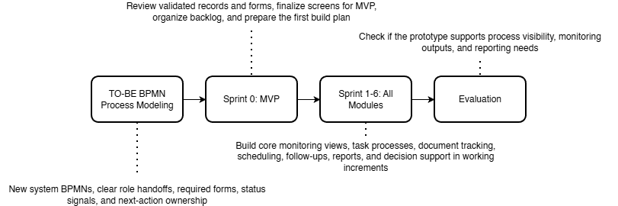

Figure 5.1 Methodology Flow of the Study with Scrum-Based Prototype Development
In this project, the capstone group will apply Scrum in a simple and practical way. One member will act as the Product Owner by organizing the backlog based on the validated Graduate School requirements. One member will act as the Scrum Master by keeping the sprint schedule, meetings, and follow-up actions on track. The remaining members will act as Developers by designing, building, and testing the prototype. Within Sprint 1 to n, the Scrum cycle is repeated through sprint planning, design, build, sprint review, and retrospective so that each increment can be improved before the next one begins.
The development process begins with TO-BE BPMN refinement and process design. In this stage, the group refines the Graduate School-only BPMNs so that the proposed flow matches the approved scope of the project. This includes clarifying who performs each step, what form or record is involved, what status signal is captured, and who owns the next action. This is important because the confirmed notes identify specific role ownership. Staff handle loading and support, the Academic Coordinator handles advising and most decisions, the Research Class Coordinator manages research-related monitoring, and the Dean approves LOA and withdrawal.
After that, the group moves to Sprint 0: MVP and Planning. During this stage, the team reviews the validated Graduate School records, including the AC-Student-Monitoring template, the Student-Research-Monitoring sheet, and the Graduate School Research Protocol. The group then prepares the first prototype screens, checks if the user flow matches the BPMNs, and organizes the backlog for the first coded sprint. This step is important because the prototype must match the actual Graduate School process, forms, and records before coding begins.
The next stage is Sprint 1 to 6: Incremental Prototype Development. In these sprints, the team builds the prototype in working increments. The early sprints focus on the most basic needs first, especially Student Progress Management and Case Status and Action Tracking because these are needed to make student status visible. Later sprints add scheduling, follow-up records, dashboards, reports, and the implementation of Retrieval-Augmented Generation (RAG) via NotebookLM. This order fits the confirmed Graduate School needs, which include one consolidated view of student status, clearer ownership of next actions, document evidence tracking, LOA monitoring, residency tracking, and reports for subject needs and graduating student lists. Each sprint goes through planning, design, build, review, and retrospective so the team can improve the next increment based on feedback.
The last stage is Evaluation. In this stage, the group checks whether the prototype supports the agreed monitoring outputs, process visibility, and reporting needs of the Graduate School. The evaluation focuses on whether the prototype helps users see where the student is now, what is pending, who owns the next action, and which reports can be generated from the structured records. This is directly tied to the confirmed Graduate School needs, especially subject needs, graduating student lists, LOA monitoring, and residency tracking.
This methodology also matches the scope of the project. The signed notes confirm that the platform should remain a monitoring and support layer only. It should not replace AIMS admissions, Registrar records, or Accounting processes. Instead, it should capture only the allowed status signals, evidence, handoffs, and timestamps needed by the Graduate School for monitoring, follow-up, and reporting. Because of this, the methodology focuses on refining the approved process flow, validating the interface through an MVP, and building only the functions that match the confirmed scope.

3.1 Proposed System Development
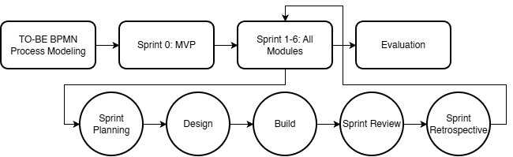

Figure 5.2 Proposed System Development Approach
The proposed platform is a Graduate School monitoring and processing platform designed to improve visibility of student progress and support Graduate School follow-up and reporting. It brings together allowed status signals, handoffs, required evidence, schedule events, and timestamps into one connected view so that Graduate School users can monitor cases without repeatedly checking separate spreadsheets, forms, and email threads.
The platform is intended for Graduate School use only and focuses on Graduate School-owned monitoring and processing. It covers admission handoff monitoring, enrollment monitoring, coursework and study plan tracking, LOA and readmission, thesis and dissertation milestones, practicum where confirmed, withdrawal, and graduation endorsement on the Graduate School side. These areas are directly supported by the confirmed notes, which identify subject needs, AY and semester taken, completion markers, LOA tracking, residency tracking, document evidence, and graduation candidate review as important monitoring needs.
The main users of the platform are Graduate School office staff, the Academic Coordinator, the Research Coordinator, the Dean, advisers and panel roles where applicable, and graduate students for limited progress viewing. The confirmed notes show that staff handle loading and support, the Academic Coordinator handles advising and most decisions, the Research Class Coordinator handles research-related monitoring, and the Dean approves LOA and withdrawal and receives reports. For this reason, the platform is designed around these Graduate School roles rather than around a general student information platform.
The prototype will first be developed as an MVP so the group can validate the screens, flow, and user actions before coding. After that, the coded prototype will be built in sprint-based increments. This allows the group to check that the screens match the BPMNs, the user roles, and the actual Graduate School records before more functions are added.
The platform organizes its main functions according to the conceptual framework modules. Student Progress Management keeps the student’s stage, status markers, curriculum tag, AY and semester taken, and completion indicators. Case Status and Action Tracking shows who owns the next action and what decision moved the case to its current state. Defense Scheduling Management records scheduling requests, availability, confirmations, and reschedules. Case Monitoring and Follow-Up supports alerts, watchlists, and follow-up records for delayed or incomplete cases. Policy and Case Guidance provides guided summaries, completion rate analysis, and next-step prompts by using Retrieval-Augmented Generation (RAG) via NotebookLM to access approved records, uploaded document repository contents, and system-computed indicators. Reports and Dashboards generate outputs such as subject needs lists, graduating student lists, LOA monitoring, residency tracking, and completion summaries.
The platform uses existing Graduate School records as its basis. For coursework and study plan monitoring, it uses fields grounded in the AC-Student-Monitoring template, especially curriculum alignment, taken or not taken status, and AY and semester taken. For research stages, it uses the Graduate School Research Protocol forms and rules, such as Form 4 for proposal or final defense endorsement, Form 5 and Form 5.1 for proposal comments and technical review, Form 5.2 for ethics review, and Forms 6, 7, 9, and 10 for final defense, manuscript finalization, and completion evidence. The protocol also provides timing rules, such as the two-week lead time, the 14-day rule, and the five-day public defense filing rule, which can be reflected in the prototype’s scheduling and follow-up logic.
The platform is not intended to replace official institutional systems. The confirmed notes state that admissions remain in AIMS, grades and official academic records remain on the Registrar side, and Accounting processes must not be replaced. The prototype therefore captures only the monitoring signals and process records that the Graduate School is allowed to use, such as status tags, handoffs, evidence checkpoints, and timestamps. This keeps the project within its approved scope and makes the proposed platform different from a full school information system.
Development under Scrum will move from the most basic monitoring needs to the more advanced outputs. The first coded sprints focus on Student Progress Management and Case Status and Action Tracking because two are the minimum functions needed to make status visible. Later sprints add scheduling, follow-up records, dashboards, reports, and the implementation of RAG via NotebookLM. This order fits the confirmed Graduate School need for a consolidated view first, followed by better reporting and guided next actions after the core records are in place.

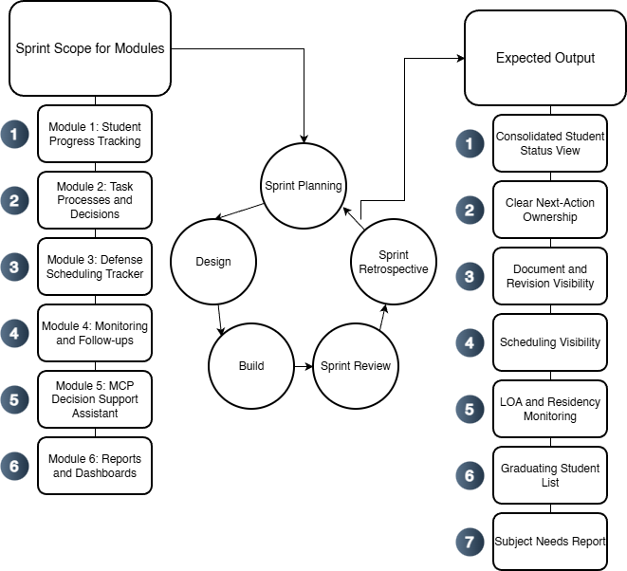

Figure 5.3. Proposed System Development Overview Using Agile Scrum
Figure 5.3 shows how the proposed platform is developed per module using a Scrum-based cycle. The validated Graduate School records serve as the basis of development. For each sprint, the team selects one module or a set of related functions, then goes through sprint planning, design, build, sprint review, and retrospective. Each sprint produces a working increment, and the cycle is then repeated for the next module. This keeps the development process aligned with the approved Graduate School scope while allowing the prototype to improve in small, reviewable increments.

3.2 Phases
Section 3.2 presents the project’s specification phases, which translate the Graduate School’s operational reality (task processing, protocol forms, records, and role handoffs) into implementable requirements. These phases are not the term-by-term schedule (which is presented later in the Workplan). Instead, the phases explain the sequence used to ensure that monitoring and decision support are built on clear definitions of completion, clear ownership of next actions, and feasible event capture, so dashboards, queues, and prescriptive recommendations do not rely on inconsistent or disputed status labels.
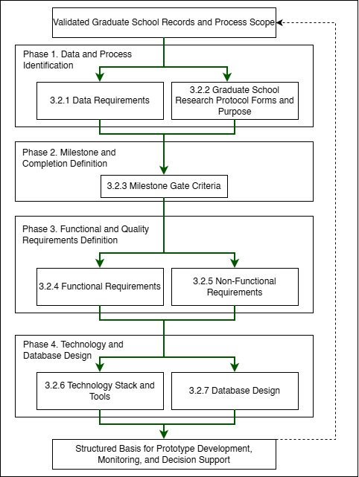

Figure 5.4. Specification Phases for the Proposed Graduate School Monitoring and Decision Support Platform
To keep the specification and requirements organized in an ordered flow:
- 3.2.1 Data Requirements identifies the minimum lifecycle and research data that must be captured, who provides it, where it currently resides (AS-IS), and why it is needed for monitoring and decision support.
- 3.2.2 Graduate School Research Protocol Forms and Purpose documents the official thesis/dissertation forms and clarifies what each form represents operationally, so form submissions and approvals can be captured as traceable process events.
- 3.2.3 Milestone Gate Criteria defines the definition of completion per gate (entry criteria, required evidence, decision outcomes, and exit criteria), and aligns these gates with the TO-BE process so completion and readiness checks become measurable and consistent.
- 3.2.4 to 3.2.5 Functional and Non-Functional Requirements convert validated processes and data needs into system capabilities and quality constraints (for example RBAC, auditability, usability, and reliability).
- 3.2.6 Technology Stack and Tools specifies the development tools and implementation approach aligned to the system scope and boundaries (monitoring and decision support layer, not an institutional record system replacement), including support for prescriptive decision support outputs and optional controlled LLM use.
- 3.2.7 Database Design defines how the platform stores lifecycle and milestone evidence as structured records, including core tables, key relationships, validation rules, the grouped ERD (A to G), and the derived indicators used for descriptive monitoring and prescriptive decision support recommendations.

3.2.1 Data Requirements
Data Category | Key Fields | Primary Source Role | Existing System (AS-IS) | Use for Monitoring and Analytics
Student identity + program profile | Student name; ID number; program/track; year level; AY entry | Staff/Admin; Student (for verification) | Student Monitoring Excel Sheet (AC-STUDENT-MONITORING-Template.xlsx) | Baseline linking key across coursework + research monitoring; supports cohort grouping and drill-down views.
Coursework / enrollment monitoring | AY entry; subjects/codes; unit totals; standing/progress markers | Staff/Admin; Coordinator | Student Monitoring Excel Sheet (AC-STUDENT-MONITORING-Template.xlsx) | Enables “coursework-to-research readiness” monitoring where applicable.
Admission monitoring (status signals) | Requirements submitted date; application status; handoff confirmation | Admission Office; Graduate School Staff | AIMS + email-based handoff | Completes lifecycle coverage from admission without replacing AIMS.
Enrollment confirmation / term activation | Enrollment confirmation status per term; timestamp; active/inactive/stop-start signals | Graduate School Staff; Academic Coordinator | Email-based triggers + enrollment platform status | Prevents “gap in enrollment” visibility; supports continuity monitoring.
Curriculum tagging and study plan generation | Curriculum ID/version; student–curriculum tag date; required subjects; planned AY/Sem mapping | Academic Coordinator; Staff | Curriculum records + Student Monitoring Excel Sheet (AC-STUDENT-MONITORING-Template.xlsx) / study plan form | Enables per-student course audit and cohort-based monitoring for offerings and readiness.
Class offerings decision-support inputs | Eligible student counts per subject; pending prerequisites; planned offerings summary | Academic Coordinator | Student Monitoring Excel Sheet (AC-STUDENT-MONITORING-Template.xlsx) + curriculum mapping outputs | Supports “subjects to offer next semester” decision support.
LOA application monitoring | LOA request date; approval status; LOA start/end; LOA expiry marker | Graduate School Staff; Dean | Email-based routing + LOA tracking record | Adds visibility and escalation signals for LOA.
Readmission monitoring | Readmission request date; decision outcome; return term; conditions (if any) | Graduate School Staff | Email/manual records | Tracks re-entry pathway after LOA; supports continuity/readiness checks.
Residency monitoring signals | Residency clock start; pause/resume markers; nearing limit flags | Graduate School Staff/Coordinator | Derived monitoring record (policy-confirmed parameters) | Supports residency monitoring without changing policy.
Research case profile | AY first enrolled in thesis/dissertation; current AY; semester; program; adviser | Staff/Admin; Coordinator | Thesis Student Research Monitoring Sheet (Student-Research-Monitoring.xlsx) | Timeline anchor for time-in-stage, residency indicators, and exception tracking.
Adviser assignment + eligibility constraints | Adviser name; appointment status; date appointed; adviser load indicator | Research leadership/Admin | Research Protocol (Form 3 / 3.1) + spreadsheet reflections | Supports routing/accountability and adviser load monitoring.
Title defense events | Endorsement; schedule date; approved title; decision outcome | Student; Coordinator; Panel Chair; Admin | Thesis Student Research Monitoring Sheet (Student-Research-Monitoring.xlsx) (Forms 1–2) | Captures early bottlenecks (endorsement + scheduling).
Proposal defense readiness + gate requirements | Endorsement; schedule; technical clearance; statistician consult (conditional) | Student; Adviser; Statistician; Admin | Thesis Student Research Monitoring Sheet (Student-Research-Monitoring.xlsx) (Forms 4, 4.1, 5) | Detects readiness blocks and scheduling bottlenecks.
Ethics review and clearance | Ethics submission; clearance date/status | Student; Ethics Office/Admin | Thesis Student Research Monitoring Sheet (Student-Research-Monitoring.xlsx) (Form 5.2) | Enables stop-the-clock/restart tracking around ethics review.
Final defense events | Endorsement; schedule; outcome (pass/minor/major); re-defense status | Student; Adviser; Panel; Admin | Thesis Student Research Monitoring Sheet (Student-Research-Monitoring.xlsx) (Forms 6–8) | Captures revision cycles/decision states for bottleneck identification.
Public defense + publication/completion tagging | Public defense schedule; Turnitin cert; editor cert; final approval sheet; publication step | Student; Adviser; Admin | Thesis Student Research Monitoring Sheet (Student-Research-Monitoring.xlsx) (Forms 9–10) + Turnitin step | Converts endgame requirements into a traceable checklist; supports stuck-case detection.
Scheduling state and constraints | Proposed/confirmed dates; reschedules; mode; venue reservation | Admin/Staff; Panel Chair; Student | Email-based coordination + protocol steps | Measures scheduling cycle time and repeated back-and-forth.
Decision records + comment consolidation | Outcomes; consolidated comment sheet; approvals/release certs | Panel Chair; Panel Members; Adviser | Research Protocol (Form 5 consolidation; Form 5.1; Form 6/7) | Reduces version confusion; strengthens traceability/accountability.
Workload and operational queues | Pending endorsements; overdue items; aging cases; adviser/panel load counts | Admin; Coordinator; Leadership | Derived from milestone events + role assignments | Core decision-support layer for escalation and workload balancing.
Authority + audit signals | RBAC; access boundaries; change logs; retention rules | Admin | Thesis Student Research Monitoring Sheet (Student-Research-Monitoring.xlsx) (Forms 1–2) | Supports privacy-aligned handling and auditability for sensitive documents.
Practicum/OJT monitoring (if applicable) | Required hours; schedule; completion status; evidence checklist | Program Coordinator | Manual logs / certificates (MOA/certifications) | Included only when the program requires it; treated as completion signals.
Withdrawal monitoring | Withdrawal request/confirmation; effective term; reason (if allowed) | Graduate School Staff; Dean | Email/manual records | Tracks stop pathway formally for attrition reporting where allowed.
Graduation endorsement monitoring (Graduate School side) | Endorsed-to-graduate date; requirements complete flag; evidence checklist | Graduate School Staff; Academic Coordinator | Endorsed list + manual checklist | Supports graduating list preparation without replacing registrar processing.

Table 5. Data to be collected and sources
Table 5 summarizes the operational data that must be captured to support lifecycle monitoring and decision support, including who provides each data element, where it currently resides (e.g., spreadsheets, email routing, and protocol forms), and what monitoring purpose it serves. In current practice, evidence of progress is distributed across spreadsheets and email-based coordination, while the Graduate School Research Protocol defines the official events, forms, decision gates, and role handoffs that must be tracked. Accordingly, the data scope emphasizes lifecycle status signals, milestone events, decision records, scheduling states, document/version evidence, and workload indicators needed to answer monitoring questions such as: where the student is now, what is pending, who owns the next action, and where delays occur.

3.2.2 Milestone Gate Criteria
Milestone | Entry Criteria | Required Evidence | Decision outcomes | Exit Criteria | Role
Admission Handoff Confirmed | Student has submitted requirements and admission status signal is available for handoff | AIMS status + handoff confirmation (email/record) | Accepted for onboarding / For completion / Not accepted | Handoff recorded; student is visible to Graduate School for onboarding and monitoring | Admission Office (status) + Graduate School Staff (handoff receipt)
Student Account + Program Onboarding Completed | Admission handoff confirmed | Enrollment platform account created; onboarding checklist (if used) | Activated / Returned for correction | Student account activated; student is tagged to program context for monitoring | Graduate School Staff / Academic Coordinator
Curriculum Tagged + Study Plan Generated | Student account exists; curriculum list/version exists | Curriculum ID/version record; student–curriculum tag record; generated study plan | Tagged / Corrected / Deferred | Student is linked to a curriculum; study plan (required subjects) is generated and viewable | Academic Coordinator
Term Enrollment Confirmed | Student is eligible to enroll for the term (per Graduate School) | Enrollment confirmation record (email trigger / enrollment platform status) | Confirmed / On hold / Not confirmed | Term status is recorded as active/inactive; monitoring continuity is visible (no “gap”) | Graduate School Staff / Academic Coordinator
Course Audit Updated | Term results/standing signals are available to be mirrored as monitoring indicators (without replacing grade encoding) | Monitoring sheet update (course completion/INC marker); supporting reference to official record where permitted | Updated / Pending update / Exception flagged | Course audit reflects latest completion/INC markers and remaining requirements for readiness checks | Academic Coordinator
Class Offerings Planning Completed | Curriculum + course audit data are available to compute eligible counts | Aggregated eligibility counts per subject; planned offerings summary | Approved offerings plan / Revised / Deferred | “Subjects to offer next semester” output is generated and recorded for term planning | Academic Coordinator
LOA Approved and Recorded | Student submits LOA request; case is active | LOA request record + approval decision + effective LOA start/end dates | Approved / Denied / Returned for completion | LOA status is recorded with effective period and expiry marker; student marked stop-start for monitoring | Dean (approval) + Graduate School Staff (recording)
Readmission Approved and Recorded | LOA period ended or readmission requested | Readmission request record + decision outcome + effective return term | Approved / Denied / Returned for completion | Readmission status recorded; student marked active for the return term | Graduate School Staff / Dean (as applicable)
Research Case Created | Readiness to start thesis/dissertation is confirmed (program-dependent) | Research case profile created (type, first enrolled AY, adviser pending/assigned) | Created / Deferred | Research case exists and becomes the basis for milestone event tracking | Research Coordinator / Staff
Adviser Designation Completed | Research case exists; adviser nomination is initiated | Research Protocol Forms 3 / 3.1 (adviser designation and appointment) and recorded adviser assignment | Appointed / Returned / Not appointed | Adviser assignment is recorded with date and ownership routing can begin | Research Leadership / Research Coordinator
Title Defense Completed | Adviser designation completed; title defense request endorsed | Research Protocol Forms 1–2 (title defense application + outcome); schedule record (if used) | Approved title / Returned for revision / Not approved | Approved title is recorded; status advances to proposal preparation stage | Panel Chair (decision) + Research Coordinator (recording)
Proposal Defense Completed | Title approved; proposal defense endorsed and scheduled | Research Protocol Forms 4, 4.1 (if applicable), 5 + schedule record + outcome/comments record | Passed / Revisions required / Re-defense required | Proposal defense outcome recorded; required changes captured as the authoritative revision basis | Panel Chair + Research Coordinator
Ethics Clearance Recorded | Proposal stage requires ethics review/clearance | Research Protocol Form 5.2 (ethics submission/clearance) | Cleared / Returned / Not cleared | Ethics clearance status and date are recorded; case may proceed to data collection/writing milestones | Ethics Office (clearance) + Research Coordinator (recording)
Final Defense Completed | Final defense endorsed and scheduled | Research Protocol Forms 6–8 (final defense comments/evaluation/settlement where applicable) + schedule/outcome record | Passed / Minor revisions / Major revisions / Re-defense | Final defense outcome recorded; revision pathway is explicit (minor/major/re-defense) | Panel Chair + Research Coordinator
Completion Evidence Verified | Final defense outcome permits completion processing | Research Protocol Forms 9–10 + Turnitin certificate + editor certification + approval sheet (as applicable) | Verified complete / Missing requirements / Returned | All required completion evidence is recorded as complete; case is eligible for GS endorsement | Graduate School Staff / Research Coordinator
Withdrawal Confirmed and Recorded | Student requests withdrawal; case is active | Withdrawal request/confirmation record (email/manual) | Approved / Denied / Returned | Withdrawal status recorded; monitoring stops with an auditable exit reason category (if allowed) | Dean + Graduate School Staff
Graduation Endorsement Completed | Completion evidence verified; no active stop-start/withdrawal | Endorsed-to-graduate list + requirements checklist (GS-side) | Endorsed / On hold / Returned for completion | Graduate School endorsement status recorded; endorsement list is prepared and handed off (registrar remains out-of-scope) | Graduate School Staff + Academic Coordinator / Dean

Table 6. Milestone Gate Criteria explaining definition of completion
Table 6 represents the “definition of completion” for lifecycle and research progress monitoring. It specifies the minimum entry criteria, required evidence, decision outcomes, and exit criteria for each gate so that process states are interpretable across roles and suitable for consistent monitoring (e.g., pending queues, aging/time-in-stage, and readiness checks). This reduces ambiguity in status labeling and supports decision support by clarifying what must be true before a case can advance and what evidence confirms completion.

3.2.3 Functional Requirements
Category | Description
Curriculum and Study Plan Management | Load and maintain program curricula, tag a student to the correct curriculum, generate a per-student study plan, and show required subjects with AY and semester taken. Record subject completion date and status for course audit.
Enrollment and Coursework Monitoring | Track enrollment confirmation and course audit status. Provide a student view of the next semester schedule where allowed, and a coordinator view of student eligibility and remaining requirements without replacing official grade encoding.
Class Offerings Decision Support | Generate outputs that help the Academic Coordinator decide what subjects to offer next semester, such as counts of eligible students per subject, pending requirements, and a planned offerings summary.
LOA and Readmission Monitoring | Track LOA request status, approval, and effective LOA period. Track residency pause and readmission status, and generate LOA monitoring views for staff and coordinators.
Thesis and Dissertation Monitoring | Track adviser designation, title defense, proposal defense, final defense, revision cycles, manuscript finalization, and required certifications or documents. Record status, assigned role, and time on stage.
Practicum or OJT Tracking (Program-dependent) | Where required by the program, track required hours, schedule, and uploaded evidence such as MOA or certifications as completion signals. Exclude this if the program does not require it.
Withdrawal and Graduation Monitoring | Track withdrawal confirmation status and Graduate School graduation endorsement status. Generate graduating list outputs based on completion evidence without replacing Registrar processing.
Task Processing and Task Queues | Provide role-based task queues for submissions, endorsements, approvals, and decisions. Show who owns the next action across lifecycle stages.
Decision Recording | Record decision outcomes such as approve, revise, or return, together with the next required action and closure evidence for each milestone step.
Document Tracking | Maintain a required document checklist for each stage, track document versions, and record consolidated comments or decision records.
Scheduling Tracking | Record defense request, availability, and schedule outcome. Log reschedules and cancellations as monitoring signals.
Dashboards and Reports | Generate counts per stage, pending queues, aging or time in stage, LOA counts, course audit readiness, adviser or panel counts where applicable, and residency, completion, or attrition outputs based on validated definitions.
Alerts and Intervention Tracking | Detect threshold breaches such as long time in stage, LOA nearing expiry, or residency nearing limits. Notify the correct roles and log intervention actions with closure evidence.
Audit Trail | Log actions, decisions, and changes in definitions or process settings to support accountability.

Table 7. Functional Requirements of the modules
Table 7 summarizes the functional requirements of the proposed platform. These requirements come from the main Graduate School monitoring and processing needs, including scattered records, unclear next-action ownership, scheduling delays, revision tracking problems, and missing or inconsistent timestamps.

3.2.4 Non-Functional Requirements
Category | Description
Security | Enforce role-based access control, strong authentication, secure session handling, and controlled privileges for higher-level users.
Privacy | Limit access to sensitive evaluation records, log access where needed, and handle data according to approved privacy boundaries (Datu, 2022).
Auditability | Keep append-only logs for key actions such as submissions, decisions, approvals, routing, and definition changes. Each log entry must show the actor, timestamp, and outcome.
Usability | Provide role-based dashboards and task queues, clear status labels, low encoding effort for staff, and consistent terms across modules.
Reliability | Apply data checks, validate required fields, support backup and recovery, and generate consistent timestamps for monitoring and reporting.
Maintainability | Allow milestone definitions, checklists, and process rules to be updated where possible without changing code, while keeping a controlled change process with logs.
Performance | Keep dashboard queries responsive, support efficient search and filtering, and handle document and log storage in a manageable way.
Interoperability | Allow export of reports and structured datasets. Allow integration or data exchange with institutional systems only where permitted by ownership and privacy rules.

Table 8. Non-Functional Requirements of the modules
Table 8 summarizes the non-functional requirements of the proposed platform. These requirements help make the system usable, dependable, and appropriate for Graduate School use. The platform also supports privacy, accountability, and adoption in an educational setting (Tanate-Lazo, 2021; Sancon, 2023).

3.2.5 Technology Stack and Tools
The proposed platform is a web-based graduate student lifecycle monitoring and decision-support system for Graduate School operations. The technology stack is selected to support the platform’s current core application modules: (1) Student Progress Management, (2) Case Status and Action Tracking, (3) Defense Scheduling Management, (4) Case Monitoring and Follow Up, (5) Analytics and Decision Support, (6) Policy and Case Guidance, and (7) Reporting and Dashboards. These modules are supported by cross-cutting platform capabilities for User and Access Management and Audit Trail and Compliance Logging to maintain secure access, traceability, and accountability across the system. The platform follows a web architecture that uses React and TypeScript for the frontend, Tailwind CSS for interface styling, Node.js and Express.js for backend services, MySQL and Prisma for data management, and JWT for authentication. This stack supports structured monitoring views, role-based task queues, scheduling records, dashboards, analytics outputs, and traceable activity logs within one system.
For analytics and reporting, the platform uses Chart.js to present counts, trends, queue conditions, and time-based monitoring indicators through dashboard views. GitHub is used for source control, issue tracking, and sprint management. Figma is used for interface mockups and clickable prototypes, while draw.io and dbdiagram.io are used for process diagrams, architecture diagrams, and database design.
For deployment and secure web access, Cloudflare is used for DNS management, HTTPS, SSL/TLS encryption, edge security, and content delivery. This supports secure access to the deployed system and helps protect the application during testing and demonstration.
For policy and case guidance, the proposed system implements Retrieval-Augmented Generation (RAG). The RAG pipeline uses LangChain.js for document retrieval orchestration, OpenAI API for embeddings and response generation, and ChromaDB as the vector database for storing and retrieving indexed policy documents, forms, guidelines, and case references. This setup allows the assistant to retrieve relevant institutional documents first and then generate grounded summaries, policy-based guidance, and suggested next steps. The assistant supports monitoring and administrative review only. Final decisions remain with authorized personnel.
The selected tools are feasible within a capstone timeline while keeping the architecture scalable, maintainable, and aligned with the project’s approved scope as a monitoring and decision-support platform rather than a replacement for official institutional systems.

3.2.5.1 Summary of IT Tools
Need | Specific Tools | Why this tool
UI mockups and clickable prototype |   Figma | Fast wireframing and interactive prototypes for stakeholder review and UI validation.
Frontend (web UI) |   React + TypeScript | Component-based UI for dashboards and queues, with TypeScript for safer handling of complex process states.
UI styling | 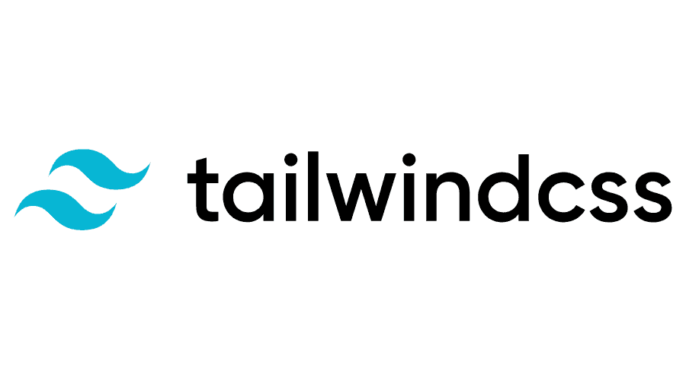  Tailwind CSS | Utility-first styling for consistent layouts with minimal custom CSS.
Charts for dashboards |   Chart.js | Lightweight charting for operational dashboards (counts, queues, aging/time-in-stage).
Backend (API + business rules) |   Node.js + Express.js (REST API) | Minimal backend framework for building API endpoints and implementing routing and process rules.
Authentication |   JWT (RFC 7519; internet standard) | Standard token format for stateless authentication between frontend and API.
Database | 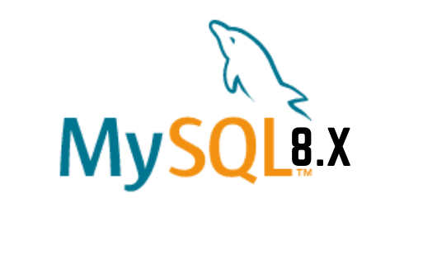  MySQL 8 (InnoDB) | Relational data model with foreign keys for lifecycle, milestones, tasks, and audit logs, enabling consistent reporting queries.
Schema migration and DB access | 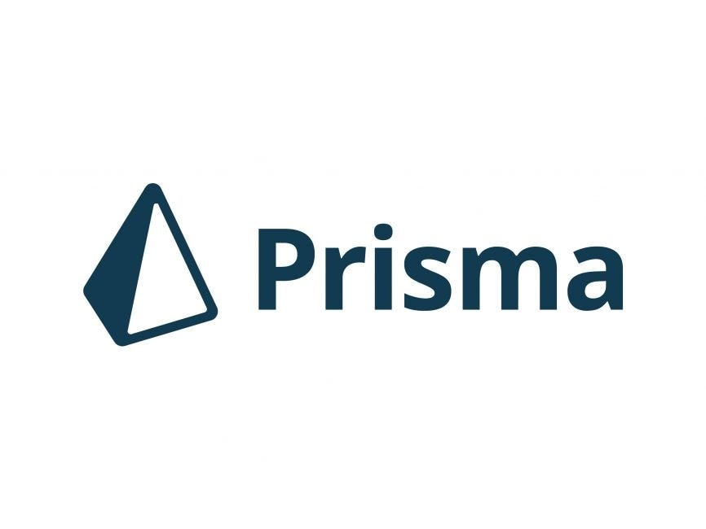  Prisma ORM (migrations + type-safe DB client) | One tool for repeatable schema migrations and type-safe database access, reducing manual SQL drift across sprints.
Project tracking and version control |   GitHub (Repo + Issues/Projects) | Source control and sprint tracking (issues, boards, basic backlog).
Diagrams | 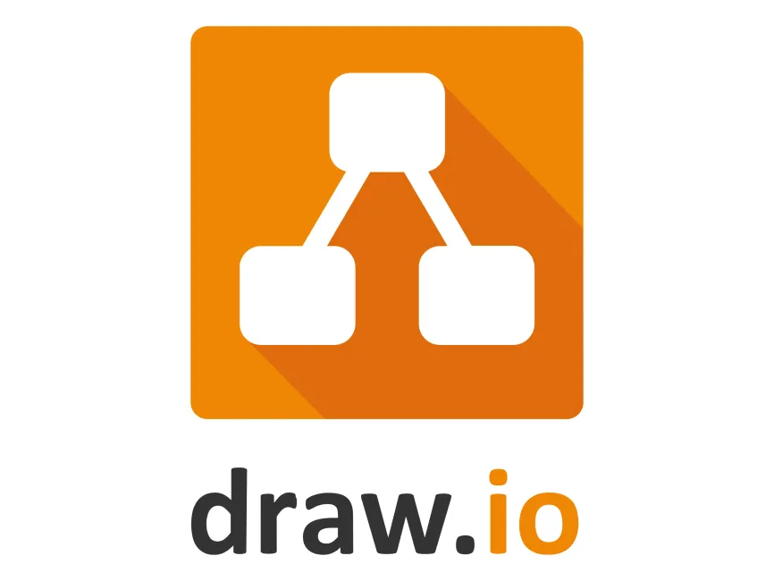  draw.io    dbdiagram.io | Process and architecture diagrams (BPMN, ERD, system diagrams) with a lightweight tool.
Domain and DNS | 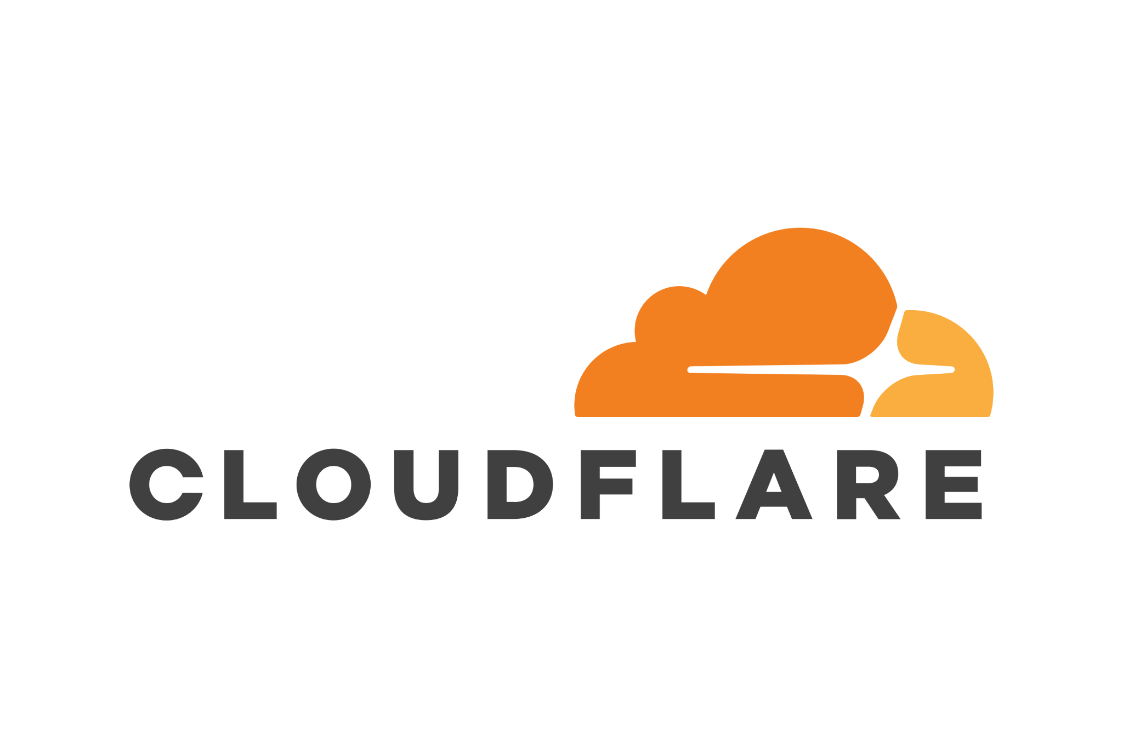  Cloudflare DNS  Cloudflare SSL/TLS  Cloudflare WAF and Firewall Tools  Cloudflare CDN | Manages the system domain/subdomain and DNS records (A/CNAME/TXT) for deployment and verification, with fast updates and centralized control
HTTPS and secure access |  | Provides HTTPS for users and encrypts traffic to the server (Full/Strict), reducing risks from misconfigured SSL on the origin.
Edge security |  | Adds a security layer in front of the server (e.g., basic filtering, rate limiting, DDoS protection) to reduce direct exposure of the origin.
Performance |  | Caches static assets to improve load time and reduce load on the origin server during peak access or demos.
RAG orchestration | 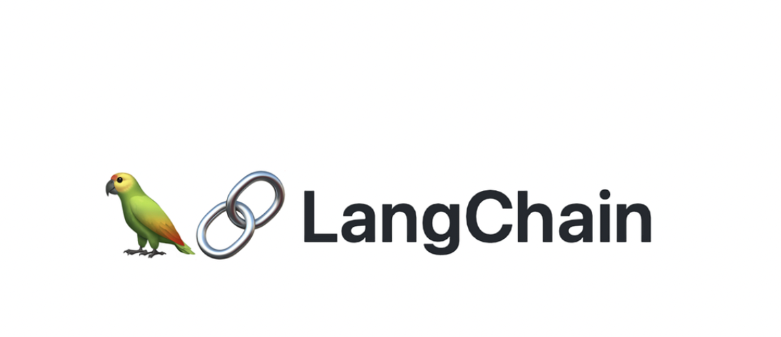  LangChain.js | Handles document chunking, retrieval flow, and prompt grounding for the assistant.
Embeddings and language model | 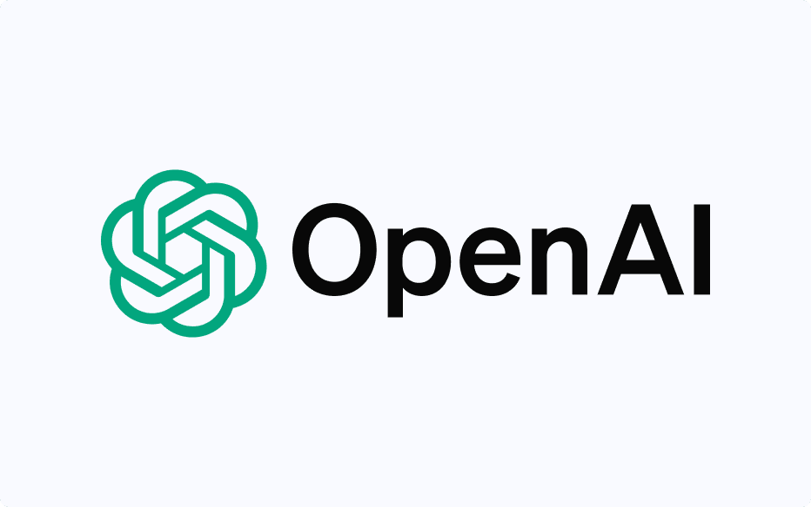  GPT-4.1 LLM | Generates embeddings for retrieval and grounded responses for policy and case guidance.
Vector database |   ChromaDB | Stores indexed document embeddings and supports similarity-based retrieval of policy and case references.
Policy and case guidance | RAG Pipeline | Retrieves approved documents first, then generates grounded summaries, guidance, and suggested next steps for administrative support.

Table 9. IT tools to be used

3.2.5.2 Platform Approach
The platform will be implemented as a web application with a simple three-layer structure:
- Presentation layer: React + TypeScript UI (dashboards, queues, forms)
- Service layer: Node.js + Express REST API for process rules, routing, and audit events
- Data layer: MySQL 8 relational database using InnoDB foreign keys for integrity; Prisma for schema migrations
This supports incremental delivery while ensuring monitoring outputs are derived from event history and timestamps, not only from manually maintained “current status” fields.

3.2.5.3 Database and Reporting
- MySQL 8 (InnoDB) stores structured entities such as Student, MilestoneEvent, TaskQueue, SchedulingEvent, DocumentArtifact metadata, Alert, and AuditLog. Foreign keys are used to keep linked records consistent.
- Dashboards and reports are computed using SQL queries and views (counts per stage, pending queues, aging/time-in-stage, LOA visibility, scheduling cycle time). Chart.js renders the results on the UI.
This approach remains scalable because reporting is based on indexed, timestamped events and relational joins, which are stable patterns for operational monitoring.

3.2.5.4 Prescriptive Analysis for Decision Support
Prescriptive decision support will be implemented as rule-based recommendations computed in the backend from confirmed events, timestamps, ownership assignments, evidence checklist status, and policy-confirmed parameters. These recommendations are not based on free-form interpretation alone. Instead, recommendations are produced from structured monitoring records and defined process logic. Examples include prompts such as “case exceeded allowed time-in-stage, escalate to coordinator,” “required evidence is incomplete, return to the student queue,” or “schedule request has no confirmed outcome, follow up with the assigned role.” The platform does not create, replace, or modify Graduate School policies. It only encodes policy-confirmed rules as decision-support logic.
These rule-based outputs are then made available to the through NotebookLM via Retrieval-Augmented Generation (RAG), which retrieves the computed indicators and related supporting records through approved tools and resources. This allows authorized stakeholders to ask natural-language questions and receive guided summaries, completion rate analysis, next-step prompts, queue prioritization prompts, and escalation prompts based on validated records. Final approvals and official decisions remain with authorized Graduate School personnel.
In this study, the purpose of prescriptive analytics is to reduce repeated manual checking across spreadsheets, protocol forms, and email-based coordination by turning recorded process data into actionable prompts. This directly supports the problem statement of the study, where graduate student status is spread across multiple sources and status confirmation is slow and prone to human error. By computing recommendations from structured records first, and then exposing them through the assistant, the platform improves visibility and follow-through without automating official authority.

3.2.5.5 RAG-Based Decision Support Assistant
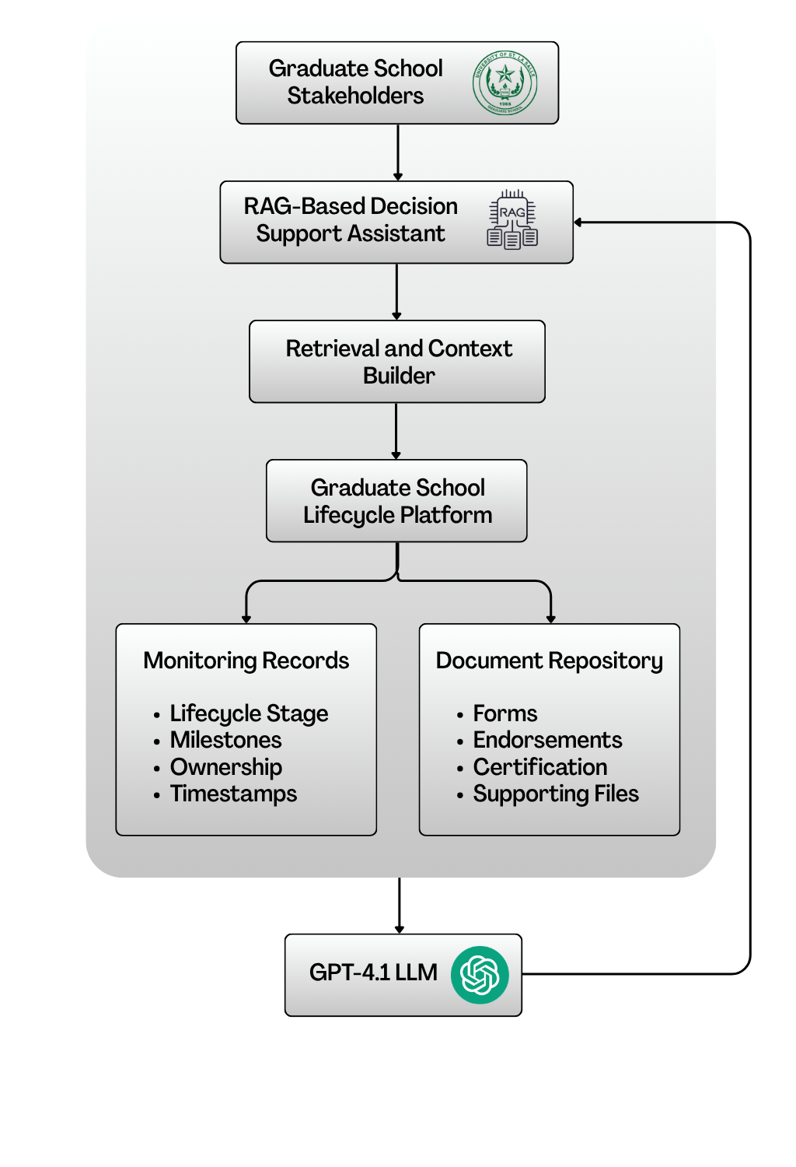

Figure 6. RAG-Based Decision Support Assistant Architecture
This study will use Retrieval-Augmented Generation (RAG) as the grounding approach for the decision support assistant. In this setup, the assistant retrieves relevant Graduate School records and approved reference documents before generating any response. This means the assistant does not rely on free-form guessing or manually maintained status text alone. Instead, it uses retrieved monitoring records, approved document contents, and system-generated indicators as the basis for its answers. This is consistent with the study’s use of RAG through NotebookLM and with the policy-grounded role of the assistant in the proposed platform.
In the proposed platform, the assistant draws from two main input groups. The first is structured operational and monitoring data, such as lifecycle stage, milestone events, ownership assignments, scheduling records, timestamps, checklist completion, and decision outcomes. The second is the approved repository of uploaded forms and documents collected throughout the Graduate School process, such as protocol forms, endorsements, comments, certifications, supporting files, and policy references. The retrieved materials are then used as context for the assistant’s response.
The assistant does not compute official status by itself. Official monitoring signals and prescriptive indicators are still computed first by the system backend and database using validated event history, timestamps, checklist rules, and policy-confirmed process logic. These computed results may include the current lifecycle stage, pending requirements, latest decision outcome, assigned next-action owner, aging or time-in-stage, overdue tasks, scheduling cycle time, evidence completeness, and completion rates. In this design, the backend remains the source of truth, while RAG serves as the retrieval and explanation layer that helps users access and understand those approved results more easily.
For example, when a stakeholder asks questions such as “What is the status of this student?”, “What is still pending?”, “Who owns the next action?”, or “Which students are delayed?”, the assistant retrieves the relevant monitoring records, computed indicators, and supporting documents before returning a guided summary. For completion rate analysis, the computation is still performed by the backend and database, not by the LLM alone. The completion rate is computed as:
Completion Rate = (Number of completed in-scope cases ÷ Total number of in-scope cases) × 100
A case is treated as completed only when the required exit criteria for the relevant lifecycle stage or milestone have been met based on the milestone gate definitions of the study. Through RAG, the assistant can retrieve these computed rates, grouped counts, and related filters such as program, term, milestone, or cohort, then explain the results in a readable form for stakeholders.
For decision support, the assistant may return guided student status summaries, completion rate summaries, pending requirement lists, next-step prompts, queue prioritization prompts, follow-up reminders, and escalation prompts for delayed cases. These outputs are for decision support only. The assistant does not automate approvals, override Graduate School authority, or change official policies. Final decisions remain with authorized personnel such as Graduate School staff, coordinators, advisers, panel members, and the Dean. This is aligned with the study’s positioning of the AI feature as a policy-grounded support tool rather than an autonomous decision maker.
This design directly supports the main problem statement of the study. Since graduate student status is currently spread across multiple sources and status confirmation depends on manual checking and encoding, the RAG-based assistant helps reduce repeated searching across spreadsheets, emails, forms, and separate records. It does this by allowing stakeholders to ask monitoring questions in natural language while still grounding the responses on validated system records, computed indicators, and approved reference documents.

3.2.5.6 Authentication, RBAC, and Audit Logging Tools
Access to information requires strict access control and traceability of actions. The system will implement:
- JWT authentication for UserAccount identities, based on the JWT standard (RFC 7519).
- RBAC authorization is mapped to system roles (staff, coordinator, research coordinator, adviser/panel, student) and scoped by ownership rules where applicable. RBAC enforcement will be validated using security control verification practices aligned with OWASP ASVS.
- Append-only audit logging (AuditLog table) capturing key events, including decisions, submissions, status transitions, evidence uploads, access attempts, and configuration changes (timestamp, actor, action type, affected record). This supports audit event logging expectations described in NIST SP 800-53.
These controls align with privacy requirements when handling sensitive student records and evaluation artifacts (Datu, 2022; Doce & Ching, 2018; Tanate-Lazo, 2021).

3.2.5.7 Reporting, Dashboards, and Analytics Tools
Dashboards and decision-support outputs will be generated through:
- Application dashboards using SQL aggregation (counts per stage, pending queues, aging/time-in-stage, scheduling cycle time, LOA visibility, workload indicators)
- Exportable reports in CSV and PDF for term-level summaries and endorsement preparation (PDF via printable report views for the prototype)
- A reporting schema or SQL views inside MySQL to standardize definitions and separate operational tables from reporting queries
This aligns with the principle that dashboards are only meaningful when events and timestamps are captured consistently and definitions are aligned (CHED Region IV-B MIMAROPA, 2018; Sorour & Atkins, 2024).

3.2.5.8 Notifications and Alerts Tools
The platform will support basic notification mechanisms for operational follow-through, such as:
- Email notifications using SMTP (for overdue items, LOA expiry reminders, missing evidence, and pending approvals).
- Notification events stored in the database (NotificationAlert records) to preserve traceability (who was notified, when, and why)
- Messages that avoid embedding sensitive content and direct users to log in to the portal for details
Messages will avoid embedding sensitive content and will direct users to log in to the portal for details.

3.2.5.9 Development, Collaboration, and Documentation Tools
To support Agile Scrum delivery and documentation needs, the project will use:
- GitHub for version control (source code, documentation, release tagging) and sprint tracking using Issues and Projects
- Figma for UI wireframes and prototype screens
- diagrams.net (draw.io) for BPMN, ERD, and architecture diagrams
These tools ensure traceability of changes, repeatable testing, and consistent deliverables per sprint.

3.2.6 Database Design
Because the project’s central contribution is monitoring and decision support, the database design prioritizes capturing lifecycle and milestone activity as structured, timestamped events. This avoids relying only on static “current status” fields and reduces inconsistencies from ad hoc spreadsheet updates. The model formalizes existing monitoring signals into related entities that support: (1) traceability (what happened, by whom, and when), (2) accountability routing (who owns the next action), and (3) reporting and prescriptive decision support (counts per stage, pending queues, aging or time-in-stage, scheduling cycle time, and workload visibility).
The model adopts a case-and-event approach. Each student has a profile and program context. Each research engagement is represented as a ResearchCase. Each progression step is recorded as a MilestoneEvent linked to a MilestoneType, including timestamps, decision outcomes, owner roles, and evidence links. Monitoring focuses on submissions, decisions, schedules, and permitted standing or readiness signals, not private adviser–student communication.

3.2.6.1 Core Entities/Tables
Area | Table | Purpose in the system
Identity and Access Management (IAM) | Student | Stores the primary student monitoring identity and program entry context (e.g., cohort/AY entry, program/track).
 | UserAccount | Stores login identities for staff, coordinators, adviser/panel roles, and students (permitted views).
 | Role | Defines system roles used for RBAC.
 | UserRole | Assigns system roles to users (supports RBAC enforcement).
 | AdviserAssignment / PanelAssignment | Links advisers and panel members to students for scoped access and review responsibilities.
Core lifecycle & milestone tracking (monitoring layer) | StudentLifecycle | Stores program/track fields and references to program-dependent settings notes.
 | MilestoneDefinition | Defines milestone requirements by lifecycle stage, expected durations, and criticality.
 | StudentMilestoneStatus | Tracks milestone progress status and due/completion timestamps at the student level.
Process routing & decisions | Task | Represents actionable process items (pending/overdue), ownership, due dates, and recommended next action fields.
 | DecisionLog | Captures decisions made on tasks (approve/revise/return) with decision actor and timestamp.
 | RoutingRule | Defines rule-based routing for next owner roles and follow-up task generation.
Academic lifecycle tracking (monitoring signals) | Program | Stores program/track information and references for program-dependent settings.
 | AcademicTerm | Stores academic year/term identifiers (start/end dates where needed).
 | TermEnrollment | Stores per-term enrollment monitoring signals (confirmation timestamps, allowed status signals).
 | Course | Master list of course code/title/units.
 | CourseEnrollment | Links term enrollment to courses and stores monitoring signals (e.g., in-progress/completed/incomplete markers).
 | Curriculum | Curriculum identifier/version information per program.
 | StudyPlanItem | Stores planned/required subjects per curriculum (and recommended term where applicable).
 | StudentCurriculumTag | Maps a student to a curriculum version/tag (e.g., revised plan/bridging).
Research pipeline tracking (case-and-event) | ResearchCase | Monitoring container for thesis/capstone engagements linked to a student.
 | MilestoneEvent | Records milestone execution as timestamped events (occurredAt, outcome, ownerRole, decision actor, notes) and may reference related process tasks.
Evidence, scheduling, and traceability | DocumentRecord | Stores required-document checklist items per student/milestone, including review status and outstanding revisions count.
 | DocumentVersion | Stores uploaded file versions (file reference, uploadedBy, timestamps) linked to DocumentRecord.
 | RevisionNote | Tracks revision comments/required changes and resolution status linked to DocumentRecord and/or DocumentVersion.
 | ScheduleRequest | Stores scheduling requests tied to a student (requestedBy, preferred dates, status).
 | Availability | Collects availability windows from users for a ScheduleRequest.
 | ScheduleEvent | Stores schedule outcomes (confirmed/rescheduled/cancelled) with timestamps and decision actor.
 | FormSubmission | Tracks protocol-driven forms with submitted/endorsed/approved timestamps and routing state.
 | ClearanceRecord | Tracks clearance submission/outcome dates where applicable.
 | TimelineEvent | Provides a consolidated “what happened” feed by recording key events and linking to related entities.
Monitoring actions and alerts | AlertThreshold | Stores configured monitoring thresholds (e.g., prolonged stage, delayed scheduling) used by the monitoring engine.
 | NotificationAlert | Logs notifications sent (recipient, reason, timestamp, success metadata).
 | Intervention | Stores follow-up actions with owner, timestamps, and closure evidence.
Auditability | AuditLog | Append-only log of key events (access attempts, decisions, transitions, uploads, configuration changes).

Table 10. Core tables and their purpose

3.2.6.2 Key Relationships and Integrity Rules
Relationship | Meaning | Integrity rule (what must be true)
Student (1) → (many) StudentLifecycle | A student has a stage history (entered/exited timestamps) | StudentLifecycle.StudentID must exist in Student
Student (1) → (many) StudentMilestoneStatus | A student has milestone progress records | StudentMilestoneStatus.StudentID must exist; MilestoneDefinitionID must exist
MilestoneDefinition (1) → (many) StudentMilestoneStatus | Milestone status references a valid milestone | StudentMilestoneStatus.MilestoneDefinitionID must exist
Student (1) → (many) TermEnrollment | A student has per-term monitoring records | TermEnrollment.StudentID must exist; TermEnrollment.TermID must exist
AcademicTerm (1) → (many) TermEnrollment | Enrollment records belong to a term | TermEnrollment.TermID must exist in AcademicTerm
TermEnrollment (1) → (many) CourseEnrollment | Term enrollment can include multiple courses | CourseEnrollment.TermEnrollmentID must exist; CourseEnrollment.CourseID must exist
Course (1) → (many) CourseEnrollment | Course enrollment references valid courses | CourseEnrollment.CourseID must exist in Course
Curriculum (1) → (many) StudyPlanItem | A curriculum defines planned subjects | StudyPlanItem.CurriculumID must exist; StudyPlanItem.CourseID must exist
Student (1) → (many) StudentCurriculumTag | A student can be tagged to a curriculum/version | StudentCurriculumTag.StudentID must exist; CurriculumID must exist
Student (1) → (many) ResearchCase | A student may have a research engagement container | ResearchCase.StudentID must exist
ResearchCase (1) → (many) MilestoneEvent | A case has milestone events over time | If used, MilestoneEvent.ResearchCaseID must exist in ResearchCase
MilestoneDefinition (1) → (many) MilestoneEvent | Events reference valid milestone definitions | MilestoneEvent.MilestoneDefinitionID must exist
Student (1) → (many) DocumentRecord | Document checklist items attach to a student | DocumentRecord.StudentID must exist
DocumentRecord (1) → (many) DocumentVersion | A checklist item can have multiple uploads/versions | DocumentVersion.DocumentRecordID must exist
DocumentRecord (1) → (many) RevisionNote | Revision notes attach to document checklist/version | RevisionNote.DocumentRecordID must exist
Student (1) → (many) ScheduleRequest | Scheduling requests attach to a student | ScheduleRequest.StudentID must exist; Requester must exist
ScheduleRequest (1) → (many) Availability | Availability windows belong to a scheduling request | Availability.ScheduleRequestID must exist; UserID must exist
ScheduleRequest (1) → (many) ScheduleEvent | Schedule outcomes/events belong to a request | ScheduleEvent.ScheduleRequestID must exist
UserAccount/Assignments → Student scope | People are linked to students for scoped access | AdviserAssignment/PanelAssignment.UserID must exist; StudentID must exist

Table 11. Key relationships (high-level PK/FK design)
Validation Rules:
- A MilestoneEvent should not be recorded as “completed/approved” unless required fields are present (timestamp, outcome, confirming role/actor) and required evidence checklist items (DocumentRecord status) are satisfied where applicable.
- A Task should not be closed without a corresponding DecisionLog entry that records decision outcome and decision actor.
- DocumentVersion should enforce version consistency (e.g., only one “current” version per DocumentRecord, if implemented), and revision notes should be traceable to a document record/version.
- A ScheduleEvent should not be marked “confirmed” unless the scheduled date/time (scheduledAt) and decision actor (decidedById) are captured.
- AuditLog entries are created for every decision, lifecycle stage transition, evidence upload, access attempt (success/denied), and configuration change.

3.2.6.3 Entity-Relationship Diagram (ERD) and Table Group Overview

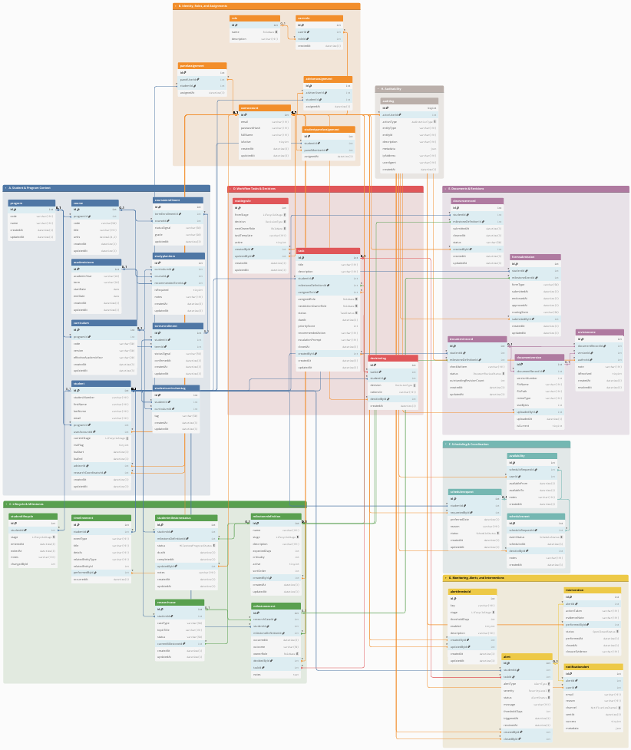

Figure 7. Full ERD of the proposed platform database (grouped)
Figure 7 presents the full ERD of the proposed database. For readability, the ERD is organized into functional groups (A to H). Figures X.1 to X.8 show cropped views of each group. Each caption highlights only the key tables and connections needed for monitoring and decision support.
A. Student and Program Context
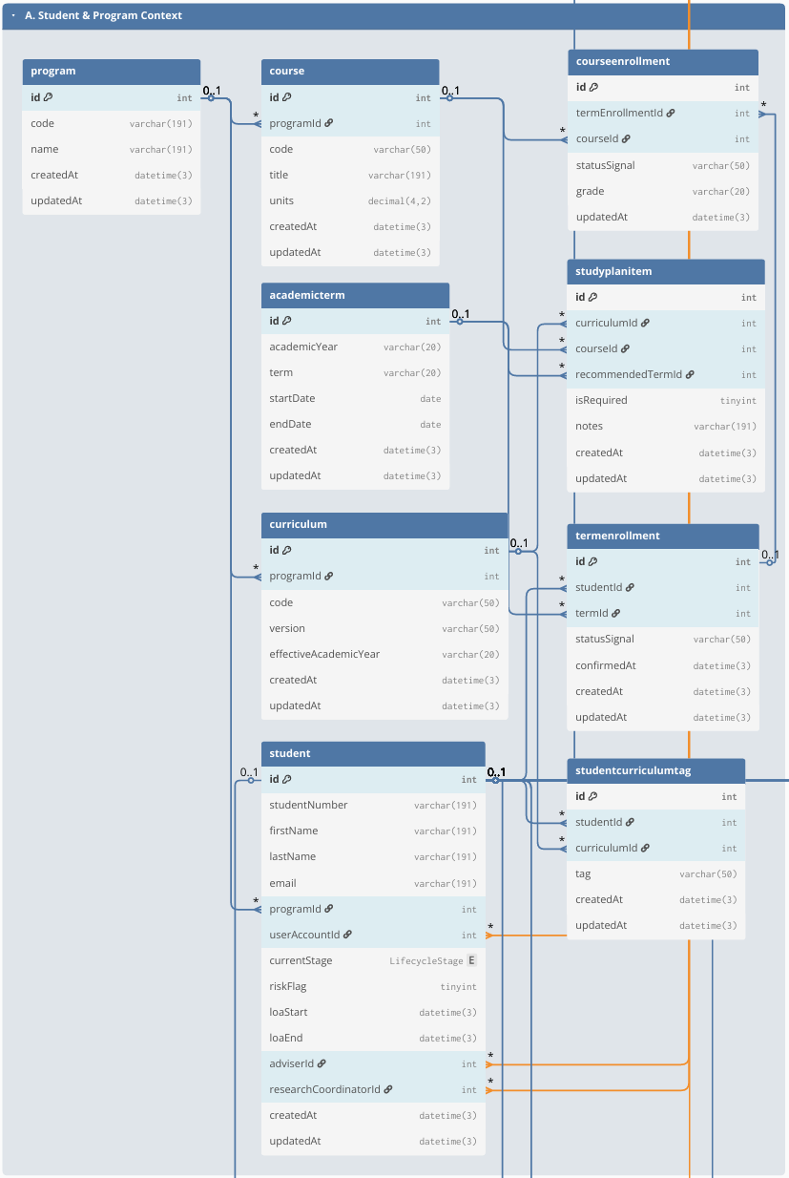

Figure 7.1 Group A. Student and Program Context
This group stores the core student monitoring identity and the student’s program context (Student, Program). Student serves as the primary reference across the database and links to academic monitoring (term/course records), lifecycle/milestone tracking, process tasks, documents, scheduling, alerts, and audit logs. Program provides the program/track context used for filtering, reporting, and program-dependent settings.
B. Identity, Roles, and Assignments

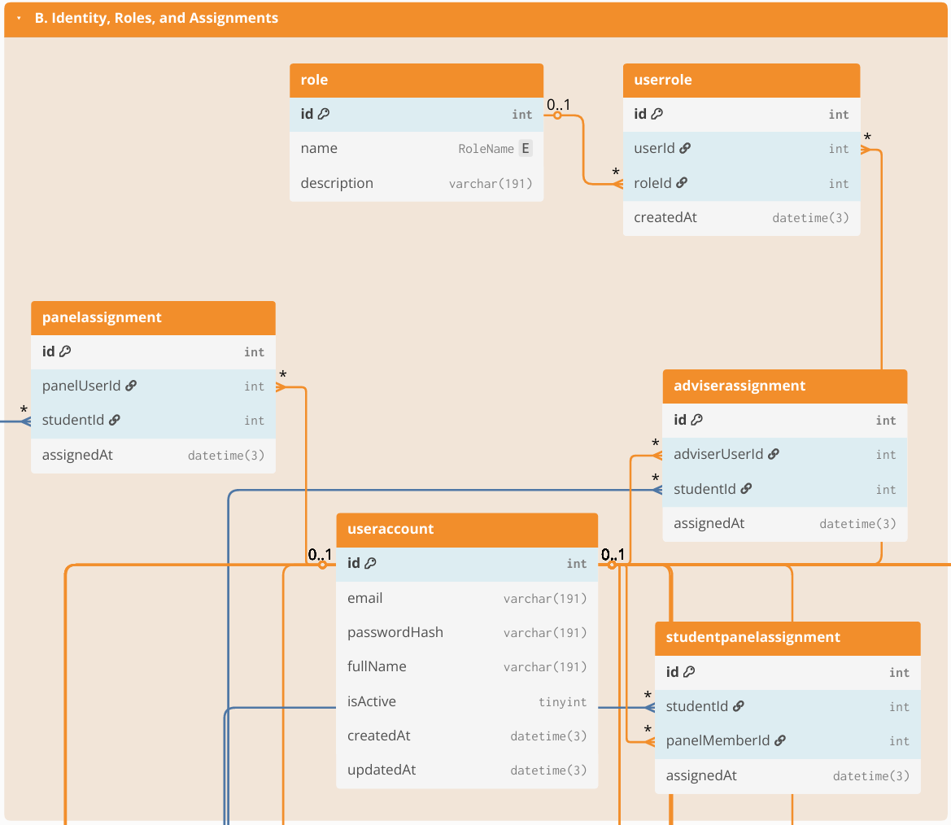

Figure 7.2 Group B. Identity, Roles, and Assignments
This group defines system accounts and role-based access control structures (UserAccount, Role, UserRole), and the scoped assignments that determine which students a user may access (e.g., AdviserAssignment, PanelAssignment, or equivalent assignment tables used by the system). These links enforce privacy boundaries (who can see which student/case) and support operational routing by clarifying who participates in review handoffs (coordinator/adviser/panel) without relying on informal messaging.
C. Lifecycle & Milestones

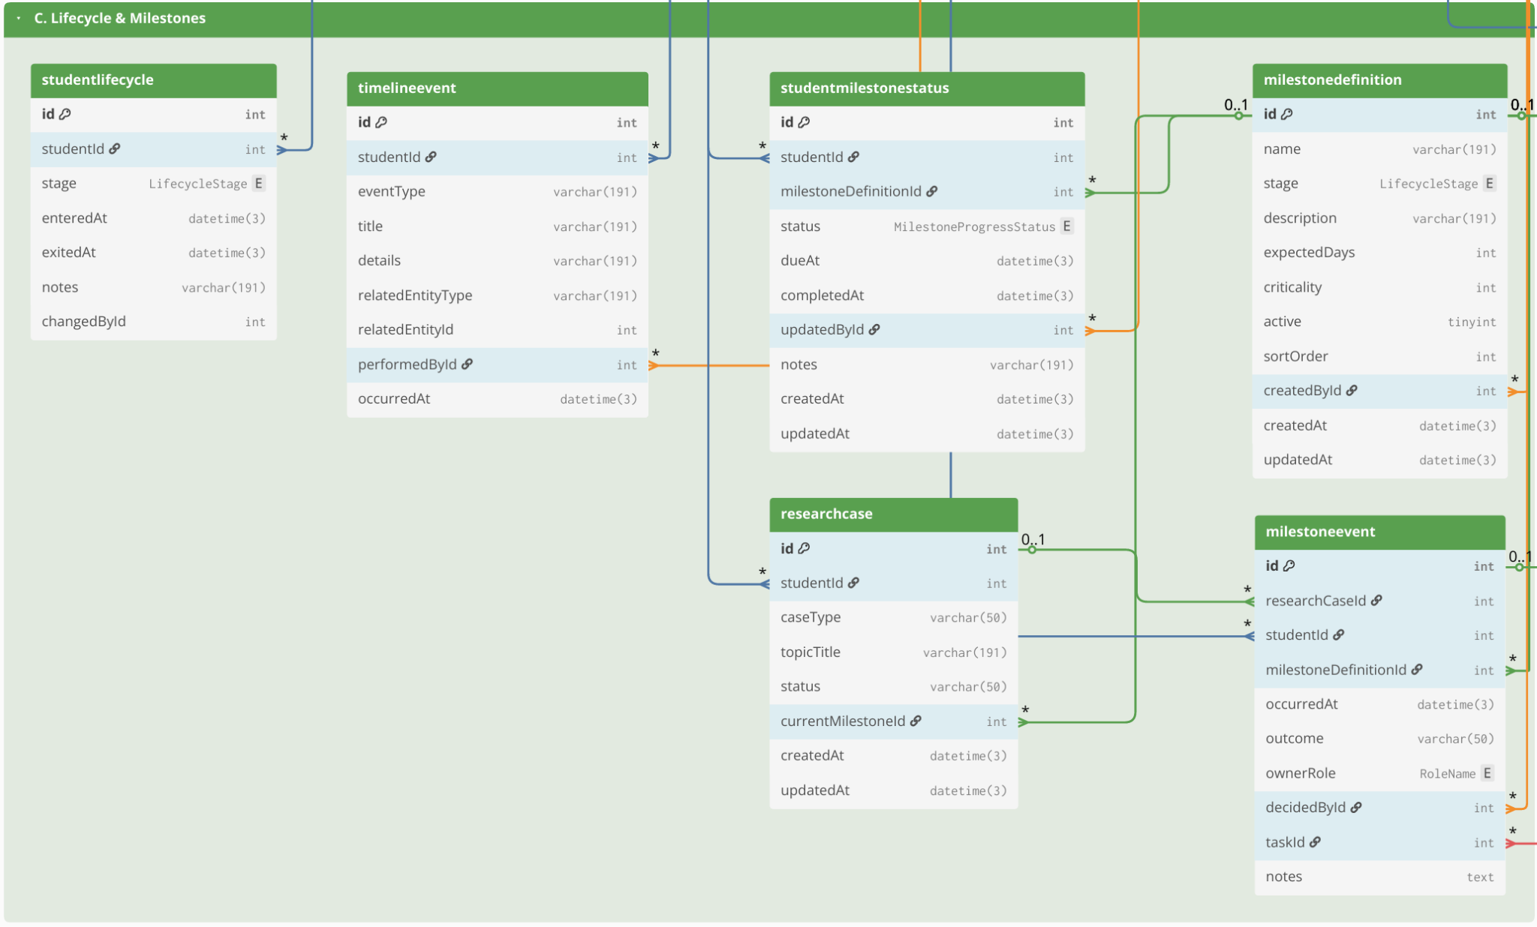Figure 7.3 Group C. Lifecycle & Milestones
This group provides the monitoring backbone for student standing and progress through lifecycle stages and requirements. It includes lifecycle stage history and milestone definitions (StudentLifecycle, MilestoneDefinition, StudentMilestoneStatus) and may also include the academic monitoring layer (AcademicTerm, TermEnrollment, CourseEnrollment, Course, Curriculum, StudyPlanItem, StudentCurriculumTag) when those signals are needed to support readiness views. The emphasis is on timestamped progress indicators (entered/exited stage, due/completion markers) that enable time-in-stage and overdue tracking.

D. Workflow Tasks & Decisions

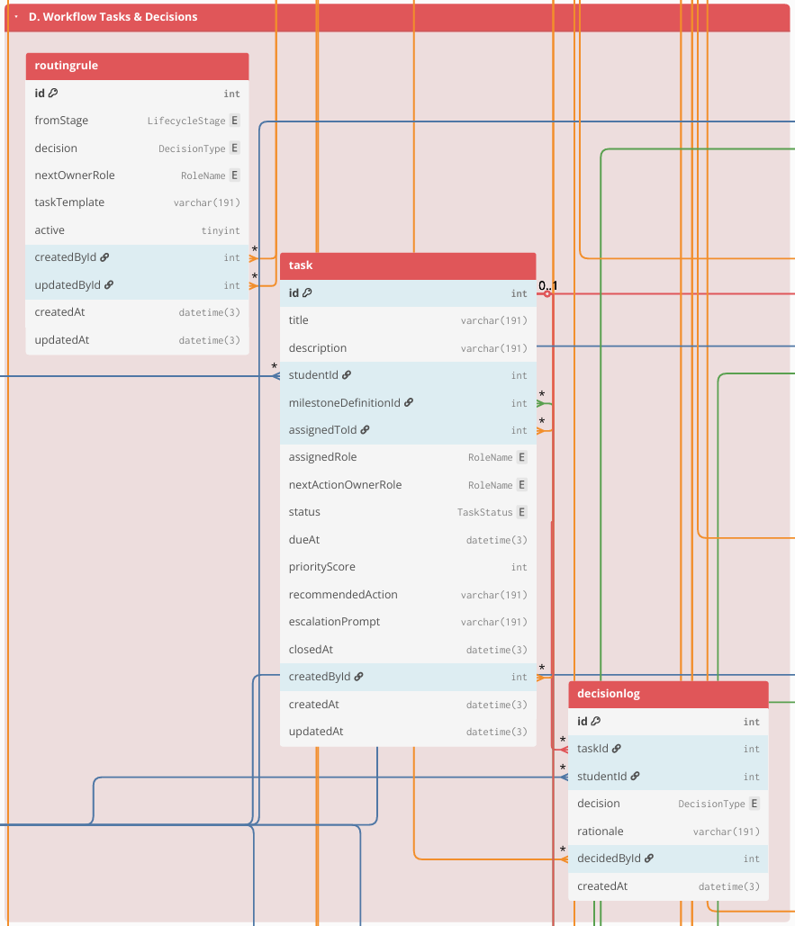

Figure 7.4 Group D. Workflow Tasks & Decisions
This group represents the operational “work queue” of the Graduate School. Workflow items are stored as Task records (owner, due date, priority/recommendations), and decisions are recorded as structured outcomes in DecisionLog (approve/revise/return), with routing rules handled through RoutingRule (or equivalent). Where the case-and-event approach is implemented, a student’s research engagement can be represented as ResearchCase, and milestone completion can be recorded as MilestoneEvent entries linked to tasks/decisions. This structure supports accountability (“who owns the next action”) and consistent decision traceability.
E. Documents & Revisions

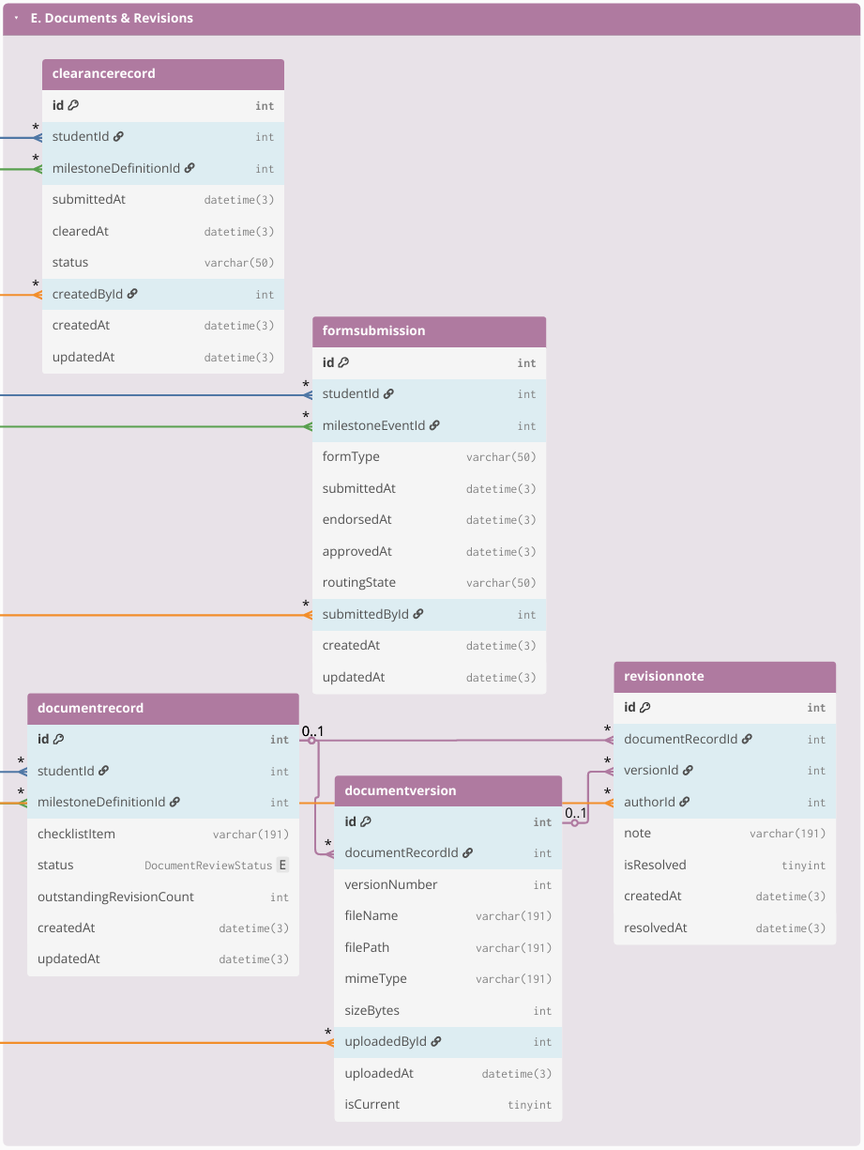

Figure 7.5 Group E. Documents & Revisions
This group stores evidence and version traceability for required submissions. Document requirements are represented through checklist-style records (DocumentRecord) and their uploaded versions (DocumentVersion), with revision and compliance tracking handled through RevisionNote (and status fields such as resolved/reopened). Where applicable, protocol-driven requirements and clearances are captured through FormSubmission and ClearanceRecord. The purpose is to keep a single, auditable reference for “what version was submitted,” “what revisions were required,” and “what is still pending.”
F. Scheduling & Coordination
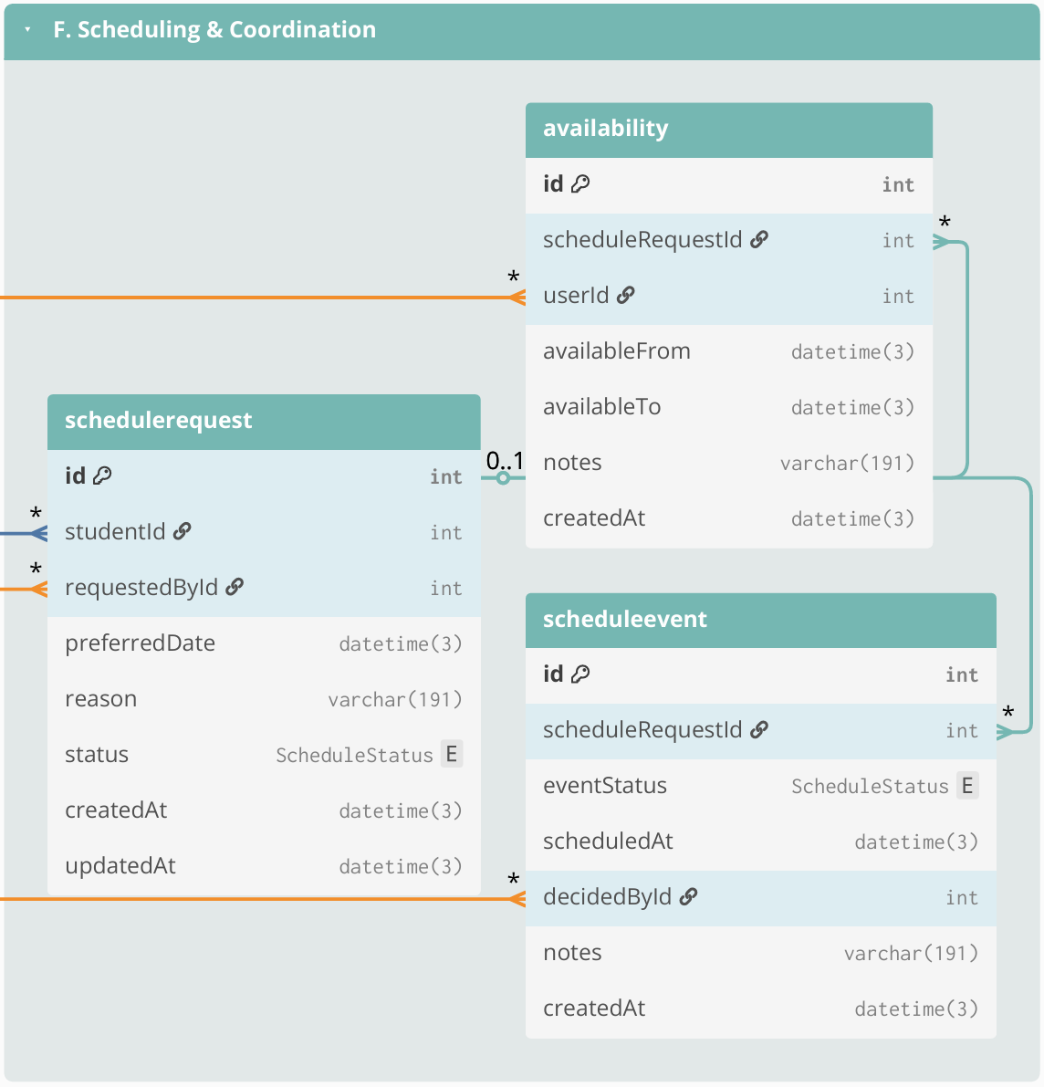

Figure 7.6 Group F. Scheduling & Coordination
This group manages scheduling process related to milestone activities (e.g., defenses and evaluations). Scheduling is stored using ScheduleRequest (request context and status), Availability (submitted availability windows), and ScheduleEvent (confirmed/rescheduled/cancelled outcomes with timestamps and decision actors). These records support scheduling cycle-time reporting and reduce back-and-forth coordination through email/chat by consolidating scheduling history in one place.
G. Monitoring, Alerts, and Interventions

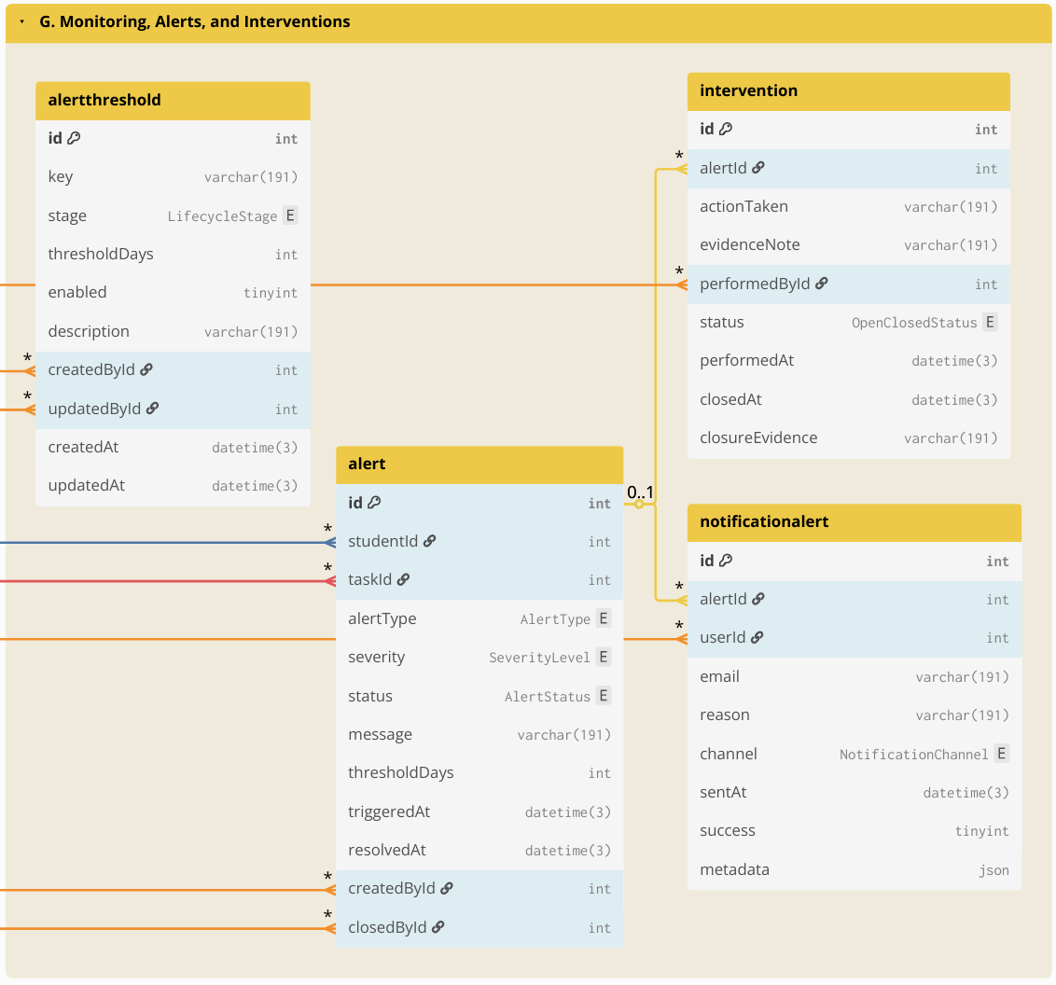

Figure 7.7 Group G. Monitoring, Alerts, and Interventions
This group supports proactive operational monitoring by turning derived indicators into actionable flags and follow-ups. Thresholds and rules may be stored in AlertThreshold (or equivalent), which are evaluated against timestamped monitoring signals (time-in-stage, overdue tasks, inactivity, delayed scheduling). Results are stored as Alert (or alert records) and notifications as NotificationAlert (who was notified, when, and why), while follow-up actions are tracked through Intervention (owner, due date, closure evidence/date). This enables early identification of delayed cases and operational follow-through.
H. Auditability
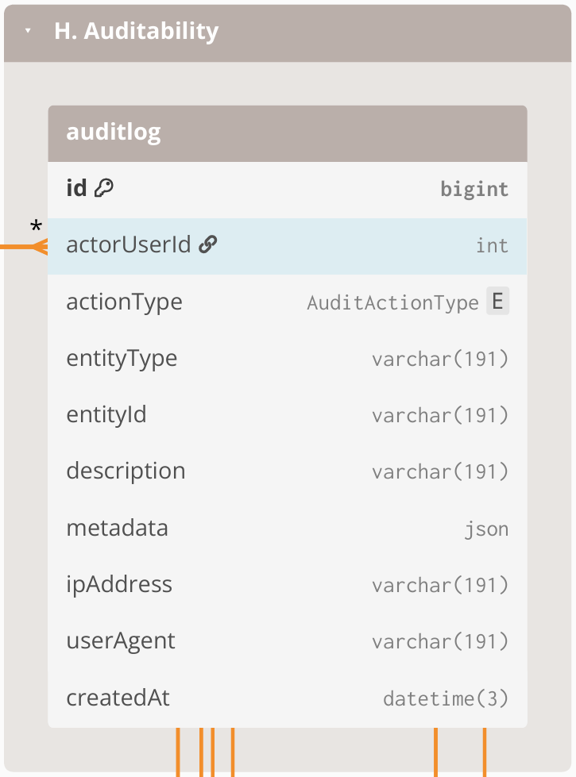

Figure 7.8 Group H. Auditability
This group provides accountability and traceability across the entire system. AuditLog is maintained as an append-only record of key events such as login/access attempts (including denied access), lifecycle transitions, task decisions, evidence uploads, scheduling outcomes, configuration changes, and notifications. Audit entries link to the acting user and store the affected record reference (entity type + entity ID), enabling traceability without requiring foreign keys from AuditLog to every table.

3.2.6.4 Computed Indicators for Prescriptive Analytics and Decision Support
To support descriptive monitoring and prescriptive decision support, operational data is transformed into computed indicators based on event history, timestamps, ownership assignments, decision outcomes, and evidence checklist status. These indicators serve as the system-generated inputs for prescriptive analytics and decision support. The computed indicators support (1) dashboards and monitoring views, such as counts per stage, pending queues, and aging or time-in-stage, and (2) rule-based recommendations such as queue prioritization, follow-up prompts, and escalation triggers. These indicators are computed from recorded events and completeness checks rather than from manually edited “current status” fields.
Computed indicator | Computed from | Decision-support use (how it drives prescriptive actions)
Current stage or milestone position | Latest MilestoneEvent per ResearchCase + MilestoneType ordering/definitions | Identifies where the case is now and which next action is relevant
Pending queue membership | MilestoneEvent with incomplete outcome + RoleAssignment owner + due date rules (if applicable) | Places cases into the correct role-based queue and enables prioritization
Aging or time-in-stage | Date difference between “now” and last MilestoneEvent timestamp, or between milestone timestamps | Flags stalled cases; triggers follow-up prompts and escalation when thresholds are reached
Overdue tasks and SLA breaches | Task due date (from process rules) vs current date + completion state | Generates “overdue” labels; recommends urgent follow-up or escalation
Scheduling cycle time | DefenseEvent request date to confirmed schedule date; reschedule count | Detects scheduling delays; recommends next coordination step and highlights repeated reschedules
Evidence completeness score | Required evidence checklist vs DocumentArtifact links for the milestone | Blocks completion when required evidence is missing; recommends what document to request
Decision outcome state | Latest decision outcome in MilestoneEvent (approve, revise, return) | Determines the next routing step; recommends who should act next
Prescriptive recommendation output | Rule-based checks applied to indicators above using policy-confirmed parameters | Produces recommended next actions, queue prioritization, and escalation prompts without automating final approvals

Table 13. Computed indicators from event history used for prescriptive analytics and decision support
This table shows that prescriptive analytics and decision support are based on system-generated indicators computed from timestamped events, ownership records, decision outcomes, and evidence completeness, rather than on manually maintained status fields. These computed indicators also serve as the structured inputs exposed for the Retrieval-Augmented Generation (RAG) through NotebookLM, so stakeholder-facing status explanations, completion rate analysis, and next-step prompts remain grounded on validated records and policy-confirmed logic.

3.2.6.5 Resource Planning
This subsection presents the resource requirements for implementing the proposed Graduate Student Lifecycle Monitoring and Analytics Platform. Since the Graduate School has a relatively small user population (approximately 400-500 students + staff) and the software stack is primarily open-source, the minimum cost of implementation can be kept low by leveraging existing school infrastructure. The major cost drivers are infrastructure availability (server and storage), routine system maintenance, and backup procedures. The following table summarizes the minimum resource requirements assuming existing campus resources, as well as the potential costs if additional resources are needed.
ON-SITE (On-Premises using existing infrastructure)
Item | Type | Cost | Potential Costs (if not existing) | Notes
Server hardware | One-time | ₱0 | ₱7,000–₱50,000 | Use an existing campus machine. Modest specs can support an MVP for a small graduate school with low concurrent usage.
OS + software stack | One-time | ₱0 | ₱0 | Open-source tools; no licensing fees.
HTTPS / SSL certificate | Annual | ₱0 | ₱0–₱5,000 | Free SSL via Let’s Encrypt; paid certificate optional depending on institutional policy.
Domain / subdomain | Annual | ₱0 | ₱800–₱1,500 | If USLS provides a subdomain under an existing domain, no additional cost.
Backups (storage + retention) | Monthly | ₱0 | ₱500–₱2,000 | Applies only if additional backup media/storage allocation or offsite copying is required.
IT operations (maintenance and support) | Monthly | ₱0 | Variable if there is an IT staff. | Patching, monitoring, user support, access management; typically absorbed by existing IT workload.
Email notification service (SMTP) | Monthly | ₱0 | ₱0–₱500 | Can use existing school email relay; external relay is optional for MVP use.
LLM API | Monthly/usage-based | ₱0 | ₱100–₱500 | Estimated for light MVP use only. If enabled, the LLM is used only for advisory outputs such as policy-grounded summaries, completion rate analysis, and next-step prompts. Official OpenAI pricing for GPT-4.1 is $2.00 per 1M input tokens, $0.50 per 1M cached input tokens, and $8.00 per 1M output tokens. Using a BSP reference rate of about ₱60.30 per US$1, this is roughly ₱120.60 per 1M input tokens, ₱30.15 per 1M cached input tokens, and ₱482.40 per 1M output tokens. A light MVP workload can reasonably stay around ₱100–₱400 per month, depending on prompt volume, retrieved context size, and output length.

Table 14. Cost table for on-site premises
This table summarizes the minimum (low-cost) resources required to deploy the platform either on-site (on-premises using existing campus infrastructure) and lists potential costs only when additional services are needed.
To minimize cost, the school may deploy the platform within the campus network using existing infrastructure. The minimum operational requirements are: (1) a stable host machine for the web application and database, (2) secured access controls (role-based access control and audit trail), and (3) backup and recovery procedures.
AI-assisted prescriptive recommendations, the system can operate fully without AI by keeping the feature flag disabled. If enabled, AI remains advisory only (no automatic decisions) and should only process aggregated, de-identified indicators. If the school wants zero additional cost and zero external processing, the AI feature remains OFF.

3.3 Workplan
This section presents the work timeline and sprint plan for the development of the Graduate Student Lifecycle Monitoring and Analytics Platform for the University of St. La Salle Graduate School. The workplan is divided into CAP-IT1 (primary build and internal validation) and CAP-IT2 (remaining refinements, stakeholder evaluation, and final packaging). CAP-IT1 carries the majority of implementation work, while CAP-IT2 focuses on evaluation-driven refinements and completion activities.

3.3.1 Target Accomplishment for CAP-IT1 (80% of IT development)
During CAP-IT1, the proponents aim to complete the main build of the proposed Graduate Student Lifecycle Monitoring and Analytics Platform. This phase will cover the primary implementation of the core platform, including user and access management, lifecycle and milestone management, workflow routing and decision tracking, document and revision management, scheduling and coordination, monitoring and alerts, analytics and reporting, and audit logging. By the end of CAP-IT1, the goal is to deliver an end-to-end working MVP with the main user interface, database, backend logic, and core module integrations already functioning. Initial testing and internal validation will also be conducted to confirm that the major monitoring, processing, and reporting features are already usable. This matches the workplan where CAP-IT1 is treated as the primary implementation phase for the system MVP.

3.3.2 Target Accomplishment for CAP-IT2 (20% of IT development)
During CAP-IT2, the proponents aim to complete the remaining 20% of the project through stakeholder evaluation, refinement, and final system improvement. This phase will focus on usability testing, user acceptance testing, workflow and dashboard refinements, access control and audit hardening, reporting polish, and final documentation and deployment preparation. In this phase, the proponents may also complete the limited prototype-level integration of the RAG-based policy and case guidance feature to support grounded policy and case interpretation, without making it the main implementation focus of the system. By the end of CAP-IT2, the goal is to deliver a more polished, validated, and defense-ready version of the platform. This follows the revised workplan, where CAP-IT2 is focused more on completion, refinement, and packaging rather than introducing new major modules.

3.3.3 CAP-IT1 Work Timeline
Development |  |  | May |  |  |  | Jun |  |  |  |  | Jul |  |  |  | Aug
# | Module | Activities | 4 | 11 | 18 | 25 | 1 | 8 | 15 | 22 | 29 | 6 | 13 | 20 | 27 | 3
1 | User & Access Management | Design role-based access interface (login, role dashboards)
 |  | Design RBAC database schema (users, roles, permissions)
 |  | Develop authentication and authorization prototype
 |  | Implement authentication logic, role-permission enforcement, and access validation rules
 |  | Conduct access testing
 |  | Sprint review and RBAC validation with stakeholders
2 | Lifecycle & Milestone Management | Design lifecycle stage interface
 |  | Design lifecycle database structure (stages, milestones, timestamps)
 |  | Prototype stage transition logic and milestone prerequisite checks
 |  | Implement lifecycle progression engine
 |  | Test stage gating and timestamp logging accuracy
 |  | Sprint review of lifecycle logic and milestone flow
3 | Workflow Routing & Decision Management | Design structured workflow queue interface
 |  | Design decision log and routing database schema
 |  | Prototype approve/revise/return decision pathways
 |  | Implement workflow routing engine and ownership reassignment
 |  | Conduct traceability and decision integrity testing
 |  | Sprint review on workflow clarity and ownership visibility
4 | Document & Revision Management | Design checklist and document submission interface
 |  | Design document metadata schema
 |  | Prototype document submission and revision tracking flow
 |  | Implement revision logging and checklist validation engine
 |  | Conduct version traceability testing
 |  | Sprint review of document tracking accuracy
5 | Scheduling & Coordination Management | Design scheduling request and availability interface
 |  | Design scheduling database
 |  | Prototype defense scheduling logic
 |  | Implement scheduling coordination engine
 |  | Conduct scheduling validation & sprint review
6 | Monitoring, Alerts & Intervention Engine | Design monitoring dashboard interface (risk indicators & alert views)
 |  | Design monitoring database logic (threshold rules, time-in-stage computation, escalation mapping)
 |  | Prototype automated alert detection logic
 |  | Implement monitoring and escalation engine (threshold evaluation + intervention logging)
 |  | Conduct alert accuracy testing (threshold validation & false-positive checks)
 |  | Sprint review of intervention logging and escalation clarity
7 | Analytics & Reporting | Design analytics dashboard layout (queue aging, bottleneck views, load metrics)
 |  | Design analytics aggregation schema reporting mart tables & computed metrics)
 |  | Implement reporting queries and dashboard visualizations
 |  | Conduct analytics validation testing (metric accuracy, aggregation consistency, cross-module data integrity)
 |  | Sprint review on reporting accuracy
8 | Database Audit | Design audit trail interface (activity log viewer & filtering tools)
 |  | Design append-only audit log schema (action logs, timestamp mapping, user-action trace)
 |  | Implement cross-module activity logging integration
 |  | Conduct audit integrity testing (log completeness, tamper resistance validation)
 |  | Sprint review on traceability coverage

Table 15.1. CAP-IT1 Work Timeline (80% target)
Table 15.1 outlines CAP-IT1 as the primary implementation phase where the system’s core modules are developed into an MVP. Modules correspond to the major components of the proposed lifecycle monitoring platform (e.g., core platform/RBAC, curriculum & study plan, enrollment/course audit, thesis/dissertation pipeline tracking, workflow routing and queues, evidence/document management, scheduling/LOA tracking, dashboards and audit logs), and analytics/reporting. Each sprint follows a consistent activity sequence (design → coding → testing → stakeholder feedback) to support iterative delivery.

3.3.4 CAP-IT2 Work Timeline
Development |  |  | Aug |  | Sep |  |  |  | Oct |  |  |  | Nov
# | Module | Activities | 24 | 31 | 7 | 14 | 21 | 28 | 5 | 12 | 19 | 26 | 2 | 9 | 16 | 23
9 | Evaluation Setup | Design structured usability and monitoring-interpretation evaluation instruments
 |  | Conduct pilot evaluation session
 |  | Finalize evaluation protocol for stakeholder sessions
10 | Stakeholder Usability / UAT | Conduct structured UAT Session 1 (Lifecycle tracking, Workflow routing validation)
Conduct structured UAT Session 2
(Monitoring alerts, Analytics dashboards, Access Control or Audit validation)
Consolidate findings
Document usability gaps and interpretation inconsistencies
11 | Refinements (Iteration 1) | Implement UI clarity improvements (dashboard readability, queue labeling, milestone visualization)
 |  | Refine workflow routing flows and decision-state clarity
Conduct full regression testing across Modules 1–8
(ensure refinements did not break monitoring, analytics, or access control logic)
12 | Access Control or Audit Hardening | RBAC scoping improvements
 |  | Audit log coverage + integrity checks
 |  | Regression testing
13 | Reporting & Export Polish | Access Control or Audit Hardening
Finalize export formats and endorsement-ready reporting outputs
(PDF/CSV exports, summary report structure validation)
14 | Documentation Finalization | Integrate final implementation updates into Chapter 3 & Chapter 4
 |  | Finalize User Guide and Admin Guide documentation
 |  | Clean appendix materials (BPMN, ERD, tables, architecture diagrams)
15 | Final Demo + Defense Prep | Package final build for deployment demonstration
 |  | Conduct final defense rehearsal and structured system walkthrough

Table 15.2. CAP-IT2 Work Timeline (20% target)
Table 15.2 outlines CAP-IT2 as the completion phase focused on stakeholder evaluation, refinement, and final packaging. Activities prioritize usability testing, validation of gate criteria and monitoring interpretations, RBAC/audit hardening, reporting polish, documentation finalization, and final defense readiness. CAP-IT2 intentionally concentrates on improving accuracy, interpretability, and stakeholder acceptability rather than introducing new major modules.

REFERENCES
Aiken, J. M., De Bin, R., Hjorth-Jensen, M., & Caballero, M. D. (2020). Predicting time to graduation at a large enrollment American university. PLOS ONE, 15(11), e0242334. https://doi.org/10.1371/journal.pone.0242334
Al-Nuaimi, H., et al. “Integration of Higher Education Systems Using APIs and Service-Oriented Architecture.” International Journal of Advanced Computer Science and Applications, 2022.
Althubiti, A., Alharthi, R., Alqarni, R., Alharthi, H., Alzahrani, F., Alotaibi, S., Al-Qahtaniy, M., & Alnfiai, M. (2024). Graduates’ progression tracking system. International Journal of Computer Science and Network Security, 24(6), 119–130. https://doi.org/10.22937/IJCSNS.2024.24.6.15
Aman, M. E. A., Delacruz, J. K. D., & (additional authors as listed in the paper). (2023). Career readiness of graduating BSA students of De La Salle University.
Arikpo, I., & Okokon, A. (2018). An automated scheduling system for university lectures and examinations. International Journal of Scientific and Engineering Research, 9, 809–813.
Arrieta, G. S., & Zulieta, N. B. (2024). Back to graduate school: Inputs for intervention program. Asia-Pacific Journal of Human Development and Family Studies (AHEAD), 3(1), 92–106.
Bernard, N. (2022). Graduate enrollment management: A case study on enrollment managers (Doctoral dissertation). ProQuest Dissertations & Theses Global.
Bíró, V., Hinnrichs, A., Krüger, I., Staack, V., Vössing, D., & Veit, V. (2012). Tracking learners’ and graduates’ progression paths: TRACKIT. European University Association.
Bizagi. (n.d.). Process modeling software: Bizagi Modeler. https://www.bizagi.com/en/platform/modeler
Brooke, J. (1996). SUS: A “quick and dirty” usability scale. In P. W. Jordan, B. Thomas, B. A. Weerdmeester, & I. L. McClelland (Eds.), Usability evaluation in industry (pp. 189–194). Taylor & Francis. https://www.taylorfrancis.com/chapters/edit/10.1201/9781498710411-35/sus-quick-dirty-usability-scale-john-brooke
Brooks, J. (2023). Monitoring the progress of doctoral students. Encyclopedia, 3, 1409–1418. https://doi.org/10.3390/encyclopedia3040101
Calora, P. O., Maranan, D. S., & Cerdeña, G. R. (2020). Exploring the potential of a ticketing-based student support system for open and distance e-learning institutions. International Journal on Open and Distance e-Learning (IJODeL), 6(2), 43–52.
Carcary, M. (2021). The research audit trail: Methodological guidance for application in practice. The Electronic Journal of Business Research Methods, 18(2). https://doi.org/10.34190/jbrm.18.2.008
Carmo, J. E. S., Lacerda, D. P., Klingenberg, C. O., & Piran, F. A. S. (2025). Digital transformation in the management of higher education institutions. Sustainable Futures, 9, 100692. https://doi.org/10.1016/j.sftr.2025.100692
Chart.js. (n.d.). Chart.js documentation. https://www.chartjs.org/docs/
Chio, M. E. B., Dal, P. M. M., Garrido, J. L., Baldelovar, A., & Saledaien, J. V. M. (2022). THESISIT: Web-based university thesis management portal with a defense scheduling system. Sci. Int. (Lahore), 34(6), 531–536.
Cieciora, M., Pietrzak, P., & Bołkunow, W. (2025). Graduate career tracking: A case study of a faculty of management in Poland. In Proceedings of the 11th International Conference on Higher Education Advances (HEAd’25) (pp. 331–338). Editorial Universitat Politècnica de València. https://doi.org/10.4995/HEAd25.2025.19973
Commission on Higher Education, Region IV-B MIMAROPA. (2018, August 6). Memorandum from the Regional Director: AY 2018–2019 annual higher education data collection (refers to CMO No. 45, Series of 2016). (Memorandum.)
Cruz, R. L., & DeLos Reyes, M. M. (2023). Using integer linear programming for university class scheduling in the College of Science in De La Salle University. (Thesis/Report). Animo Repository.
Datu, N. H. (2022). Compliance of higher education institutions (HEIs) with the Data Privacy Act of 2012: A case study approach (Dissertation). De La Salle University.
De Guzman, J. A. C. (2022). Using MS Power BI visualization and dashboard to improve financial reporting in a data analytics company. (Thesis).
Deleña, R. D., et al. (2025). Predicting student retention: A comparative study of machine learning approach utilizing sociodemographic and academic factors. Systems and Soft Computing, 7, 200352. https://doi.org/10.1016/j.sasc.2025.200352
Delos Santos, M. S. M. (2025). Thesis and dissertation advising preferences and best practices in the Philippines. Frontiers in Education, 10, 1541115. https://doi.org/10.3389/feduc.2025.1541115
Doce, L. J. P., & Ching, M. R. D. (2018). RA 10173 and its challenges to Philippine state universities and colleges’ compliance performance: The case of Mindanao State University – General Santos City. In Proceedings of the 2nd International Conference on E-commerce, E-Business and E-Government (ICEEG ’18). Association for Computing Machinery. https://doi.org/10.1145/3234781.3234789
Eclarin, B. A. (2020). Mariano Marcos State University IT-assets management system. (Thesis).
Essex, N. L. (2004). Confidentiality and student records: Ten ways to invite legal challenges. The Clearing House, 77(3), 111–113.
Express. (n.d.). Express: Node.js web application framework. https://expressjs.com/
Fielding, Roy. Architectural Styles and the Design of Network-Based Software Architectures. University of California, Irvine, 2000.
Figma. (n.d.). Guide to prototyping in Figma. https://help.figma.com/hc/en-us/articles/360040314193-Guide-to-prototyping-in-Figma
Flores, R. T. G., & Ching, M. R. D. (2018). Philippine SUCs compliance performance on RA 10173: A case study on Bukidnon State University. In Proceedings of the 2nd International Conference on E-commerce, E-Business and E-Government (ICEEG ’18). Association for Computing Machinery. https://doi.org/10.1145/3234781.3234790
Flores, R. T. G., & Ong, E. C. (2024). Exploring learning analytics: A case study of tertiary educators’ utilization and integration of AnimoSpace LMS in the online learning environment. In Proceedings of the 32nd International Conference on Computers in Education (ICCE 2024). Asia-Pacific Society for Computers in Education.
Gao, Yunfan, et al. “Retrieval-Augmented Generation for Large Language Models: A Survey.” arXiv, 2023.
GitHub. (n.d.). GitHub Issues documentation. https://docs.github.com/issues
Grooms, J., Kline, D., & Cummings, J. (2016). Streamlining the capstone process: A time-saving approval system for graduate theses/projects. Information Systems Education Journal, 14(4), 81–96.
Gutiérrez, F., Seipp, K., Ochoa, X., Chiluiza, K., De Laet, T., & Verbert, K. (2020). LADA: A learning analytics dashboard for academic advising. Computers in Human Behavior, 107, 105826. https://doi.org/10.1016/j.chb.2018.12.004
Hashim, H. B. (2025). Securing data transfer in MySQL cloud environments using role-based access control. International Journal of Computational and Applied Mathematics & Computer Science, 5, 66–72. https://doi.org/10.37394/232028.2025.5.8
Hillison, W., Pacini, C., & Williams, P. F. (2000). Confidentiality of student records in the electronic frontier: Professors’ and administrators’ obligations. Journal of Accounting Education, 18(4), 301–313. https://doi.org/10.1016/S0748-5751(01)00003-3
Huang, M., Wang, Y., Dai, X., & Chang, J. (2024). Online cloud management and quality monitoring of the whole process of undergraduate thesis. Applied Mathematics and Nonlinear Sciences, 9(1). https://doi.org/10.2478/amns.2023.2.00591
Hyzy, M., Bond, R., Mulvenna, M., Bai, L., Dix, A., Leigh, S., & Hunt, S. (2022). System Usability Scale benchmarking for digital health apps: Meta-analysis. JMIR mHealth and uHealth, 10(8), e37290. https://doi.org/10.2196/37290
International Organization for Standardization. (2018). ISO 9241-11:2018 Ergonomics of human-system interaction—Part 11: Usability: Definitions and concepts. https://www.iso.org/standard/63500.html
International Organization for Standardization. (2011). ISO/IEC 25010:2011 Systems and software engineering—Systems and software quality requirements and evaluation (SQuaRE)—System and software quality models. https://www.iso.org/standard/35733.html
International Organization for Standardization. (2008). ISO/IEC 25012:2008 Software engineering—Software product Quality Requirements and Evaluation (SQuaRE)—Data quality model. https://www.iso.org/standard/35736.html
Joint Task Force. (2020). Security and privacy controls for information systems and organizations (NIST Special Publication 800-53, Revision 5). National Institute of Standards and Technology. https://doi.org/10.6028/NIST.SP.800-53r5
Jones, C., Wilkes, J., Murphy, N., & Smith, C. (2016). Service level objectives. In B. Beyer, C. Jones, J. Petoff, & N. R. Murphy (Eds.), Site reliability engineering: How Google runs production systems. O’Reilly Media. https://sre.google/sre-book/service-level-objectives/
Jones, M., Bradley, J., & Sakimura, N. (2015). JSON Web Token (JWT) (RFC 7519). Internet Engineering Task Force. https://datatracker.ietf.org/doc/html/rfc7519
Kamala, K., & Kamalakar, G. (2023). Academic leadership and governance of higher education. Indian Journal of Social Research, 64, 159–172.
Khader, A. A. H., & Mahmoud, W. W. (2025). Graduate student management system: Enhancing organization in the academic department. International Research Journal of Innovations in Engineering and Technology (IRJIET), 9(3), 239–248. https://doi.org/10.47001/IRJIET/2025.903032
Khosravi, H., Shabaninejad, S., Bakharia, A., Sadiq, S., Indulska, M., & Gašević, D. (2021). Intelligent learning analytics dashboards: Automated drill-down recommendations to support teacher data exploration. Journal of Learning Analytics, 8(3), 133–154. https://doi.org/10.18608/jla.2021.7279
Klensin, J. (2008). Simple Mail Transfer Protocol (RFC 5321). Internet Engineering Task Force. https://datatracker.ietf.org/doc/html/rfc5321
Lee, W. C., Holloman, T. K., Knight, D. B., Huggins, N., Matusovich, H. M., & Brisbane, J. (2024). Catalyzing organizational change for equity in graduate education: A case study of adopting collective impact in a college of engineering. Education Sciences, 14(3), 292. https://doi.org/10.3390/educsci14030292
Lewis, Patrick, et al. “Retrieval-Augmented Generation for Knowledge-Intensive NLP Tasks.” Advances in Neural Information Processing Systems, 2020.
Masiello, I., Mohseni, Z., Palma, F., Nordmark, S., Augustsson, H., & Rundquist, R. (2024). A current overview of the use of learning analytics dashboards. Education Sciences, 14, 82. https://doi.org/10.3390/educsci14010082
Mendoza, A. D., & Mendoza, L. M. D. (2023). Students’ life concerns and graduate school journey. International Journal of Science and Management Studies, 6(6), 107–117. https://doi.org/10.51386/25815946/ijsms-v6i6p107
Mendoza, L., Lindblom-Ylänne, S., Lehtonen, T., & Hyytinen, H. (2022). Writing a master’s thesis: Associations between the grade, self-efficacy for thesis writing, approaches to writing, and experiences of the thesis as a teaching and learning environment. Journal of Writing Research, 14(2), 257–286. https://doi.org/10.17239/jowr-2022.14.02.04
Monash University. (2024, June 30). Graduate research progress management procedure (Version 1.0).
Montalban, L. J. T. (2023). Record management with a decision support system for faculty and employees association. Open Access Research Journal of Engineering and Technology, 4(2), 018–023. https://doi.org/10.53022/oarjet.2023.4.2.0059
MySQL (Oracle). (n.d.). CREATE VIEW statement. MySQL Reference Manual. https://dev.mysql.com/doc/refman/8.2/en/create-view.html
MySQL (Oracle). (n.d.). FOREIGN KEY constraints. MySQL documentation. https://dev.mysql.com/doc/en/create-table-foreign-keys.html
MySQL (Oracle). (n.d.). Introduction to InnoDB. MySQL 8.0 Reference Manual. https://docs.oracle.com/cd/E17952_01/mysql-8.0-en/innodb-introduction.html
Nurkamto, J., Djatmika, D., & Prihandoko, L. A. (2022). Students’ problems of academic writing competencies, challenges in online thesis supervision, and the solutions: Thesis supervisors’ perspectives. TEFLIN Journal, 33(1), 123–147. https://doi.org/10.15639/teflinjournal.v33i1/123-147
Onunga, J. O. (2020). Information systems audit framework to improve the quality of audit in higher education in East Africa. Open Journal for Information Technology, 3(2), 53–62. https://doi.org/10.32591/coas.ojit.0302.02053o
OpenAI. (n.d.). Data controls in the OpenAI platform. https://developers.openai.com/api/docs/guides/your-data/
OpenAI. (n.d.). Responses API reference. https://developers.openai.com/api/reference/resources/responses/
OWASP. (2021). OWASP Application Security Verification Standard (ASVS), Version 4.0.3 [PDF]. https://raw.githubusercontent.com/OWASP/ASVS/v4.0.3/4.0/OWASP%20Application%20Security%20Verification%20Standard%204.0.3-en.pdf
Pan, Z., Biegley, L., Taylor, A., & Zheng, H. (2024). A systematic review of learning analytics–incorporated instructional interventions on learning management systems. Journal of Learning Analytics, 11(2), 52–72. https://doi.org/10.18608/jla.2023.8093
Paulsen, L., & Lindsay, E. (2024). Learning analytics dashboards are increasingly becoming about learning and not just analytics: A systematic review. Education and Information Technologies, 29, 14279–14308. https://doi.org/10.1007/s10639-023-12401-4
Perera, M. P. L., & Vidanagama, D. U. (2020). A web-based paperless meeting management system. In Proceedings of the 11th International Research Conference, General Sir John Kotelawala Defence University.
Philippine Normal University, Student Affairs and Services Office. (2024). Graduate student handbook (2024 ed.). Philippine Normal University.
Pitogo, V. (2019). National government agency’s compliance on Data Privacy Act of 2012: A case study. Journal of Physics: Conference Series, 1201(1), 012021. https://doi.org/10.1088/1742-6596/1201/1/012021
Podobnikar, T. (2025). Bridging perceived and actual data quality: Automating the framework for governance reliability. Geosciences, 15(4), 117. https://doi.org/10.3390/geosciences15040117
Prisma. (n.d.). Prisma Migrate documentation. https://www.prisma.io/docs/orm/prisma-migrate
Prisma. (n.d.). Prisma ORM documentation. https://www.prisma.io/docs/orm
Purcia, E. L., & Velarde, A. (2022). Student registration and records management services of the three private universities in the Philippines: Basis for academic records digitization. American Journal of Multidisciplinary Research and Innovation, 1(4), 1–10. https://doi.org/10.54536/ajmri.v1i4.447
Rapada, V. P., Jr. (2023). Factors affecting the delay in the completion of the masters degree among CAR (complete academic requirement) holder teachers in Borongan City Division: Inputs for a proposed extension projects. AD ALTA: Journal of Interdisciplinary Research, 14(2).
React. (n.d.). Using TypeScript. React documentation. https://react.dev/learn/typescript
Republic Act No. 10173. (2012). Data Privacy Act of 2012 (Philippines).
Reyes, C. T. (2018). Developing a student support system through learning analytics for undergraduates at the University of the Philippines Open University. Foundation for Information Technology Education and Development, Inc. (FIT-ED).
Sancon, R. J. S. (2023). Data privacy best practices of a local higher educational institution: A model for governance. IOER International Multidisciplinary Research Journal. https://doi.org/10.54476/ioer-imrj/688585
Semler, R. F., Semler, J. R., Wehrmeister, M. A., Southier, L. F. P., Casanova, D., & Teixeira, M. (2025). Educational process mining: Literature classification, gaps, and emerging opportunities. Frontiers in Education, 10, 1543761. https://doi.org/10.3389/feduc.2025.1543761
Silva, C., Barraca, J. P., & Salvador, P. (2025). Proactive data categorization for privacy in DevPrivOps. Information, 16(3), 185. https://doi.org/10.3390/info16030185
Sorour, A., & Atkins, A. S. (2024). Big data challenge for monitoring quality in higher education institutions using business intelligence dashboards. Journal of Electronic Science and Technology, 22, 100233. https://doi.org/10.1016/j.jnlest.2024.100233
Susnjak, T., Ramaswami, G. S., & Mathrani, A. (2022). Learning analytics dashboard: A tool for providing actionable insights to learners. International Journal of Educational Technology in Higher Education, 19, 12. https://doi.org/10.1186/s41239-021-00313-7
Tailwind CSS. (n.d.). Styling with utility classes. https://tailwindcss.com/docs/styling-with-utility-classes
Tanate-Lazo, R. J. C., & Cabonero, D. A. (2021). Philippine Data Privacy Law: Is it implemented in a private university library, or not? Library Philosophy and Practice.
TechnoScience Academy. (2025). Decoding role-based access control (RBAC). International Journal of Scientific Research in Computer Science Engineering and Information Technology, 11(1), 2082–2090. https://doi.org/10.32628/cseit251112211
The University of Adelaide. (2020). Research student handbook 2020. The University of Adelaide.
Ulanday, M. L. P., Verdejo, M. N., Cayanan, E. N., Santos, J. A., & Obispo, R. D. (2024). Making decisions: An analysis of styles and time pressure among selected graduate students in the Philippines. Diversitas Journal, 9(Special Issue 1), 193–202. https://doi.org/10.48017/dj.v9iSpecial1.2832
University of the Free State, Centre for Graduate Support. (2023). Graduate research management (GRM): Manual for postgraduate students 2023. University of the Free State.
University of the Philippines Los Baños, Graduate School. (2010). Graduate school organization, policies, rules and regulations (Revised 2010). University of the Philippines Los Baños.
van Lill, M. H. (2024). A study of doctoral time-to-degree in selected disciplines at South African public universities. South African Journal of Higher Education, 38(1), 168–188. https://doi.org/10.20853/38-1-6268
Wambsganss, T., & Schmitt, A. (2024). Enhancing personalized learning through process mining: A taxonomy and design patterns approach. Business & Information Systems Engineering. Advance online publication. https://doi.org/10.1007/s12599-024-00901-7
Willess, B. J. (2023). A mixed methods design exploring factors and experiences of Ed.D. graduates and time to degree (Doctoral dissertation). California State University, San Bernardino.
World Bank. (2022). Digital transformation of Philippine higher education (Report No. AUS0002964). World Bank.
Young, M. E., Miller, M., Urban, C., & Petrescu, C. (2024). Tracking student progress through graduate programs. Discover Education, 3, 43. https://doi.org/10.1007/s44217-024-00129-3

GLOSSARY OF TERMS
Academic Coordinator (AC) – The Graduate School personnel responsible for many academic monitoring tasks such as checking student progress, reviewing requirements, and helping prepare reports.
Academic operations – The day-to-day work involved in managing Graduate School processes, such as monitoring student progress, checking requirements, preparing reports, and coordinating actions.
Access control – A system feature that limits what each user can view or do based on their assigned role.
Admissions handoff – The stage where admission-related results or records are passed to the Graduate School for monitoring and follow-through.
Adviser / Research Adviser – The faculty member assigned to guide a student in thesis, dissertation, or other research work.
Adviser designation – The process of officially assigning a research adviser to a student.
Aging / Queue aging – The amount of time a case or task has remained pending without being completed.
Agile – A development approach where a system is built and improved in small working parts through repeated feedback.
AIMS – The existing university system used for official academic and student records. In this study, it is treated as an existing institutional system and not something to be replaced.
Analytics – The use of data to produce summaries, trends, reports, and insights that help users understand what is happening.
Append-only audit log – A record of system actions where entries are only added and not deleted, so past actions remain traceable.
Approval sheet – A required document used to confirm that a student has completed a particular academic or research requirement.
Attrition – A situation where a student leaves the program without completing it.
Audit trail – A traceable record showing who performed an action, what was done, and when it happened.
Auditability – The ability of a system to provide records that can be checked later for review and accountability.
Backlog – The list of planned features, tasks, and requirements for the system.
Bottleneck – A point in the process where work slows down because of delays, missing requirements, or too much manual coordination.
BPMN (Business Process Model and Notation) – A standard way of drawing process flows to show tasks, decisions, handoffs, and the roles involved.
Case – A student record or process instance being monitored by the system, such as a leave request, defense schedule, or graduation endorsement.
Case monitoring – The process of tracking a case over time to see if it is moving properly, delayed, or missing requirements.
Checklist – A list of required documents, actions, or conditions that must be completed at a certain stage.
Clearance – Official confirmation that a requirement has been satisfied.
Closed-door final defense – A final defense stage that is conducted privately before the public final defense, depending on the research protocol.
Cohort – A group of students considered together, usually based on program, year level, or academic entry period.
Completion evidence – Documents, records, or status entries that prove a student has completed a requirement or milestone.
Completion marker – A status sign that shows a required stage or activity has been completed.
Completion rate – The percentage of students or cases that successfully completed a required step or process.
Compliance monitoring – The checking of whether students or cases are following required policies, rules, and academic procedures.
Conceptual framework – The part of the study that shows how the problem, inputs, processes, system features, and expected outputs are connected.
Consolidated group view – A combined view where many student records can be seen together in one place instead of checking them one by one in separate files.
Course audit – A review of completed and remaining subjects based on the student’s curriculum.
Course offerings – The subjects that the Graduate School plans to open in a given term.
Course offerings decision support – System-generated information that helps the Graduate School decide which subjects should be offered.
Curriculum alignment – Ensuring that a student is matched with the correct curriculum and subject requirements.
Curriculum version – A specific version of a program curriculum that applies to a particular batch or student group.
Cycle time – The total time it takes for a case or process step to move from start to completion.
Dashboard – A screen that shows summarized information such as status counts, pending items, delays, and alerts.
Data privacy – The protection of sensitive student information so that it is only accessible to authorized users.
Decision log – A record of decisions made in the system, including the action taken, the person responsible, and the date.
Decision outcome – The result of a review or action, such as approved, returned, revised, endorsed, or denied.
Decision support – System-generated help such as summaries, reports, alerts, or recommendations that assist users in making decisions.
Dean – The Graduate School authority who approves or confirms certain actions such as leave of absence, withdrawal, or endorsement-related matters.
Defense scheduling – The process of arranging the date, time, and participants for a title, proposal, or final defense.
Delayed case – A case that has stayed too long in one stage or has not progressed within the expected period.
Derived indicator / Computed indicator – A value that is calculated from existing records, timestamps, and status entries instead of being manually typed in.
Document checklist – A list of required documents for a certain stage or process.
Document version – A specific copy or revision of a file used to track changes over time.
Document tracking – Monitoring what has been submitted, what is missing, and what still needs revision.
Email-based coordination – A process where updates, approvals, and follow-ups are mainly done through email instead of through one centralized system.
Encoding – The act of manually entering or updating data into a file or system.
Enrollment confirmation – The recorded status that shows whether a student is officially enrolled or active for a term.
Endorsement – A formal approval or recommendation that allows a student to move to the next academic or administrative stage.
Endorsement list – A prepared list of students or cases that are ready to be forwarded for the next official step.
Entity-Relationship Diagram (ERD) – A diagram that shows the database tables and how they are connected.
Escalation – The act of forwarding a case to a higher authority or role when attention or action is urgently needed.
Ethics clearance / Ethics review – A formal research approval process required for studies involving ethical review.
Evidence – A document, status entry, or recorded action used to prove that something happened or was completed.
Final defense – The research stage where the student presents the completed study for formal evaluation.
Follow-up – A reminder or action made to move a pending, delayed, or incomplete case forward.
Form 1 to Form 10 – The Graduate School research protocol forms used to document major research stages such as title defense, adviser designation, proposal review, final defense, technical review, and approval.
Gate / Milestone gate – A required checkpoint that must be passed before a student can move to the next stage.
Gate criteria – The required conditions, evidence, and decisions needed for a case to pass a stage.
Graduate School monitoring layer – The role of the proposed system as a support and visibility platform for monitoring Graduate School processes without replacing official institutional systems.
Graduate student lifecycle – The full student journey from admission up to graduation endorsement, including enrollment, coursework, leave of absence, readmission, research milestones, practicum when applicable, withdrawal, and graduation processing.
Graduation candidate list – A report showing which students appear ready for graduation endorsement based on monitored requirements.
Graduation endorsement – The Graduate School’s confirmation that a student appears ready to proceed to the official graduation process.
Handoff – The transfer of responsibility, information, or status from one person, office, or stage to another.
Human error – Mistakes that happen during manual checking, counting, encoding, or report preparation.
IAM (Identity and Access Management) – The part of the system that handles user accounts, roles, permissions, and access levels.
INC – A subject status meaning incomplete.
In-scope – Included within the intended coverage of the study or system.
Interoperability – The ability of the system to exchange or work with data from other systems when allowed.
Intervention – An action taken to address a delayed, stalled, or problematic case.
Ishikawa diagram / Fishbone diagram – A tool used to identify and organize the possible causes of a problem.
JWT (JSON Web Token) – A standard token used in web systems for user authentication and secure access.
KPI (Key Performance Indicator) – A measurable value used to check whether a process, module, or system is performing as expected.
Leave of Absence (LOA) – An approved temporary break from studies.
Lifecycle stage – A major part of the student journey, such as admission, enrollment, research, leave, withdrawal, or graduation.
Lifecycle status – The student’s current recorded position in the graduate student lifecycle.
LLM (Large Language Model) – The AI model used in the proposed decision-support feature to generate summaries or responses based on approved data.
Loading – Entering or importing records into the system.
Manual consolidation – The process of combining information from different files or sources by hand.
Manual coordination – A process that depends on checking separate files, sending emails, and following up manually instead of using one shared system.
Manuscript – The student’s thesis, dissertation, or research paper being reviewed and revised.
Manuscript finalization – The last stage of preparing the research document before completion or endorsement.
Milestone – A key checkpoint in student progress, especially in research, such as title approval, proposal defense, or final defense.
Milestone-based tracking – Monitoring progress using major checkpoints and approvals instead of only general enrollment records.
Monitoring – The continuous checking of student status, pending requirements, delays, and next actions.
Monitoring artifact – Any file, form, spreadsheet, or record currently used to help monitor student progress.
Monitoring signal – A status, event, document, or date that helps show the current condition of a student or case.
MOA (Memorandum of Agreement) – A formal agreement document often used for practicum or external placement requirements.
MVP (Minimum Viable Product) – The earliest usable version of the system with only the core features needed for initial testing and validation.
Next action – The immediate step that needs to be completed so the case can move forward.
Next-action owner – The person or role currently responsible for doing the next required step.
Non-functional requirements – System requirements related to quality, such as security, usability, reliability, maintainability, and performance.
Official record – The formal record maintained by the proper office or institutional system.
Operational dashboard – A dashboard focused on day-to-day work such as pending items, delays, watchlists, and cases needing action.
Operational oversight – The ability to clearly see what is happening across many cases and process stages.
ORM (Object-Relational Mapping) – A development tool that makes it easier to work with database records through code.
Out-of-scope – Not included within the intended coverage of the study or system.
Ownership mapping – A clear identification of which office or role is responsible for each process or task.
Panel – The group of evaluators assigned to assess a student during a defense.
Panel chair – The lead member of the defense panel who helps organize the review and discussion.
Pending – Waiting for action, review, approval, or completion.
Pending queue – A list of cases or tasks waiting for action from a specific person or role.
Performance – How efficiently and responsively the system works.
Policy-confirmed parameter – A rule or system setting based on confirmed Graduate School policy.
Prescriptive analytics – Analytics that not only describe the current situation but also suggest what action should be taken next based on rules and recorded data.
Practicum – A program-related requirement involving supervised fieldwork, placement, or practice-based learning.
Privacy boundary – The limit that defines who can see particular information in the system.
Program-dependent – A requirement or process that applies only to certain programs and not to all students.
Project owner / Product Owner – The team role responsible for helping define priorities and organize development work.
Proposal defense – A research milestone where the student presents and defends the proposed study before proceeding further.
Prototype – An early working version of the system used for review, feedback, and testing.
Public defense / Public final defense – A defense stage that is publicly announced or opened according to the research protocol.
Queue – A list of tasks or cases waiting for action.
Queue prioritization – The process of deciding which tasks or cases should be acted on first.
RBAC (Role-Based Access Control) – A security method where user access depends on their role.
Readiness check – A check to confirm whether a student or case has met the requirements to move to the next stage.
Readmission – The process of returning to active student status after an approved leave of absence.
Record completeness – The condition in which all required fields, documents, or details are present.
Registrar-side system – The official academic records system maintained by the Registrar and not replaced by the proposed platform.
Reliability – The ability of the system to work consistently and keep dependable records.
Research case – A student’s tracked research progress, including research milestones and related requirements.
Research Coordinator / Research Class Coordinator – The Graduate School role responsible for helping monitor research-related requirements, scheduling, and progress.
Residency – The allowed or monitored period within which a graduate student is expected to complete the program.
REST API – A structured way for the frontend and backend of a system to exchange data.
Revision cycle – The repeated process of receiving comments, making revisions, resubmitting, and waiting for confirmation.
Role lane – In a BPMN diagram, the section showing which role is responsible for a particular task.
Root cause analysis – A method used to identify the deeper reasons behind a problem.
Routing – Sending a task, case, or request to the correct next step or responsible role.
Schedule request – A formal request to set a defense or milestone schedule.
Schedule outcome – The result of the scheduling process, such as confirmed, rescheduled, or cancelled.
Scheduling cycle time – The total time from the scheduling request to the final confirmed schedule.
Scheduling tracker – The part of the system that records scheduling requests, confirmations, and changes.
Scope creep – The gradual expansion of a project beyond its original purpose or limits.
Scrum – A practical Agile framework where work is done in short, focused development cycles called sprints.
Semester taken / Academic Year and Semester Taken – The academic year and semester when a student actually took a subject.
Sprint – A short work period in Agile development during which a set of planned tasks is completed.
Sprint review – A meeting where the team checks what was built and collects feedback.
Stakeholder – Any person or office involved in or affected by the process, such as students, staff, coordinators, advisers, panel members, and the Dean.
Stakeholder validation – The process of confirming with actual users or personnel that the study’s descriptions, assumptions, and requirements are correct.
Stage marker – A recorded sign showing where a student is currently positioned in the process.
Start-stop / Stop-start process – A process that can pause and later continue, such as leave of absence and readmission.
Status confirmation – The act of verifying a student’s actual standing using records and supporting evidence.
Status tagging – Assigning a clear label such as active, LOA, readmitted, withdrawn, or endorsed.
Structured event capture – Recording actions in a standard format that includes details such as date, actor, outcome, and related case.
Study plan – The list and sequence of subjects that a student is expected to complete under the correct curriculum.
Subject needs – The subjects that students still need to take, often used for planning course offerings.
Task – A recorded action item assigned to a person or role.
Task queue – A list of open tasks waiting for action by a user or role.
Technical review certificate – A document that confirms a required technical review has been completed.
Term activation – Marking a student as active for a particular academic term.
Thesis / Dissertation pipeline – The series of linked research stages from adviser designation up to final completion.
Time in stage / Time-to-stage – The amount of time a case has stayed in a particular process stage.
Time-to-degree – The total length of time it takes for a student to complete the degree.
Timestamp – The recorded date and time of an event, status update, or action.
Title defense – An early research milestone where the student presents the proposed research title for approval.
TO-BE system – The improved or proposed version of the process or platform.
Traceability – The ability to follow what happened, who did it, and when it happened across the process.
Turnaround time – The time needed to complete a process, action, or request after it has started.
UAT (User Acceptance Testing) – Testing performed by intended users to confirm that the system is understandable, useful, and aligned with real work processes.
Unified monitoring system / Unified view – A single place where users can see student status, progress, pending items, ownership, and next actions without checking many separate records.
Usability – How easy the system is to understand and use correctly.
Validation – The process of checking whether data, process details, or system rules are correct.
Version control – A method of tracking changes to files or source code over time.
Visibility – How easily users can see the true current status, pending items, delays, and next steps in the process.
Watchlist – A list of cases that need closer monitoring because they may be delayed or require attention.
Withdrawal – The formal process of leaving the graduate program.
Workflow – The sequence of tasks, approvals, handoffs, and decisions that move a case from one stage to another.
Workflow routing – The logic that determines where a task or case goes next after an action or decision.

LIST OF ACRONYMS
AC – Academic Coordinator
AIMS – Academic Information Management System
AY – Academic Year
BPMN – Business Process Model and Notation
ERD – Entity-Relationship Diagram
GS – Graduate School
IAM – Identity and Access Management
INC – Incomplete
JWT – JSON Web Token
KPI – Key Performance Indicator
LLM – Large Language Model
LOA – Leave of Absence
MOA – Memorandum of Agreement
MVP – Minimum Viable Product
ORM – Object-Relational Mapping
RBAC – Role-Based Access Control
REST API – Representational State Transfer Application Programming Interface
UAT – User Acceptance Testing

APPENDICES

Appendix A. BPMN Workflows

Appendix A.1. Admission

Appendix A.2. : Enrollment


Appendix A.3. Course Adjustments


Appendix A.4. Coursework


Appendix A.5. Leave of Absence and Readmission


Appendix A.6. Title Defense


Appendix A.7. Advisor Designation


Appendix A.8. Thesis/Dissertation Pipeline (Milestone Workflow)


Appendix A.9. Defense and Revisions
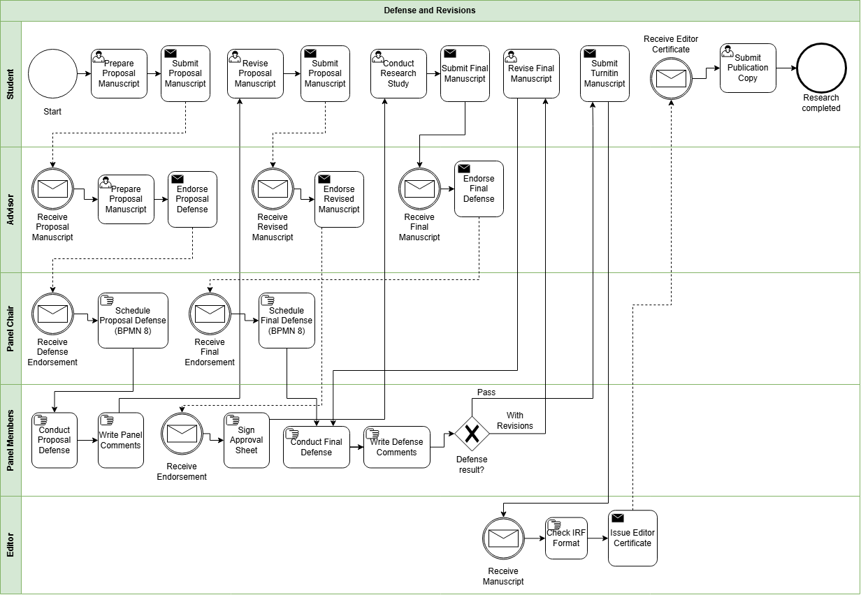
Appendix A.10. Practicum
Appendix A.11. Withdrawal

Appendix A.12. Graduation


Appendix B. Ishikawa Diagram – Root Causes of Difficulty in Monitoring and Processing Graduate Student Progress


Appendix C. Conceptual Framework Diagram

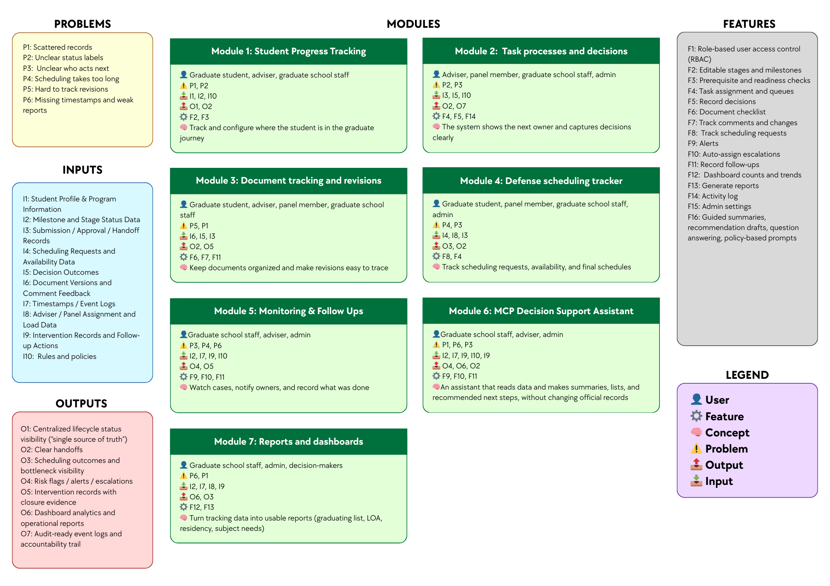

Appendix D. High-Level System Architecture Diagram
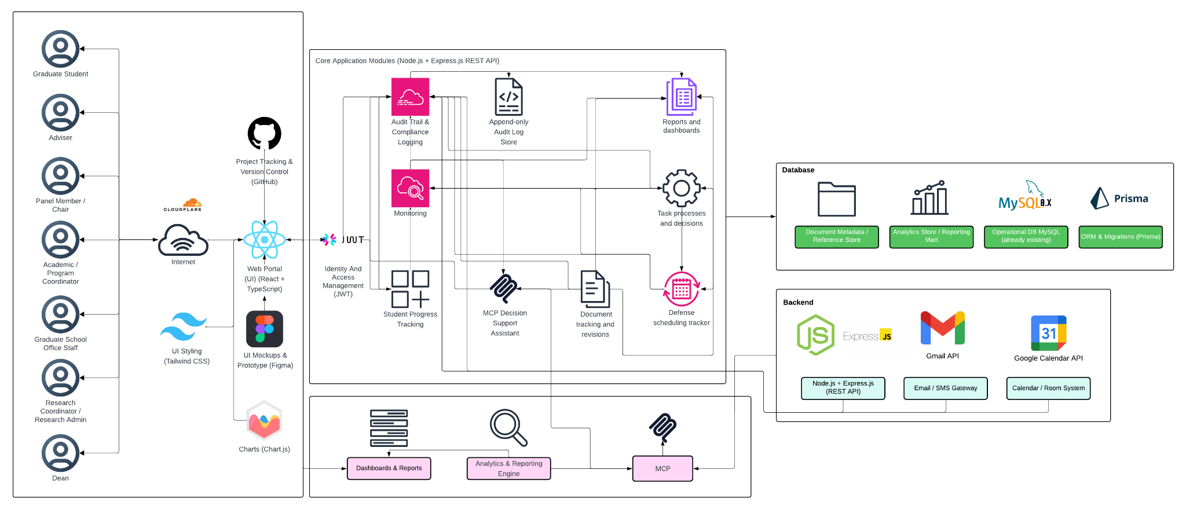

Appendix E. Key Performance Indicators (KPIs) of the Conceptual Framework

Appendix E.1. User and Access Management KPI
KPI | Target | Measurement Method | Reporting Frequency
Access control enforcement rate | 100% pass for all defined role-permission test cases | (Passed role-permission test cases ÷ Total defined role-permission test cases) × 100 | Every test cycle

Appendix E.2. Audit Trail and Accountability KPI
KPI | Target | Measurement Method | Reporting Frequency
Audit event coverage | 100% of defined auditable actions create timestamped log entries | (Auditable actions with valid timestamped logs ÷ Total defined auditable actions tested) × 100 | Every test cycle

Appendix E.3. Student Progress Management KPI
KPI | Target | Measurement Method | Reporting Frequency
Required monitoring field completion rate | 100% of active prototype records have all required monitoring fields | (Active prototype records with all required monitoring fields ÷ Total active prototype records) × 100 | Every academic term

Appendix E.4. Case Status and Action Tracking KPI

KPI | Target | Measurement Method | Reporting Frequency
Next-action ownership coverage | 100% of active in-scope cases have an assigned next-action owner | (Active in-scope cases with assigned next-action owner ÷ Total active in-scope cases) × 100 | Weekly

Appendix E.5. Defense Scheduling Management KPI
KPI | Target | Measurement Method | Reporting Frequency
Scheduling record completeness | ≥ 90% of scheduling cases have both request and outcome timestamps | (Scheduling cases with complete request and outcome timestamps ÷ Total scheduling cases) × 100 | Per defense cycle

Appendix E.6. Case Monitoring and Follow-Up KPI
KPI | Target | Measurement Method | Reporting Frequency
Follow-up closure logging rate | ≥ 90% of flagged cases have a recorded follow-up action and closure status | (Flagged cases with recorded follow-up and closure status ÷ Total flagged cases) × 100 | Monthly

Appendix E.7.Analytics and Decision Support KPI
KPI | Target | Measurement Method | Reporting Frequency
Follow-up closure logging rate | ≥ 90% of flagged cases have a recorded follow-up action and closure status | (Flagged cases with recorded follow-up and closure status ÷ Total flagged cases) × 100 | Monthly

Appendix E.8. RAG-Based Decision Support Assistant KPI
KPI | Target | Measurement Method | Reporting Frequency
Policy-grounded response match rate for decision-support outputs | 100% match on the defined prototype rule and reference test set | (Decision-support outputs that correctly match the approved rule and retrieved reference test set ÷ Total rule-based test cases) × 100 | Every test cycle

Appendix E.9. Reporting and Dashboards KPI
KPI | Target | Measurement Method | Reporting Frequency
Required report availability | 100% of the agreed report set is available in the prototype | (Available agreed reports ÷ Total agreed report set) × 100 | Every academic term

Appendix F. Reference labels used in the KPI table
Reference | Source | Brief explanation
SDP | 2nd Meeting Transcript Confirmation w/ Sir Eddie De Paula | Used for the confirmed AS-IS process, role ownership, monitoring needs, reporting needs, and scope boundaries.
GSRP | Graduate School Research Protocol | Used for required forms, stage rules, document checkpoints, and scheduling rules.
ISO 25012 | ISO/IEC 25012 Data Quality Model | Used for data quality measures such as completeness, consistency, and timeliness of records.
ISO 25010 | ISO/IEC 25010 System and Software Quality Model | Used for measurable system and software quality requirements.
Google SRE | Google Site Reliability Engineering guidance | Used for alert timing, follow-up timing, and target-setting ideas such as service level indicators and objectives.
OWASP ASVS | OWASP Application Security Verification Standard | Used to guide access control testing.
NIST SP 800-53 | NIST Security and Privacy Controls | Used to guide audit logging and accountability checks.

Appendix G. Existing (AS-IS) vs Proposed (TO-BE) System
Module | AS-IS (Existing System) | TO-BE (Prototype)
Module 1: Student Progress Management | Student progress is tracked across spreadsheets, monitoring sheets, email updates, and separate records. There is no single view of where a student is in the lifecycle. | One monitoring view shows the student’s current lifecycle stage, key status markers, required next steps, and recorded timestamps.
Module 2: Case Status and Action Tracking | Handoffs and decisions are often handled through manual follow-up, email coordination, and person-to-person checking. It is not always clear who owns the next action. | Role-based task queues show who owns the next action, what decision was recorded, and which cases need follow-up.
Module 3: Defense Scheduling Tracker | Scheduling is mainly coordinated through email and manual follow-up. Delays, reschedules, and final outcomes are not consistently recorded in one place. | Scheduling requests, availability, confirmations, and reschedules are recorded as structured events with dates and outcomes.
Module 4: Case Monitoring and Follow-Up | Monitoring depends on manual checking, reminders, and role-maintained records. Delayed cases may only be noticed after repeated follow-up. | Flagged cases, alerts, follow-up actions, and intervention records are tracked in one place to support case monitoring and follow-through.
Module 5: Analytics and Decision Support | There is no existing analytics and decision support function in the current process. Records may exist across different files and systems, but they are not consolidated in a way that produces timely insights for monitoring, planning, or intervention. | Structured lifecycle records are transformed into analytics outputs that show trends, delays, bottlenecks, and case patterns, helping Graduate School personnel monitor operations and support decisions using organized data.
Module 6: Policy and Case Guidance | Status questions, summaries, and next-step checking depend on manual review of forms, sheets, and emails. This takes time and depends on who is doing the checking. | The assistant reads allowed records and produces summaries, lists, and suggested next steps to support monitoring and processing. Final decisions still remain with authorized personnel.
Module 7: Reporting and Dashboards | Reports are prepared manually from separate files and records. Definitions may vary, and staff often need to consolidate data before reports can be used. | Dashboards and reports are generated from the same structured data, including subject needs, graduating student lists, LOA monitoring, residency tracking, and completion summaries.

Appendix H. Methodology

Appendix H.1. Methodology Flow of the Study with Scrum-Based Prototype Development
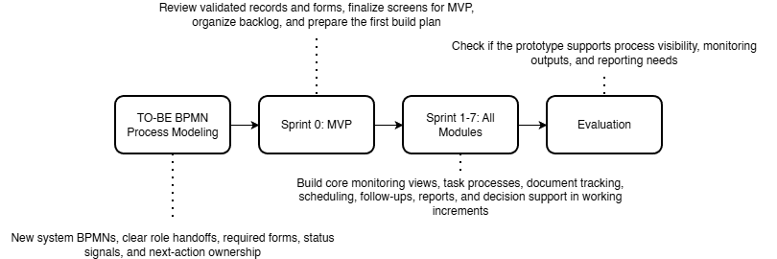

Appendix H.2. Proposed System Development Approach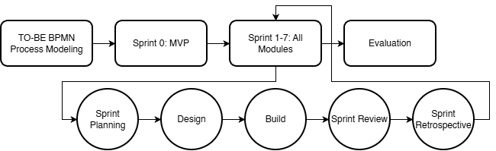

Appendix H.3. Proposed System Development Overview Using Agile Scrum

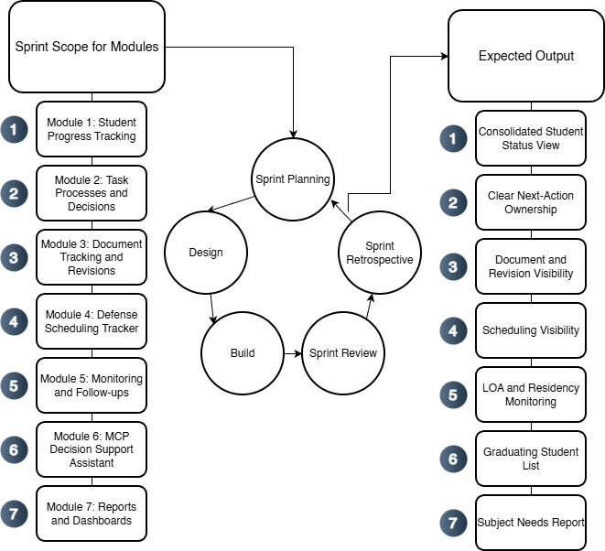

Appendix H.4. Specification Phases for the Proposed Graduate School Monitoring and Decision Support Platform


Appendix I. Data Requirements

Appendix I.1. Data to be collected and sources
Data Category | Key Fields | Primary Source Role | Existing System (AS-IS) | Use for Monitoring and Analytics
Student identity + program profile | Student name; ID number; program/track; year level; AY entry | Staff/Admin; Student (for verification) | Student Monitoring Excel Sheet (AC-STUDENT-MONITORING-Template.xlsx) | Baseline linking key across coursework + research monitoring; supports cohort grouping and drill-down views.
Coursework / enrollment monitoring | AY entry; subjects/codes; unit totals; standing/progress markers | Staff/Admin; Coordinator | Student Monitoring Excel Sheet (AC-STUDENT-MONITORING-Template.xlsx) | Enables “coursework-to-research readiness” monitoring where applicable.
Admission monitoring (status signals) | Requirements submitted date; application status; handoff confirmation | Admission Office; Graduate School Staff | AIMS + email-based handoff | Completes lifecycle coverage from admission without replacing AIMS.
Enrollment confirmation / term activation | Enrollment confirmation status per term; timestamp; active/inactive/stop-start signals | Graduate School Staff; Academic Coordinator | Email-based triggers + enrollment platform status | Prevents “gap in enrollment” visibility; supports continuity monitoring.
Curriculum tagging and study plan generation | Curriculum ID/version; student–curriculum tag date; required subjects; planned AY/Sem mapping | Academic Coordinator; Staff | Curriculum records + Student Monitoring Excel Sheet (AC-STUDENT-MONITORING-Template.xlsx) / study plan form | Enables per-student course audit and cohort-based monitoring for offerings and readiness.
Class offerings decision-support inputs | Eligible student counts per subject; pending prerequisites; planned offerings summary | Academic Coordinator | Student Monitoring Excel Sheet (AC-STUDENT-MONITORING-Template.xlsx) + curriculum mapping outputs | Supports “subjects to offer next semester” decision support.
LOA application monitoring | LOA request date; approval status; LOA start/end; LOA expiry marker | Graduate School Staff; Dean | Email-based routing + LOA tracking record | Adds visibility and escalation signals for LOA.
Readmission monitoring | Readmission request date; decision outcome; return term; conditions (if any) | Graduate School Staff | Email/manual records | Tracks re-entry pathway after LOA; supports continuity/readiness checks.
Residency monitoring signals | Residency clock start; pause/resume markers; nearing limit flags | Graduate School Staff/Coordinator | Derived monitoring record (policy-confirmed parameters) | Supports residency monitoring without changing policy.
Research case profile | AY first enrolled in thesis/dissertation; current AY; semester; program; adviser | Staff/Admin; Coordinator | Thesis Student Research Monitoring Sheet (Student-Research-Monitoring.xlsx) | Timeline anchor for time-in-stage, residency indicators, and exception tracking.
Adviser assignment + eligibility constraints | Adviser name; appointment status; date appointed; adviser load indicator | Research leadership/Admin | Research Protocol (Form 3 / 3.1) + spreadsheet reflections | Supports routing/accountability and adviser load monitoring.
Title defense workflow events | Endorsement; schedule date; approved title; decision outcome | Student; Coordinator; Panel Chair; Admin | Thesis Student Research Monitoring Sheet (Student-Research-Monitoring.xlsx) (Forms 1–2) | Captures early bottlenecks (endorsement + scheduling).
Proposal defense readiness + gate requirements | Endorsement; schedule; technical clearance; statistician consult (conditional) | Student; Adviser; Statistician; Admin | Thesis Student Research Monitoring Sheet (Student-Research-Monitoring.xlsx) (Forms 4, 4.1, 5) | Detects readiness blocks and scheduling bottlenecks.
Ethics review and clearance | Ethics submission; clearance date/status | Student; Ethics Office/Admin | Thesis Student Research Monitoring Sheet (Student-Research-Monitoring.xlsx) (Form 5.2) | Enables stop-the-clock/restart tracking around ethics review.
Final defense workflow events | Endorsement; schedule; outcome (pass/minor/major); re-defense status | Student; Adviser; Panel; Admin | Thesis Student Research Monitoring Sheet (Student-Research-Monitoring.xlsx) (Forms 6–8) | Captures revision cycles/decision states for bottleneck identification.
Public defense + publication/completion tagging | Public defense schedule; Turnitin cert; editor cert; final approval sheet; publication step | Student; Adviser; Admin | Thesis Student Research Monitoring Sheet (Student-Research-Monitoring.xlsx) (Forms 9–10) + Turnitin step | Converts endgame requirements into a traceable checklist; supports stuck-case detection.
Scheduling state and constraints | Proposed/confirmed dates; reschedules; mode; venue reservation | Admin/Staff; Panel Chair; Student | Email-based coordination + protocol steps | Measures scheduling cycle time and repeated back-and-forth.
Decision records + comment consolidation | Outcomes; consolidated comment sheet; approvals/release certs | Panel Chair; Panel Members; Adviser | Research Protocol (Form 5 consolidation; Form 5.1; Form 6/7) | Reduces version confusion; strengthens traceability/accountability.
Workload and operational queues | Pending endorsements; overdue items; aging cases; adviser/panel load counts | Admin; Coordinator; Leadership | Derived from milestone events + role assignments | Core decision-support layer for escalation and workload balancing.
Authority + audit signals | RBAC; access boundaries; change logs; retention rules | Admin | Thesis Student Research Monitoring Sheet (Student-Research-Monitoring.xlsx) (Forms 1–2) | Supports privacy-aligned handling and auditability for sensitive documents.
Practicum/OJT monitoring (if applicable) | Required hours; schedule; completion status; evidence checklist | Program Coordinator | Manual logs / certificates (MOA/certifications) | Included only when the program requires it; treated as completion signals.
Withdrawal monitoring | Withdrawal request/confirmation; effective term; reason (if allowed) | Graduate School Staff; Dean | Email/manual records | Tracks stop pathway formally for attrition reporting where allowed.
Graduation endorsement monitoring (Graduate School side) | Endorsed-to-graduate date; requirements complete flag; evidence checklist | Graduate School Staff; Academic Coordinator | Endorsed list + manual checklist | Supports graduating list preparation without replacing registrar processing.

Appendix J. Milestone Gate Criteria

Appendix J.1 Milestone Gate Criteria explaining definition of completion
Milestone | Entry Criteria | Required Evidence | Decision outcomes | Exit Criteria | Role
Admission Handoff Confirmed | Student has submitted requirements and admission status signal is available for handoff | AIMS status + handoff confirmation (email/record) | Accepted for onboarding / For completion / Not accepted | Handoff recorded; student is visible to Graduate School for onboarding and monitoring | Admission Office (status) + Graduate School Staff (handoff receipt)
Student Account + Program Onboarding Completed | Admission handoff confirmed | Enrollment platform account created; onboarding checklist (if used) | Activated / Returned for correction | Student account activated; student is tagged to program context for monitoring | Graduate School Staff / Academic Coordinator
Curriculum Tagged + Study Plan Generated | Student account exists; curriculum list/version exists | Curriculum ID/version record; student–curriculum tag record; generated study plan | Tagged / Corrected / Deferred | Student is linked to a curriculum; study plan (required subjects) is generated and viewable | Academic Coordinator
Term Enrollment Confirmed | Student is eligible to enroll for the term (per Graduate School) | Enrollment confirmation record (email trigger / enrollment platform status) | Confirmed / On hold / Not confirmed | Term status is recorded as active/inactive; monitoring continuity is visible (no “gap”) | Graduate School Staff / Academic Coordinator
Course Audit Updated | Term results/standing signals are available to be mirrored as monitoring indicators (without replacing grade encoding) | Monitoring sheet update (course completion/INC marker); supporting reference to official record where permitted | Updated / Pending update / Exception flagged | Course audit reflects latest completion/INC markers and remaining requirements for readiness checks | Academic Coordinator
Class Offerings Planning Completed | Curriculum + course audit data are available to compute eligible counts | Aggregated eligibility counts per subject; planned offerings summary | Approved offerings plan / Revised / Deferred | “Subjects to offer next semester” output is generated and recorded for term planning | Academic Coordinator
LOA Approved and Recorded | Student submits LOA request; case is active | LOA request record + approval decision + effective LOA start/end dates | Approved / Denied / Returned for completion | LOA status is recorded with effective period and expiry marker; student marked stop-start for monitoring | Dean (approval) + Graduate School Staff (recording)
Readmission Approved and Recorded | LOA period ended or readmission requested | Readmission request record + decision outcome + effective return term | Approved / Denied / Returned for completion | Readmission status recorded; student marked active for the return term | Graduate School Staff / Dean (as applicable)
Research Case Created | Readiness to start thesis/dissertation is confirmed (program-dependent) | Research case profile created (type, first enrolled AY, adviser pending/assigned) | Created / Deferred | Research case exists and becomes the basis for milestone event tracking | Research Coordinator / Staff
Adviser Designation Completed | Research case exists; adviser nomination is initiated | Research Protocol Forms 3 / 3.1 (adviser designation and appointment) and recorded adviser assignment | Appointed / Returned / Not appointed | Adviser assignment is recorded with date and ownership routing can begin | Research Leadership / Research Coordinator
Title Defense Completed | Adviser designation completed; title defense request endorsed | Research Protocol Forms 1–2 (title defense application + outcome); schedule record (if used) | Approved title / Returned for revision / Not approved | Approved title is recorded; status advances to proposal preparation stage | Panel Chair (decision) + Research Coordinator (recording)
Proposal Defense Completed | Title approved; proposal defense endorsed and scheduled | Research Protocol Forms 4, 4.1 (if applicable), 5 + schedule record + outcome/comments record | Passed / Revisions required / Re-defense required | Proposal defense outcome recorded; required changes captured as the authoritative revision basis | Panel Chair + Research Coordinator
Ethics Clearance Recorded | Proposal stage requires ethics review/clearance | Research Protocol Form 5.2 (ethics submission/clearance) | Cleared / Returned / Not cleared | Ethics clearance status and date are recorded; case may proceed to data collection/writing milestones | Ethics Office (clearance) + Research Coordinator (recording)
Final Defense Completed | Final defense endorsed and scheduled | Research Protocol Forms 6–8 (final defense comments/evaluation/settlement where applicable) + schedule/outcome record | Passed / Minor revisions / Major revisions / Re-defense | Final defense outcome recorded; revision pathway is explicit (minor/major/re-defense) | Panel Chair + Research Coordinator
Completion Evidence Verified | Final defense outcome permits completion processing | Research Protocol Forms 9–10 + Turnitin certificate + editor certification + approval sheet (as applicable) | Verified complete / Missing requirements / Returned | All required completion evidence is recorded as complete; case is eligible for GS endorsement | Graduate School Staff / Research Coordinator
Withdrawal Confirmed and Recorded | Student requests withdrawal; case is active | Withdrawal request/confirmation record (email/manual) | Approved / Denied / Returned | Withdrawal status recorded; monitoring stops with an auditable exit reason category (if allowed) | Dean + Graduate School Staff
Graduation Endorsement Completed | Completion evidence verified; no active stop-start/withdrawal | Endorsed-to-graduate list + requirements checklist (GS-side) | Endorsed / On hold / Returned for completion | Graduate School endorsement status recorded; endorsement list is prepared and handed off (registrar remains out-of-scope) | Graduate School Staff + Academic Coordinator / Dean

Appendix K. Functional Requirements
Category | Description
Curriculum and Study Plan Management | Load and maintain program curricula, tag a student to the correct curriculum, generate a per-student study plan, and show required subjects with AY and semester taken. Record subject completion date and status for course audit.
Enrollment and Coursework Monitoring | Track enrollment confirmation and course audit status. Provide a student view of the next semester schedule where allowed, and a coordinator view of student eligibility and remaining requirements without replacing official grade encoding.
Class Offerings Decision Support | Generate outputs that help the Academic Coordinator decide what subjects to offer next semester, such as counts of eligible students per subject, pending requirements, and a planned offerings summary.
LOA and Readmission Monitoring | Track LOA request status, approval, and effective LOA period. Track residency pause and readmission status, and generate LOA monitoring views for staff and coordinators.
Thesis and Dissertation Monitoring | Track adviser designation, title defense, proposal defense, final defense, revision cycles, manuscript finalization, and required certifications or documents. Record status, assigned role, and time on stage.
Practicum or OJT Tracking (Program-dependent) | Where required by the program, track required hours, schedule, and uploaded evidence such as MOA or certifications as completion signals. Exclude this if the program does not require it.
Withdrawal and Graduation Monitoring | Track withdrawal confirmation status and Graduate School graduation endorsement status. Generate graduating list outputs based on completion evidence without replacing Registrar processing.
Task Processing and Task Queues | Provide role-based task queues for submissions, endorsements, approvals, and decisions. Show who owns the next action across lifecycle stages.
Decision Recording | Record decision outcomes such as approve, revise, or return, together with the next required action and closure evidence for each milestone step.
Document Tracking | Maintain a required document checklist for each stage, track document versions, and record consolidated comments or decision records.
Scheduling Tracking | Record defense request, availability, and schedule outcome. Log reschedules and cancellations as monitoring signals.
Dashboards and Reports | Generate counts per stage, pending queues, aging or time in stage, LOA counts, course audit readiness, adviser or panel counts where applicable, and residency, completion, or attrition outputs based on validated definitions.
Alerts and Intervention Tracking | Detect threshold breaches such as long time in stage, LOA nearing expiry, or residency nearing limits. Notify the correct roles and log intervention actions with closure evidence.
Audit Trail | Log actions, decisions, and changes in definitions or process settings to support accountability.

Appendix L. Non-Functional Requirements
Category | Description
Security | Enforce role-based access control, strong authentication, secure session handling, and controlled privileges for higher-level users.
Privacy | Limit access to sensitive evaluation records, log access where needed, and handle data according to approved privacy boundaries (Datu, 2022).
Auditability | Keep append-only logs for key actions such as submissions, decisions, approvals, routing, and definition changes. Each log entry must show the actor, timestamp, and outcome.
Usability | Provide role-based dashboards and task queues, clear status labels, low encoding effort for staff, and consistent terms across modules.
Reliability | Apply data checks, validate required fields, support backup and recovery, and generate consistent timestamps for monitoring and reporting.
Maintainability | Allow milestone definitions, checklists, and workflow rules to be updated where possible without changing code, while keeping a controlled change process with logs.
Performance | Keep dashboard queries responsive, support efficient search and filtering, and handle document and log storage in a manageable way.
Interoperability | Allow export of reports and structured datasets. Allow integration or data exchange with institutional systems only where permitted by ownership and privacy rules.

Appendix M. IT tools to be used
Need | Specific Tools | Why this tool
UI mockups and clickable prototype |   Figma | Fast wireframing and interactive prototypes for stakeholder review and UI validation.
Frontend (web UI) |   React + TypeScript | Component-based UI for dashboards and queues, with TypeScript for safer handling of complex workflow states.
UI styling |   Tailwind CSS | Utility-first styling for consistent layouts with minimal custom CSS.
Charts for dashboards |   Chart.js | Lightweight charting for operational dashboards (counts, queues, aging/time-in-stage).
Backend (API + business rules) |   Node.js + Express.js (REST API) | Minimal backend framework for building API endpoints and implementing routing and workflow rules.
Authentication |   JWT (RFC 7519; internet standard) | Standard token format for stateless authentication between frontend and API.
Database |   MySQL 8 (InnoDB) | Relational data model with foreign keys for lifecycle, milestones, tasks, and audit logs, enabling consistent reporting queries.
Schema migration and DB access |   Prisma ORM (migrations + type-safe DB client) | One tool for repeatable schema migrations and type-safe database access, reducing manual SQL drift across sprints.
Project tracking and version control |   GitHub (Repo + Issues/Projects) | Source control and sprint tracking (issues, boards, basic backlog).
Diagrams |   draw.io    dbdiagram.io | Process and architecture diagrams (BPMN, ERD, system diagrams) with a lightweight tool.
Domain and DNS |   Cloudflare (DNS)  Cloudflare (SSL/TLS + Origin Certificate)  Cloudflare (Proxy + WAF/Firewall tools)  Cloudflare (CDN caching) | Manages the system domain/subdomain and DNS records (A/CNAME/TXT) for deployment and verification, with fast updates and centralized control
HTTPS and secure access |  | Provides HTTPS for users and encrypts traffic to the server (Full/Strict), reducing risks from misconfigured SSL on the origin.
Edge security |  | Adds a security layer in front of the server (e.g., basic filtering, rate limiting, DDoS protection) to reduce direct exposure of the origin.
Performance (optional) |  | Caches static assets to improve load time and reduce load on the origin server during peak access or demos.
RAG-enabled decision support | NotebookLM | Enables the system to retrieve relevant institutional records, policies, and supporting documents first, then generate responses based on those sources. This makes the assistant more appropriate for student status checking, guided summaries, completion rate analysis, and rule-guided next-step prompts. The tool is intended for retrieval-based decision support only and does not perform automated approvals or policy modifications.

Appendix N. Core tables and their purpose
Area | Table | Purpose in the system
Identity and Access Management (IAM) | Student | Stores the primary student monitoring identity and program entry context (e.g., cohort/AY entry, program/track).
 | UserAccount | Stores login identities for staff, coordinators, adviser/panel roles, and students (permitted views).
 | Role | Defines system roles used for RBAC.
 | UserRole | Assigns system roles to users (supports RBAC enforcement).
 | AdviserAssignment / PanelAssignment | Links advisers and panel members to students for scoped access and review responsibilities.
Core lifecycle & milestone tracking (monitoring layer) | StudentLifecycle | Stores program/track fields and references to program-dependent settings notes.
 | MilestoneDefinition | Defines milestone requirements by lifecycle stage, expected durations, and criticality.
 | StudentMilestoneStatus | Tracks milestone progress status and due/completion timestamps at the student level.
Workflow routing & decisions | Task | Represents actionable workflow items (pending/overdue), ownership, due dates, and recommended next action fields.
 | DecisionLog | Captures decisions made on tasks (approve/revise/return) with decision actor and timestamp.
 | RoutingRule | Defines rule-based routing for next owner roles and follow-up task generation.
Academic lifecycle tracking (monitoring signals) | Program | Stores program/track information and references for program-dependent settings.
 | AcademicTerm | Stores academic year/term identifiers (start/end dates where needed).
 | TermEnrollment | Stores per-term enrollment monitoring signals (confirmation timestamps, allowed status signals).
 | Course | Master list of course code/title/units.
 | CourseEnrollment | Links term enrollment to courses and stores monitoring signals (e.g., in-progress/completed/incomplete markers).
 | Curriculum | Curriculum identifier/version information per program.
 | StudyPlanItem | Stores planned/required subjects per curriculum (and recommended term where applicable).
 | StudentCurriculumTag | Maps a student to a curriculum version/tag (e.g., revised plan/bridging).
Research pipeline tracking (case-and-event) | ResearchCase | Monitoring container for thesis/capstone engagements linked to a student.
 | MilestoneEvent | Records milestone execution as timestamped events (occurredAt, outcome, ownerRole, decision actor, notes) and may reference related workflow tasks.
Evidence, scheduling, and traceability | DocumentRecord | Stores required-document checklist items per student/milestone, including review status and outstanding revisions count.
 | DocumentVersion | Stores uploaded file versions (file reference, uploadedBy, timestamps) linked to DocumentRecord.
 | RevisionNote | Tracks revision comments/required changes and resolution status linked to DocumentRecord and/or DocumentVersion.
 | ScheduleRequest | Stores scheduling requests tied to a student (requestedBy, preferred dates, status).
 | Availability | Collects availability windows from users for a ScheduleRequest.
 | ScheduleEvent | Stores schedule outcomes (confirmed/rescheduled/cancelled) with timestamps and decision actor.
 | FormSubmission | Tracks protocol-driven forms with submitted/endorsed/approved timestamps and routing state.
 | ClearanceRecord | Tracks clearance submission/outcome dates where applicable.
 | TimelineEvent | Provides a consolidated “what happened” feed by recording key events and linking to related entities.
Monitoring actions and alerts | AlertThreshold | Stores configured monitoring thresholds (e.g., prolonged stage, delayed scheduling) used by the monitoring engine.
 | NotificationAlert | Logs notifications sent (recipient, reason, timestamp, success metadata).
 | Intervention | Stores follow-up actions with owner, timestamps, and closure evidence.
Auditability | AuditLog | Append-only log of key events (access attempts, decisions, transitions, uploads, configuration changes).

Appendix O. Key relationships (high-level PK/FK design)
Relationship | Meaning | Integrity rule (what must be true)
Student (1) → (many) StudentLifecycle | A student has a stage history (entered/exited timestamps) | StudentLifecycle.StudentID must exist in Student
Student (1) → (many) StudentMilestoneStatus | A student has milestone progress records | StudentMilestoneStatus.StudentID must exist; MilestoneDefinitionID must exist
MilestoneDefinition (1) → (many) StudentMilestoneStatus | Milestone status references a valid milestone | StudentMilestoneStatus.MilestoneDefinitionID must exist
Student (1) → (many) TermEnrollment | A student has per-term monitoring records | TermEnrollment.StudentID must exist; TermEnrollment.TermID must exist
AcademicTerm (1) → (many) TermEnrollment | Enrollment records belong to a term | TermEnrollment.TermID must exist in AcademicTerm
TermEnrollment (1) → (many) CourseEnrollment | Term enrollment can include multiple courses | CourseEnrollment.TermEnrollmentID must exist; CourseEnrollment.CourseID must exist
Course (1) → (many) CourseEnrollment | Course enrollment references valid courses | CourseEnrollment.CourseID must exist in Course
Curriculum (1) → (many) StudyPlanItem | A curriculum defines planned subjects | StudyPlanItem.CurriculumID must exist; StudyPlanItem.CourseID must exist
Student (1) → (many) StudentCurriculumTag | A student can be tagged to a curriculum/version | StudentCurriculumTag.StudentID must exist; CurriculumID must exist
Student (1) → (many) ResearchCase | A student may have a research engagement container | ResearchCase.StudentID must exist
ResearchCase (1) → (many) MilestoneEvent | A case has milestone events over time | If used, MilestoneEvent.ResearchCaseID must exist in ResearchCase
MilestoneDefinition (1) → (many) MilestoneEvent | Events reference valid milestone definitions | MilestoneEvent.MilestoneDefinitionID must exist
Student (1) → (many) DocumentRecord | Document checklist items attach to a student | DocumentRecord.StudentID must exist
DocumentRecord (1) → (many) DocumentVersion | A checklist item can have multiple uploads/versions | DocumentVersion.DocumentRecordID must exist
DocumentRecord (1) → (many) RevisionNote | Revision notes attach to document checklist/version | RevisionNote.DocumentRecordID must exist
Student (1) → (many) ScheduleRequest | Scheduling requests attach to a student | ScheduleRequest.StudentID must exist; Requester must exist
ScheduleRequest (1) → (many) Availability | Availability windows belong to a scheduling request | Availability.ScheduleRequestID must exist; UserID must exist
ScheduleRequest (1) → (many) ScheduleEvent | Schedule outcomes/events belong to a request | ScheduleEvent.ScheduleRequestID must exist
UserAccount/Assignments → Student scope | People are linked to students for scoped access | AdviserAssignment/PanelAssignment.UserID must exist; StudentID must exist

Appendix P. RAG-Based Decision Support Assistant Architecture


Appendix Q. Entity-Relationship Diagram (ERD) and Table Group Overview



Appendix Q.1. Group A. Student and Program Context

Appendix Q.2. Group B. Identity, Roles, and Assignments



Appendix Q.3. Group C. Lifecycle & Milestones



Appendix Q.4. D. Workflow Tasks & Decisions

Appendix Q.5. Group E. Documents & Revisions

Appendix Q.6. Group F. Scheduling & Coordination



Appendix Q.7. Group G .Monitoring, Alerts, and Interventions

Appendix Q.8. Group H. Auditability

Appendix R. Computed indicators from event history used for prescriptive analytics and decision support
Computed indicator | Computed from | Decision-support use (how it drives prescriptive actions)
Current stage or milestone position | Latest MilestoneEvent per ResearchCase + MilestoneType ordering/definitions | Identifies where the case is now and which next action is relevant
Pending queue membership | MilestoneEvent with incomplete outcome + RoleAssignment owner + due date rules (if applicable) | Places cases into the correct role-based queue and enables prioritization
Aging or time-in-stage | Date difference between “now” and last MilestoneEvent timestamp, or between milestone timestamps | Flags stalled cases; triggers follow-up prompts and escalation when thresholds are reached
Overdue tasks and SLA breaches | Task due date (from workflow rules) vs current date + completion state | Generates “overdue” labels; recommends urgent follow-up or escalation
Scheduling cycle time | DefenseEvent request date to confirmed schedule date; reschedule count | Detects scheduling delays; recommends next coordination step and highlights repeated reschedules
Evidence completeness score | Required evidence checklist vs DocumentArtifact links for the milestone | Blocks completion when required evidence is missing; recommends what document to request
Decision outcome state | Latest decision outcome in MilestoneEvent (approve, revise, return) | Determines the next routing step; recommends who should act next
Prescriptive recommendation output | Rule-based checks applied to indicators above using policy-confirmed parameters | Produces recommended next actions, queue prioritization, and escalation prompts without automating final approvals

Appendix S. Cost table for on-site premises
ON-SITE (On-Premises using existing infrastructure)
Item | Type | Cost | Potential Costs (if not existing) | Notes
Server hardware | One-time | ₱0 | ₱7,000–₱50,000 | Use an existing campus machine. Modest specs can support an MVP for a small graduate school with low concurrent usage.
OS + software stack | One-time | ₱0 | ₱0 | Open-source tools; no licensing fees.
HTTPS / SSL certificate | Annual | ₱0 | ₱0–₱5,000 | Free SSL via Let’s Encrypt; paid certificate optional depending on institutional policy.
Domain / subdomain | Annual | ₱0 | ₱800–₱1,500 | If USLS provides a subdomain under an existing domain, no additional cost.
Backups (storage + retention) | Monthly | ₱0 | ₱500–₱2,000 | Applies only if additional backup media/storage allocation or offsite copying is required.
IT operations (maintenance and support) | Monthly | ₱0 | Variable if there is an IT staff. | Patching, monitoring, user support, access management; typically absorbed by existing IT workload.
Email notification service (SMTP) | Monthly | ₱0 | ₱0–₱500 | Can use existing school email relay; external relay is optional for MVP use.
LLM API | Monthly/usage-based | ₱0 | ₱100–₱500 | Estimated for light MVP use only. If enabled, the LLM is used only for advisory outputs such as summaries, completion rate analysis, and next-step prompts. Official OpenAI text pricing currently ranges from $0.25 / 1M input tokens and $2.00 / 1M output tokens for GPT-5 mini, up to $1.25 / 1M input and $10.00 / 1M output for GPT-5, and $2.50 / 1M input and $15.00 / 1M output for GPT-5.4.

Appendix T. Workplan

Appendix T.1. CAP-IT1 Work Timeline (80% target)
Development |  |  | May |  |  |  | Jun |  |  |  |  | Jul |  |  |  | Aug
# | Module | Activities | 4 | 11 | 18 | 25 | 1 | 8 | 15 | 22 | 29 | 6 | 13 | 20 | 27 | 3
1 | User & Access Management | Design role-based access interface (login, role dashboards)
 |  | Design RBAC database schema (users, roles, permissions)
 |  | Develop authentication and authorization prototype
 |  | Implement authentication logic, role-permission enforcement, and access validation rules
 |  | Conduct access testing
 |  | Sprint review and RBAC validation with stakeholders
2 | Lifecycle & Milestone Management | Design lifecycle stage interface
 |  | Design lifecycle database structure (stages, milestones, timestamps)
 |  | Prototype stage transition logic and milestone prerequisite checks
 |  | Implement lifecycle progression engine
 |  | Test stage gating and timestamp logging accuracy
 |  | Sprint review of lifecycle logic and milestone flow
3 | Workflow Routing & Decision Management | Design structured workflow queue interface
 |  | Design decision log and routing database schema
 |  | Prototype approve/revise/return decision pathways
 |  | Implement workflow routing engine and ownership reassignment
 |  | Conduct traceability and decision integrity testing
 |  | Sprint review on workflow clarity and ownership visibility
4 | Document & Revision Management | Design checklist and document submission interface
 |  | Design document metadata schema
 |  | Prototype document submission and revision tracking flow
 |  | Implement revision logging and checklist validation engine
 |  | Conduct version traceability testing
 |  | Sprint review of document tracking accuracy
5 | Scheduling & Coordination Management | Design scheduling request and availability interface
 |  | Design scheduling database
 |  | Prototype defense scheduling logic
 |  | Implement scheduling coordination engine
 |  | Conduct scheduling validation & sprint review
6 | Monitoring, Alerts & Intervention Engine | Design monitoring dashboard interface (risk indicators & alert views)
 |  | Design monitoring database logic (threshold rules, time-in-stage computation, escalation mapping)
 |  | Prototype automated alert detection logic
 |  | Implement monitoring and escalation engine (threshold evaluation + intervention logging)
 |  | Conduct alert accuracy testing (threshold validation & false-positive checks)
 |  | Sprint review of intervention logging and escalation clarity
7 | Analytics & Reporting | Design analytics dashboard layout (queue aging, bottleneck views, load metrics)
 |  | Design analytics aggregation schema reporting mart tables & computed metrics)
 |  | Implement reporting queries and dashboard visualizations
 |  | Conduct analytics validation testing (metric accuracy, aggregation consistency, cross-module data integrity)
 |  | Sprint review on reporting accuracy
8 | Database Audit | Design audit trail interface (activity log viewer & filtering tools)
 |  | Design append-only audit log schema (action logs, timestamp mapping, user-action trace)
 |  | Implement cross-module activity logging integration
 |  | Conduct audit integrity testing (log completeness, tamper resistance validation)
 |  | Sprint review on traceability coverage

Appendix T.2. CAP-IT2 Work Timeline (20% target)

Development |  |  | Aug |  | Sep |  |  |  | Oct |  |  |  | Nov
# | Module | Activities | 24 | 31 | 7 | 14 | 21 | 28 | 5 | 12 | 19 | 26 | 2 | 9 | 16 | 23
9 | Evaluation Setup | Design structured usability and monitoring-interpretation evaluation instruments
 |  | Conduct pilot evaluation session
 |  | Finalize evaluation protocol for stakeholder sessions
10 | Stakeholder Usability / UAT | Conduct structured UAT Session 1 (Lifecycle tracking, Workflow routing validation)
Conduct structured UAT Session 2
(Monitoring alerts, Analytics dashboards, Access Control or Audit validation)
Consolidate findings
Document usability gaps and interpretation inconsistencies
11 | Refinements (Iteration 1) | Implement UI clarity improvements (dashboard readability, queue labeling, milestone visualization)
 |  | Refine workflow routing flows and decision-state clarity
Conduct full regression testing across Modules 1–8
(ensure refinements did not break monitoring, analytics, or access control logic)
12 | Access Control or Audit Hardening | RBAC scoping improvements
 |  | Audit log coverage + integrity checks
 |  | Regression testing
13 | Reporting & Export Polish | Access Control or Audit Hardening
Finalize export formats and endorsement-ready reporting outputs
(PDF/CSV exports, summary report structure validation)
14 | Documentation Finalization | Integrate final implementation updates into Chapter 3 & Chapter 4
 |  | Finalize User Guide and Admin Guide documentation
 |  | Clean appendix materials (BPMN, ERD, tables, architecture diagrams)
15 | Final Demo + Defense Prep | Package final build for deployment demonstration
 |  | Conduct final defense rehearsal and structured system walkthrough

